2022 National Sample Survey of Registered Nurses Methodology Report

U.S. Census Bureau

February 2024

**Contents**

Abstract 3

Introduction 4

Frame and Sample 6

Instrument Development 12

Data Collection 16

Response Rate 21

Data Editing 23

Weighting 45

Item Level Response and Imputation 50

Variance Estimation and Hypothesis Testing 54

Supporting Material 56

Appendix A – Letters 162

Appendix B – Questionnaire 171

# Abstract

## Objective

This report details the plan, development, and operations for the 2022 National Sample Survey of Registered Nurses (NSSRN). The NSSRN survey is designed to estimate the characteristics of registered nurses (RN) and nurse practitioners (NP) in the workforce at the state and national levels.

## Methods

A sample of approximately 125,000 registered nurses was selected from a sampling frame compiled from files provided by the National Council of the State Boards of Nursing (NCSBN), The American Association of Nurse Practitioners (AANP), and individual state Boards of Nursing (BONs). The sample was stratified by licensing state. Within each state there were two strata: one for RNs holding an NP license and another for all other RNs. To ensure reliable state estimates for RNs and NPs at the state level, different sampling rates were used across states and for RNs and NPs within each state.

There were changes to the questionnaire redesign for the 2022 NSSRN due to changes in the health care system and best practices in survey methodology since its last administration in 2018. New concepts were added to the survey, including, but not limited to, the Coronavirus pandemic and telehealth. An expert review was conducted to determine how to best implement the survey concepts, then cognitive interviews were conducted to evaluate these enhancements.

Data collection for the 2022 NSSRN began on December 15th, 2022 and extended to April 13th, 2023. Survey invitations were mailed to potential respondents that gave them the opportunity to participate via a web instrument or a paper questionnaire. Additionally, sampled RNs had access to a staffed questionnaire assistance telephone line where they could receive login assistance, language support, or complete the interview with a Census telephone interview agent. Potential respondents were sent up to five invitations and reminders.

## Results

The weighted overall response rate for the 2022 NSSRN was 41.1% (40.6% unweighted).[1] A total of 49,234 questionnaires were completed from December 2022 to April 2023. Weighted estimates from the NSSRN data generalize to state and national RN and NP populations.

# Introduction

The 2022 National Sample Survey of Registered Nurses (NSSRN) was conducted by the U.S. Census Bureau for the National Center for Health Workforce Analysis (NCHWA), Health Resources and Services Administration (HRSA), Department of Health and Human Services (HHS). This is the eleventh cycle of the NSSRN. This study was conducted with registered nurses (RNs) who held an active RN license as of December 31, 2021.

This document details the objectives, methodologies, and results of the 2022 NSSRN. It is organized in 9 sections.

* Survey History. The 2022 NSSRN is the second production implementation following the redesign and merging of the previous NSSRN and the National Sample Survey of Nurse Practitioners (NSSNP).
* Frame and Sample Specifications. The 2022 NSSRN utilized a sampling frame built from a list of registered nurses compiled from the National Council of State Board of Nursing (NCSBN) and from individual state Boards of Nursing (BONs). Sampling was done independently within each of the 50 states and the District of Columbia. There were two sampling strata per state: The first group was for all registered nurses (RNs) without an NP license. The second was RNs holding an NP license to represent NPs.
* Content Development and Instrument Specifications. Data were collected using a web instrument and/or paper questionnaire. Respondents could also complete the questionnaire over the telephone by request.
* Data Collection. This section discusses the mail schedule and data capture methods for web, paper, and telephone questionnaire assistance operations.
* Response Analysis. This section discusses the calculation of the response rates.
* Data Processing and Editing. Web and paper survey responses were unduplicated, standardized across modes, and prepared for analysis.
* Weighting Specifications. Weights ensure the sample estimates are representative of the target populations of NPs and RNs in one or more states in the U.S. They incorporate the differential probabilities of selection and adjustments for nonresponse and ensuring the sample estimates weight up to population counts.
* Imputation Specifications. Hot deck imputation was used to treat item nonresponse and create rectangular data set for data analysis. For each imputed variable, correlated variables were selected to form imputation classes and serve as sorting variables to improve the quality of the imputation.
* Estimation and Data Usage. This section discusses best practices for data users and limitations of the 2022 NSSRN.

## Survey History

Since the 1970s, the NSSRN has served as the cornerstone of nursing workforce data. The 2022 NSSRN is the study’s eleventh cycle. The NSSRN was previously fielded in 1977, 1980, 1984, 1988, 1992, 1996, 2000, 2004, 2008, and 2018.

The National Sample Survey of Registered Nurses (NSSRN) was collected to assist in fulfilling the goals of the congressional mandates of the Public Health Service Act 42 U.S.C. Section 294n(b)(2)(A). These mandates ensure the development of information describing and analyzing the health care workforce and workforce related issues and provide necessary information for decision-making regarding future directions in health professions and nursing programs in response to societal and professional needs. In addition, Public Health Service Act 42 U.S.C. Section 295k (a)-(b) states:

“The Secretary shall establish a program, including a uniform health professions data reporting system, to collect, compile, and analyze data on health professions personnel … The Secretary is authorized to expand the program to include, whenever he determines it necessary, the collection, compilation, and analysis of data … health care administration personnel, nurses, allied health personnel…in States designated by the Secretary to be included in the program.”

The 2022 NSSRN is the second time that the U.S. Census Bureau administered this survey. The U.S. Census Bureau conducts the NSSRN on behalf of the HHS under Title 13, United States Code, Section 8(b), which allows the Census Bureau to conduct surveys on behalf of other agencies.

The NSSRN is designed to provide necessary data to understand the characteristics and distribution of registered nurses throughout the United States, including education, employment, licensing and certification, and demographics. These data provide the means for evaluation and assessment of evolving demographics, education qualifications, and career employment patterns of RNs.

The 2022 NSSRN provides estimates for both RNs and NPs at the state and national levels. The 2018 NSSRN combined the previous runs of the NSSRN along with the 2012 NSSNP. Since 2018, the survey has been updated to include emerging trends in the healthcare setting such as telehealth and nursing during the Coronavirus pandemic.

## 2022 Questionnaire Changes

For the 2022 NSSRN, several updates were added from the 2018 NSSRN. The 2018 questionnaire underwent a content review to make improvements based on changes in health care policy and best practices in survey methodology. In addition, a section was added concerning COVID-19 and nursing during the pandemic. More information about the changes in questionnaire content from the 2018 NSSRN to 2022 NSSRN can be found in the Content Development section of this report.

# Frame and Sample[2]

## Overview

The target population for the 2022 NSSRN were the U.S. resident population holding an active nursing license in one or more U.S. states. The 2022 NSSRN utilized a sampling frame of registered nurses built from a list of registered nurses compiled from NCSBN, AANP, and from individual State Boards of Nursing.[3] Sampling was done independently within each of the 50 states and the District of Columbia. There were two sampling strata per state: one for nurses that hold a nurse practitioner (NP) license and another for all other registered nurses (RN). The sampling rates for RNs and NPs differed across and within each state in order to produce reliable estimates for RNs and NPs within each state. A total of 124,900 nurses were sampled, including 61,550 NPs and 63,350 RNs.

## Frame Development

The sampling frame of registered nurses was compiled from NCSBN’s list of registered nurse licenses, AANP’s lists of nurse practitioners for some states and lists from individual State Boards of Nursing. While most states provide their nursing data to the NCSBN, there were ten states that did not. These ten states provided their data directly to the U.S. Census Bureau for inclusion in the sampling frame.

For some states additional data were needed to identify nurse practitioners in order to ensure that reliable estimates could be produced for NPs at the state level. To identify NPs for sampling purposes, 39 states provided individual advanced practice registered nurse (APRN) files. In five states, the APRN records did not distinguish NPs from clinical nurse specialists, certified nurse midwifes, or certified registered nurse anesthetists. In each of these states, all of the APRN records are flagged as being a nurse practitioner to guarantee that there would be nurse practitioners in the NP stratum.

Since nurses can hold multiple licenses within the same state or across a number of states, multiple records for a nurse may exist. The U.S. Census Bureau’s Person Identification Validation System (PVS) was used to assign a unique person identifier to identify duplicate nurse records within and across the state files. The PVS uses probabilistic matching to assign a unique Census Bureau identifier to each person.[4] The unique identifier, referred to as the Protected Identification Key (PIK) is the key linking variable used to match among Census Bureau data and administrative records. The PIK was used to match administrative data to fill missing demographic information when it was not provided by the NCSBN or individual state nursing board files, including race, ethnicity, date of birth, and sex. These demographic data were used to sort the list of nurses prior to sampling and were used in the weighting process.

## Universe Creation

*Removing Ineligible Records*

First, the following records were made ineligible for sampling:

1. Nurses in the California Survey of Registered Nurses conducted by the California Board of Nursing (CBN)[5]
2. Nurses who had passed away
3. Licensed Practical Nurses (LPNs)
4. Inactive nurses based on license status
5. Addresses that were out of the country
6. Addresses that were incomplete (i.e. not mailable)
7. Nurses whose license expired prior to January 1, 2021[6]
8. Nurses who are missing license end dates and are 70+ years old
9. Nurses with missing license end dates, missing license numbers, and missing dates of birth

After the removal of these ineligible cases, the sampling frame consisted of approximately 10,060,000 records.

*Identifying a Single Record for Nurses with More Than One License*

Because nurses can hold more than one license within the same state or across multiple states, there were instances where there were multiple records for the same nurse in the sampling frame. Additionally, multiple file deliveries from state boards of nursing were received so some nurses had completely duplicated records from being on multiple file deliveries from a single state. In order to unduplicate the records to obtain one record for each nurse, duplicate records were handled in the following way:

1. If an NP record existed along with RN record(s), the NP record remained eligible while all other records were made ineligible. The license state for the nurse was the license state of the NP license. When there were multiple NP records, the remaining steps below were used to allocate the NP to a license state.
2. When a nurse still had multiple records, the record where the license state matched the state of residence was kept. If multiple such records existed, the remaining steps below were used to determine a single record to keep.
3. If a nurse still had multiple records, the record that had the latest expiration date and most demographic information available remained eligible, while the other record(s) were made ineligible.

After unduplication, the number of unique records remaining on the sampling frame was approximately 4,212,000.

## Sample Selection

Each record on the sampling frame was assigned to a sampling stratum associated with the licensing state and whether it was an NP license. In most cases, the license state was determined by data provided by the NCSBN and the individual state BONs. In some rare situations the license state variable did not match the state file from which the record was received. In these situations, the Census Master Address File was used to determine the correct state.

There were two strata per state: Stratum 1 includes all RNs that do *not* have an NP license. Stratum 2 contains nurses with an NP license. There were different sampling rates across states and for RNs and NPs within a state in order to produce reliable state estimates of each population.

The size of the sample allocated to each stratum depended on response rates from prior surveys and the estimate of the nurses employed in each state. The expected response rate for each state and stratum was assumed to be the 2018 NSSRN rate. Since the primary estimates of interest were employed nurses, we took the employed rate for each state from the 2018 NSSRN into account. See Table 1 for these rates. For each stratum, we specified a minimum sampling rate and a margin of error (MOE), such that the overall sample size was close to 125,000.[7] Priority was given to having more states with a MOE of approximately 0.046 over having a design with the lowest standard error on the national estimates. Consequently, the design does not give the lowest possible standard error for national estimates. See Table 2.

**Table 1.** 2018 NSSRN Response and Employed Rates by State and License Type, used in 2022 NSSRN Sampling

|  |  |  |  |  |
| --- | --- | --- | --- | --- |
|  | **Stratum 1 (RNs)** | | **Stratum 2 (NPs)** | |
| License State | 2018  Response Rate | 2018  Employed Rate | 2018  Response Rate | 2018  Employed Rate |
| **Alabama** | 0.425 | 0.819 | 0.429 | 0.827 |
| **Alaska** | 0.404 | 0.879 | 0.407 | 0.913 |
| **Arizona** | 0.444 | 0.802 | 0.498 | 0.843 |
| **Arkansas** | 0.431 | 0.820 | 0.423 | 0.899 |
| **California** | 0.567 | 0.815 | 0.603 | 0.808 |
| **Colorado** | 0.617 | 0.819 | 0.627 | 0.872 |
| **Connecticut** | 0.488 | 0.827 | 0.468 | 0.950 |
| **Delaware** | 0.443 | 0.861 | 0.470 | 0.835 |
| **District of Columbia** | 0.475 | 0.958 | 0.498 | 0.826 |
| **Florida** | 0.545 | 0.787 | 0.549 | 0.836 |
| **Georgia** | 0.459 | 0.851 | 0.469 | 0.840 |
| **Hawaii** | 0.328 | 0.842 | 0.463 | 0.797 |
| **Idaho** | 0.552 | 0.823 | 0.531 | 0.894 |
| **Illinois** | 0.558 | 0.809 | 0.579 | 0.859 |
| **Indiana** | 0.556 | 0.800 | 0.556 | 0.832 |
| **Iowa** | 0.495 | 0.842 | 0.521 | 0.885 |
| **Kansas** | 0.455 | 0.816 | 0.484 | 0.919 |
| **Kentucky** | 0.524 | 0.852 | 0.440 | 0.909 |
| **Louisiana** | 0.411 | 0.855 | 0.408 | 0.873 |
| **Maine** | 0.512 | 0.799 | 0.498 | 0.831 |
| **Maryland** | 0.797 | 0.877 | 0.681 | 0.903 |
| **Massachusetts** | 0.599 | 0.835 | 0.619 | 0.800 |
| **Michigan** | 0.587 | 0.778 | 0.582 | 0.863 |
| **Minnesota** | 0.614 | 0.838 | 0.562 | 0.904 |
| **Mississippi** | 0.373 | 0.877 | 0.355 | 0.868 |
| **Missouri** | 0.476 | 0.824 | 0.538 | 0.808 |
| **Montana** | 0.541 | 0.849 | 0.484 | 0.894 |
| **Nebraska** | 0.505 | 0.926 | 0.480 | 0.979 |
| **Nevada** | 0.427 | 0.887 | 0.442 | 0.899 |
| **New Hampshire** | 0.554 | 0.897 | 0.458 | 0.893 |
| **New Jersey** | 0.517 | 0.846 | 0.486 | 0.873 |
| **New Mexico** | 0.467 | 0.849 | 0.485 | 0.879 |
| **New York** | 0.474 | 0.817 | 0.473 | 0.815 |
| **North Carolina** | 0.574 | 0.847 | 0.597 | 0.883 |
| **North Dakota** | 0.467 | 0.928 | 0.450 | 0.935 |
| **Ohio** | 0.547 | 0.824 | 0.654 | 0.820 |
| **Oklahoma** | 0.429 | 0.802 | 0.468 | 0.872 |
| **Oregon** | 0.500 | 0.886 | 0.601 | 0.899 |
| **Pennsylvania** | 0.616 | 0.815 | 0.638 | 0.798 |
| **Rhode Island** | 0.422 | 0.847 | 0.355 | 0.800 |
| **South Carolina** | 0.475 | 0.787 | 0.438 | 0.802 |
| **South Dakota** | 0.530 | 0.901 | 0.549 | 0.901 |
| **Tennessee** | 0.483 | 0.889 | 0.450 | 0.852 |
| **Texas** | 0.542 | 0.813 | 0.526 | 0.855 |
| **Utah** | 0.522 | 0.858 | 0.509 | 0.923 |
| **Vermont** | 0.383 | 0.931 | 0.550 | 0.942 |
| **Virginia** | 0.671 | 0.847 | 0.592 | 0.868 |
| **Washington** | 0.690 | 0.884 | 0.569 | 0.855 |
| **West Virginia** | 0.396 | 0.855 | 0.399 | 0.965 |
| **Wisconsin** | 0.575 | 0.803 | 0.633 | 0.811 |
| **Wyoming** | 0.378 | 0.877 | 0.378 | 0.921 |

This design produces an MOE of 0.046 for RN and NP estimates with a sample size of approximately 125,000. The sampling rate in each state and stratum was just large enough to ensure a MOE of 0.046 on an estimate of 50% at the 95% confidence level.[8] For four states (Alaska, DC, Hawaii, Wyoming), the entire frame of NPs were included in the sample. Consequently, these states have no sampling variance.

**Table 2.** Summary of the 2022 NSSRN Sample Design

|  |  |  |
| --- | --- | --- |
|  | **Stratum 1 - RNs** | **Stratum 2 – NPs** |
| National sample size | 63,000 | 62,000 |
| States with sampling rate = 1.0 | 0 | 4 (AK, DC, HI, WY) |
| Margin of Error (MOE) | 0.046 | 0.046 |
| Minimum state sample size | 700 | 550 |
| Maximum state sample size | 2,000 | 1,800 |
| Average state sample size | 1,200 | 1,200 |
| Average state interview employment sample | 500 | 550 |

The frame included approximately 3,839,000 RN and 373,000 NP records nationwide. Table 3 shows the size of the frame and the sampling rate used for each stratum by license state.

The frame was sorted by race, ethnicity, and year of birth within each of the sampling strata prior to sample selection in order to improve the distribution of these variables in the sample and decrease the variance of survey estimates. Table 3 also shows final sample sizes.

**Table 3.** 2022 NSSRNFrame Size and Sampling Rate by License State and Stratum

|  |  |  |  |  |  |  |
| --- | --- | --- | --- | --- | --- | --- |
|  | **Stratum 1 (RNs)** | | | **Stratum 2 (NPs)** | | |
| **License State** | Frame Size | Sampling Rate | Sample Size | Frame Size | Sampling Rate | Sample Size |
| **Alabama** | 69,000 | 0.0217 | 1,500 | 7,100 | 0.2254 | 1,600 |
| **Alaska** | 8,600 | 0.1512 | 1,300 | 1,200 | 1.0000 | 1,200 |
| **Arizona** | 86,500 | 0.0162 | 1,400 | 9,600 | 0.1458 | 1,400 |
| **Arkansas** | 38,500 | 0.0390 | 1,500 | 3,800 | 0.3684 | 1,400 |
| **California** | 187,000 | 0.0064 | 1,200 | 14,000 | 0.0857 | 1,200 |
| **Colorado** | 67,000 | 0.0149 | 1,000 | 7,100 | 0.1549 | 1,100 |
| **Connecticut** | 47,000 | 0.0255 | 1,200 | 5,500 | 0.2545 | 1,400 |
| **Delaware** | 15,000 | 0.0933 | 1,400 | 1,300 | 0.8462 | 1,100 |
| **District of Columbia** | 8,500 | 0.1294 | 1,100 | 850 | 1.0000 | 850 |
| **Florida** | 291,000 | 0.0041 | 1,200 | 31,000 | 0.0419 | 1,300 |
| **Georgia** | 78,000 | 0.0141 | 1,100 | 15,500 | 0.0968 | 1,500 |
| **Hawaii** | 11,500 | 0.1739 | 2,000 | 550 | 1.0000 | 550 |
| **Idaho** | 20,500 | 0.0585 | 1,200 | 1,700 | 0.5588 | 950 |
| **Illinois** | 173,000 | 0.0069 | 1,200 | 13,500 | 0.0889 | 1,200 |
| **Indiana** | 99,500 | 0.0131 | 1,300 | 5,900 | 0.2034 | 1,200 |
| **Iowa** | 46,500 | 0.0280 | 1,300 | 3,500 | 0.3429 | 1,200 |
| **Kansas** | 43,000 | 0.0326 | 1,400 | 3,900 | 0.3077 | 1,200 |
| **Kentucky** | 59,500 | 0.0185 | 1,100 | 7,400 | 0.2027 | 1,500 |
| **Louisiana** | 56,000 | 0.0268 | 1,500 | 5,400 | 0.2963 | 1,600 |
| **Maine** | 22,000 | 0.0591 | 1,300 | 2,000 | 0.6000 | 1,200 |
| **Maryland** | 73,000 | 0.0096 | 700 | 8,900 | 0.1067 | 950 |
| **Massachusetts** | 104,000 | 0.0096 | 1,000 | 10,500 | 0.1143 | 1,200 |
| **Michigan** | 134,000 | 0.0090 | 1,200 | 12,000 | 0.1000 | 1,200 |
| **Minnesota** | 92,500 | 0.0119 | 1,100 | 5,700 | 0.1930 | 1,100 |
| **Mississippi** | 42,000 | 0.0357 | 1,500 | 5,200 | 0.3462 | 1,800 |
| **Missouri** | 94,000 | 0.0149 | 1,400 | 8,000 | 0.1625 | 1,300 |
| **Montana** | 14,500 | 0.0759 | 1,100 | 1,200 | 0.7917 | 950 |
| **Nebraska** | 28,500 | 0.0421 | 1,200 | 1,400 | 0.6786 | 950 |
| **Nevada** | 30,500 | 0.0459 | 1,400 | 2,900 | 0.4483 | 1,300 |
| **New Hampshire** | 13,000 | 0.0846 | 1,100 | 900 | 1.0000 | 900 |
| **New Jersey** | 107,000 | 0.0112 | 1,200 | 10,500 | 0.1429 | 1,500 |
| **New Mexico** | 22,500 | 0.0578 | 1,300 | 2,100 | 0.5238 | 1,100 |
| **New York** | 269,000 | 0.0052 | 1,400 | 19,000 | 0.0842 | 1,600 |
| **North Carolina** | 129,000 | 0.0085 | 1,100 | 9,700 | 0.1134 | 1,100 |
| **North Dakota** | 11,500 | 0.1043 | 1,200 | 950 | 0.9474 | 900 |
| **Ohio** | 188,000 | 0.0064 | 1,200 | 16,500 | 0.0667 | 1,100 |
| **Oklahoma** | 46,500 | 0.0344 | 1,600 | 3,600 | 0.3611 | 1,300 |
| **Oregon** | 46,000 | 0.0261 | 1,200 | 3,900 | 0.2564 | 1,000 |
| **Pennsylvania** | 206,000 | 0.0053 | 1,100 | 15,000 | 0.0800 | 1,200 |
| **Rhode Island** | 19,500 | 0.0718 | 1,400 | 2,300 | 0.7391 | 1,700 |
| **South Carolina** | 59,000 | 0.0203 | 1,200 | 11,000 | 0.1545 | 1,700 |
| **South Dakota** | 15,500 | 0.0710 | 1,100 | 1,100 | 0.7273 | 800 |
| **Tennessee** | 68,000 | 0.0125 | 850 | 21,000 | 0.0762 | 1,600 |
| **Texas** | 307,000 | 0.0039 | 1,200 | 28,500 | 0.0491 | 1,400 |
| **Utah** | 34,000 | 0.0353 | 1,200 | 3,100 | 0.3871 | 1,200 |
| **Vermont** | 9,200 | 0.1522 | 1,400 | 800 | 0.8750 | 700 |
| **Virginia** | 95,000 | 0.0089 | 850 | 12,500 | 0.0960 | 1,200 |
| **Washington** | 76,500 | 0.0111 | 850 | 6,500 | 0.1846 | 1,200 |
| **West Virginia** | 26,000 | 0.0577 | 1,500 | 2,400 | 0.5417 | 1,300 |
| **Wisconsin** | 43,000 | 0.0256 | 1,100 | 4,800 | 0.2292 | 1,100 |
| **Wyoming** | 6,500 | 0.2308 | 1,500 | 550 | 1.0000 | 550 |
| **National** | **3,839,300** |  | **63,350** | **373,300** |  | **61,550** |

# Instrument Development

## 2022 Survey Content

The following provides an overview of the key questionnaire topics included in the 2022 National Sample Survey of Registered Nurses.

**Section A: License and Certification** – Questions on specific certifications and licensing information.

**Section B: Education** – Questions about initial nursing education, education following their first license, and education preparation for advanced practice nursing.

**Section C: Primary Nursing Employment** – Included questions about the nursing position held on December 31, 2021 in which the nurse spent the largest share of their working hours to include geographic location, employment setting, hours worked, level of care or type of work, patient population, clinical specialty, earnings and whether they have remained in this position since December 31, 2021.

**Section D: Left Primary Nursing Position Held on December 31, 2021** – For nurses that have left the primary nursing position held on December 31, 2021, this section contained questions on their reason for leaving the position, if they will continue to work in nursing, when they plan to retire from nursing and how long they expect to work in the geographic area of the primary nursing position.

**Section E: Remained in the Primary Nursing Position Held on December 31, 2021** – For nurses that have remained in the primary nursing position they held on December 31, 2021.

**Section F: Secondary Employment in Nursing** – Included questions about the employment settings, earnings, and the hours and weeks worked in secondary employment.

**Section G: Nurse Practitioners** – Questions for those who are Nurse Practitioners included areas of certification, characteristics of their patient population, billing and insurance, perceptions of and satisfaction with their work and the presence of physicians where they work.

**Section H: Nurses Not Working in Nursing** – For nurses who were not working on December 31, 2021, this section included questions on their intention of returning to nursing and reasons for not working in nursing.

**Section I: Prior Nursing Employment** – Included questions about the reasons for job change, geographic location of prior employment, and prior employment setting.

S**ection J: Nursing During the Coronavirus Pandemic –** Questions pertaining to COVID response, vaccinations, and overall management of working in the pandemic.

**Section K: National Practitioner Data Bank** – Questions on opinions and experiences with the National Practitioner Data Bank.

**Section L: General Information** – Contained questions about the responding RN’s demographics and other background information. Provided the responding RN an opportunity to correct address information.

## Content Development

For the 2022 NSSRN, several updates were added from the 2018 NSSRN. The 2018 questionnaire underwent a content review to make improvements based on changes in health care policy and best practices in survey methodology. In addition, a section was added concerning COVID-19 and nursing during the pandemic. The 2022 questionnaire is provided in Appendix B of this document. A separate crosswalk file provides additional information on the 2022 questionnaire along with corresponding question numbers from the 2018 questionnaire.

As part of the process in updating the 2018 questionnaire to fit current best practices in survey methodology, the questionnaire underwent an expert review and cognitive interviews to evaluate potential enhancements to the 2018 paper questionnaire. U.S. Census Bureau survey methodology experts reviewed the 2018 paper questionnaire examining the question wording, question ordering, consistency, layout, and how to best convey the survey concepts.

After the expert review, a draft of the 2018 instrument was created and a series of cognitive interviews were conducted in early 2021. Cognitive interviews with RNs and NPs lasted about 60 to 90 minutes and were used to gain an understanding of how well the questions worked when administered to a sample of the survey’s target population. Participants were instructed to read each question aloud, think aloud while forming a response, and then provide the response to the interviewer. The interviewer administered scripted and spontaneous probes to collect more information regarding the participants’ perception of questions and the cognitive process they used to retrieve information and formulate answers to questions.

## Web Instrument Specifications

All sampled nurses selected to participate in the 2022 NSSRN received an invitation by mail to respond to the survey by web. The invitation included the website URL and a unique 8-digit Login ID. The initial invitation to complete the survey using the web instrument. In each follow-up reminder, the letter contained the website URL and the Login ID. The fourth mailed reminder also included a paper questionnaire.

After logging into the website using their Login ID and reviewing a Privacy Act statement, respondents were asked two questions to verify they were the correct sampled person. If the respondents did not verify they were the correct sampled nurse, then the survey concluded and they were removed from future follow-up mailings. After verifying that they were the correct sampled nurse, the respondent was taken to the PIN-assignment screen, which assigned a 4-digit PIN in case they wanted to save their answers and return later to finish the survey. Respondents were also asked to set up a security question in case they forgot their PIN.

After receiving their PIN and setting up their security question, respondents were asked the following screener question to determine if they were a registered nurse as of December 31, 2021: As of December 31, 2021, were you actively licensed to practice as a Registered Nurse (RN) in the U.S. (whether or not you were employed in nursing at that time)?” If the respondent indicated they were a registered nurse, they continued on with the rest of the survey. If the respondent indicated they were not a registered nurse as of the reference date, they were asked a follow-up question to confirm their response: “On the prior question you indicated that you were NOT a registered nurse on December 31, 2021. Is this correct?” If the respondent answered “No” they returned to the survey starting with the first question that followed the screener question. If the respondent answered “Yes”, they were taken to a Thank You screen and the respondent was then removed from all future mailings.

After the final question in the survey, respondents were presented with a screen that indicated they were about to submit their answers. After clicking “Submit” on this screen, a submission confirmation screen appeared with the date and time of completion. Once respondents submitted their survey, they could login to the web instrument again, but they could only view the submission confirmation screen. Respondents were not able to alter any of the answers to the questions in the survey after submitting.

## Programming and Testing the Web Instrument

The web survey was conducted using the U.S. Census Bureau’s Centurion system for internet data collection. This software presented the questionnaire on a screen of a computer or mobile device, and the interview was self-administered by the respondent.

There were several hard edits programmed into the web instrument which required the respondent to provide a valid answer before continuing. These answers were necessary for determining if the respondent was a registered nurse, if the respondent was employed in the nursing field, and if the nurse was a certified nurse practitioner. There were other questions in the survey that had soft edits, prompting the respondent to provide an answer to the question; however, if the respondent clicked “Next” after seeing these prompts and without answering the question again, they would be able to skip that question without answering. These soft edits were only used in a few questions that were critical for determining whether the respondent should receive a series of questions or not. There were also several soft edits to prompt respondents that the answer they were entering was invalid; however, the respondent was able to skip past these as well. Overall, the web instrument guided respondents through skip patterns and established legitimate ranges for numerical write-ins.

Once programming of the instrument was completed, the various requirements of the instrument, such as, respondent login, skip pattern implementation, fills, data output, were tested to ensure that the Centurion system was functioning correctly.

Usability testing of the web instrument was conducted in the summer of 2021 by the Center for Behavioral Science Methods (formerly the Center for Survey Measurement) within the U.S. Census Bureau. The goal of the testing was to uncover usability issues with the original design and recommend enhancements to ensure that the web survey performed optimally during data collection. During usability testing, the respondent completed the initial version of the web instrument, while under observation by a U.S. Census Bureau test administrator. Respondents were instructed to answer the questions as they applied to their own situations and were asked to “think aloud” as they were completing the survey. Eye tracking data was also collected for seven of the participants. Once the participants finished the survey, they were asked to complete a satisfaction questionnaire that included questions on general usability aspects of the survey and the comprehension of general survey terminology. Finally, some screenshots of select new questions on the survey were shown and discussed. Usability testing was done using a range of devices including laptops, smartphones, and tablets. Design recommendations based on the results were implemented into the final version of the web instrument.

With respondent consent, each session was video- and audio-recorded. Many sessions were also observed by other researchers and U.S. Census Bureau and NCHWA employees. The sessions were conducted virtually via Microsoft Teams.

## Paper Instrument Specifications

The paper questionnaire and web questionnaire were designed to be as similar as possible to minimize the influence of mode on responses. While automatic skips and hard or soft edits cannot be implemented in the paper instrument, the questionnaire did include skip instructions within the question wording to mimic the web instrument.

Paper questionnaires were designed using Amgraf One Form Plus software, which enables the design of scannable forms. Returned forms were processed by integrated Computer-Assisted Data Entry (iCADE), which automatically extracts all check box entries (optical mark recognition (OMR)) and preselected answer fields (optical character recognition (OCR)), then captures and displays an image of all other entries to an operator for keying from image (KFI). Specific keying procedures were written for the 2022 NSSRN and keyers were trained on the NSSRN KFI procedures. Questionnaires were printed, trimmed, and assembled by a commercial printer. The printing and assembly of the NSSRN questionnaires was monitored by U.S. Census Bureau staff for quality assurance.

# Data Collection

Data collection efforts for the 2022 National Sample Survey of Registered Nurses (NSSRN) began on December 15, 2022 and closed on April 7, 2023. Potential respondents were sent up to five invitations and reminders. The 2022 NSSRN was conducted as a Web Push Plus Mail mixed-mode format after contacting by mail. Sampled RNs were randomly assigned to either the Incentive Group and Non-Incentive group. In the initial mailing, approximately 112,500 respondents in the Incentive Group were mailed a letter with the web survey URL and a five-dollar cash incentive. The Non-Incentive Group received the same letter as the Incentive Group; however, they did not receive the five-dollar enclosed incentive.

The mailing schedule for the 2022 NSSRN was much simpler than the 2018 NSSRN. Everyone in both the Incentive and Non-Incentive groups received the same five mailings: an initial letter containing the web instrument’s URL, a pressure sealed reminder, an additional letter reminder, a letter with the web URL and a paper questionnaire, and a final pressure sealed reminder letter. Once the sampled RN submitted a web survey, returned a paper questionnaire, explicitly refused to participate, or indicated that the sampled person was not eligible for the survey, follow-up mailing ceased for the individual.

The detailed mailout schedule including the dates for the label file creation and late mail return (LMR) pulls is provided in **Table 4**. A label file was created for each mailing that included the names, addresses, and additional details necessary for assembling the package for mailout. In order to assemble the packages in time for the next mailout, the label files were created several weeks prior to the mailing and often included individuals that may have responded between the label file creation and mailout. To reduce the number of individuals who received a follow-up mailing after submitting their response, a late mail return file (LMR) was created. The LMR dictates which packages should be pulled and destroyed before mailout to prevent those who have already responded from receiving another mailing.

**Table 4. Mailout Schedule**

|  |  |  |  |  |
| --- | --- | --- | --- | --- |
| **FILE NAME** | **NSSRN Team**  **for review** | **Label File** | **LMR** | **MAIL DATE** |
| **Mailing 1, initial web invitation** | 10/31/22 | 11/2/22, 11/8/22 | NA | 12/15/22 |
| **Mailing 2, pressure sealed reminder** | 11/6/23 | 11/8/22 | NA | 12/22/22 |
| **Mailing 3, reminder letter** | 12/20/22 | 12/22/22 |  | 1/26/23 |
| **Mailing 4, letter reminder with paper questionnaire** | 1/17/23 | 1/19/23 | 2/21/23 | 2/23/23 |
| **Mailing 5, final reminder letter** | 1/31/23 | 2/2/23 | NA | 3/9/23 |

## Mailout Specifications

In the initial mailing all sampled RNs received instructions for participating by web. The first letter included the web survey URL along with their unique login ID. In the initial mailing, approximately 112,500 respondents in the Incentive Group were mailed a letter with the web survey URL and a five-dollar cash incentive. The Non-Incentive Group received the same letter as the Incentive Group; however, they did not receive the five-dollar enclosed incentive.

A week after the initial mailing, all sampled nurses received a reminder mailing that included the web survey URL and the individual’s unique login ID. The reminder letter was a bi-fold pressure-sealed envelope. Approximately a month after the second mailing, all sampled nurses who had not responded received an additional reminder letter that included the web survey URL and the individual’s unique login ID.

The fourth mailing occurred approximately a month after the third mailing. All sampled nurses who had not responded received a reminder mailing that included the web survey URL and the individual’s unique login ID as well as a paper questionnaire. A final reminder letter was sent to the nurses who had not responded approximately two weeks after the fourth mailing.

## Telephone Questionnaire Assistance (TQA)

Invitations for the survey included a toll-free telephone number for respondents to contact the U.S. Census Bureau if they had questions on the survey, wanted to complete the interview over the phone, or wanted to submit feedback. All invitation letters, the web instrument, and the paper instrument identified this toll-free number.

The telephone line was answered by NSSRN trained interviewers at the U.S. Census Bureau’s call center in Tucson, Arizona. During data collection for the 2022 NSSRN, 468 calls were made to the toll-free line. If the potential respondent requested to respond to the survey over the phone or was having difficulty completing the instrument on their own, the TQA interviewer would administer the survey using the Centurion web instrument. Table 5 lists all possible TQA purpose codes that could be assigned during a call or an interview. TQA Code 60 expanded to cover 13 additional FAQ codes and definitions that interviewers could use to categorize a question.

**Table 5. TQA Purpose Codes and Definitions for the 2022 NSSRN**

|  |  |
| --- | --- |
| **TQA Purpose Codes and Definitions** | **Count** |
| 01: Internet instrument completed over the phone | 27 |
| 02: Refusal to participate | 18 |
| 04: Person does not live/work at this address | 25 |
| 05: Not an RN (Registered Nurse) | 55 |
| 11: Not living in the US | 1 |
| 12: Deceased | 28 |
| 20: Paper questionnaire status | 23 |
| 30: Questions about incentive | 9 |
| 31: Request replacement survey (English) | 25 |
| 40: Trouble filling out paper questionnaire | 2 |
| 49: PIN requested | 13 |
| 50: Login ID request | 3 |
| 51: Problem logging into internet instrument | 21 |
| 52: Other instrument issues | 9 |
| 53: PIN/security question reset request | 24 |
| 60: Question regarding the survey (general FAQ) | 80 |
| 80: Comments | 105 |
| **TOTAL** | 468 |

TQA interviewer training was conducted prior to the initial 2022 mailing. The interviewers were trained to answer respondent questions about the NSSRN and conduct interviews over the phone using the web instrument. A background of the survey was provided, along with details on the mailout schedule and non-monetary incentives used. Interviewers were trained on how to determine and assign the correct purpose codes in ATAC (Automated Tracking and Control) system. They were given examples on how to search for respondent’s cases in the web instrument and how to administer the survey over the phone. Finally, they were trained on how to properly close out the case and assign a purpose code to identify the web questionnaire had been completed over the phone. TQA interviewers were given a manual that included these details and answers to frequently asked question that they were able to reference during the 2022 NSSRN production cycle.

Call monitoring sessions of recorded TQA calls were scheduled throughout data collection. If any changes were needed to the ATAC TQA instrument based on comments received from interviewers, the survey team coordinated programming updates. All updates to procedures were communicated to the TQA interviewers. Incoming call volumes were also monitored throughout data collection and scheduling of the interviewers was adjusted accordingly.

## Email Questionnaire Assistance (EQA)

Potential respondents were also able to interact with Census Bureau staff via email. An email address (addp.nssrn@census.gov) was listed in all invitations and on the web and paper instruments. Emails were answered by NSSRN staff. The NSSRN staff employed scripted responses for common concerns and questions. These scripts ensured consistent and accurate information. When replying to the messages, staff removed any information in the response email that could be considered personally identifiable (e.g., address and name). The EQA operation responded to approximately 100 potential respondents.

## Confidentiality

Participation in the 2022 NSSRN was voluntary, and all data collected that could potentially identify an individual person are confidential. Data are kept private in accordance with applicable law. Respondents are assured of the confidentiality of their replies in accordance with 13 U.S.C. Section 9. All access to Title 13 data from this survey is restricted to Census Bureau employees and those holding Census Bureau Special Sworn Status pursuant to 13 U.S.C. Section 23(c). In compliance with this law, all data released to the public are only in a statistical format. No information that could personally identify a respondent or household may be released. The Census Bureau ensured that all HRSA staff obtained Special Sworn Status prior to receiving access to any confidential data. The NSSRN public use data files went through a thorough disclosure review process and were approved by the Census Disclosure Review Board prior to release.

## Efforts to Maximize Response Rates

The data collection process for the 2022 NSSRN was carefully designed to encourage participation from potential respondents. A series of tools were used to help maximize response rates including following best practices in instrument design for the web and paper instruments, using multiple modes for data collection, providing a toll-free telephone line for respondents, sending cash incentives to respondents, using of follow-up reminders, and cleaning frame address information to determine the best contact address.

To increase cooperation, attention was placed in various design elements when constructing the questionnaire. In developing questions, concrete question wording was used with simple grammar. Efforts were made to provide clear instructions on how to answer questions, as necessary. Questions were grouped according to subject matter areas within the instrument. To reduce burden, complicated items were restructured and simplified, long lists of response options were shortened, and unnecessary items were removed from the questionnaire altogether. Cognitive interviews were conducted to evaluate these enhancements.

For the paper instrument, the design and format maximized readability to include the appropriate spacing between questions, font size and type, and clear skip instructions. The web instrument was mobile- optimized to ensure readability on a variety of devices. Usability testing was completed on the web instrument, which provided feedback on the instrument’s design features for improving potential respondent’s interactions with the web instrument.

Data collection involved a series of mailings and follow-ups designed to grab the attention of the potential respondent and pique their interest in the subject matter. FAQs were provided in several mailings to give potential respondents more details on the survey. The mailing strategy used the 2022 NSSRN was based on recommendations from Dillman et al (2009) for maximizing response rates:

* *Invitation Letter:* An invitation letter was mailed to all potential respondents providing details about the study, a web URL with a login ID for accessing the web version of the questionnaire, and a toll-free number for the individual to call if there were any questions or comments. About half of the sample received a paper questionnaire in the initial mailing. In addition, about 112,500 sampled nurses also received a token of appreciation (five dollar cash incentive).
* *Additional Mailings:* The NSSRN employed multiple contacts with nurses to maximize responses.

# Response Rate

An outcome code was assigned to each case at the end of data collection in order to calculate the response rate. These outcome codes were categorized into (1) complete returns, (2) unknown eligibility, and (3) ineligible. Table 8 provides a summary of the final outcome codes for the 2022 NSSRN and how they were categorized into these three larger groups.

Complete returns are defined as those who answered three critical items as well as at least 50% of a subset of 28 questions. To be eligible for the survey and counted as a complete return, respondents had to have an active nursing license as of December 31, 2022 and be living in the United States.

For some potential respondents, we did not receive sufficient information to determine whether or not the individual was eligible to participate in the survey. These cases include those where the individual refused to complete the survey or did not complete a sufficient portion of the survey to yield a complete. The unknown eligibility category also includes cases where the mailings were undeliverable with the address we had on file and those whose mailings were delivered, but never responded.

Potential respondents were ineligible if they did not have an active nursing license as of December 31, 2022 or did not live in the U.S. Those who were deceased at the time of the survey or who were terminally ill or institutionalized were also ineligible for the survey.

**Table 6.** Summary of Final Disposition Codes for the 2022 NSSRN

|  |  |  |
| --- | --- | --- |
| **Final Disposition** | **Description of Outcome Codes** | **Count** |
| Complete Return | Complete Returns | 49,234 |
| Unknown Eligibility | Refusals/Incompletes | 92 |
| Undeliverable as addressed | 11,122 |
| Delivered, but no response received | 63,383 |
| Ineligible | Not a Registered Nurse | 1,069 |
| Deceased |

The response rate was calculated using the American Association for Public Opinion Research Response Rate #3 definition (RR-3).[9] RR-3 is defined as the number of completed returns divided by the number of completed returns plus an estimate of the number of eligible cases among all unresolved cases. The proportion that were eligible out of all resolved cases was 97.9%. This figure was multiplied by the number of cases with unknown eligibility to estimate the number of eligible cases among all unresolved cases.

Response Rate = Complete Returns / (Complete Returns + e(Unknown Eligibility)

where *e* is the proportion that were eligible out of all responses received: e = eligible / (eligible + ineligible).

The national weighted response rate for the NSSRN was 41.1% (40.6% unweighted). The weighted response rate accounts for the sample design and the probabilities of selection due to disproportional selection in some states and strata in the sample.

# Data Editing

We processed the data for those cases identified as completes for inconsistent, out-of-range, and out-of- path responses, and constructed new indicators from respondent answers that were useful for analysis by end users.

## Completeness and Unduplication

Complete returns were defined as responding to four critical items and at least 50% of a subset of 26 other important questions throughout the instrument although, in almost all cases, respondents answered more than the minimum 13 questions required for completion. The four critical items were NP_LCNP (recognition as a NP by a State Board of Nursing), ED_LCRN (actively licensed as an RN), PN_EMPLYD (employed in nursing), and LC_INUS (living in the U.S.). Backfill edits on these four critical items were run prior to determining completeness. Once there were a set of completed cases, we needed to unduplicate those cases where the respondent utilized both the web and paper instruments for responding. Completed web surveys were always selected over completed paper returns.

Because there are multiple follow-up mailings, it was also possible that respondents received more than one paper questionnaire and sent back two paper submissions. In these cases, data from only one of the returned paper questionnaires was included in the data file. The paper return with the higher level of completeness as defined by the completion criteria above was selected for inclusion in the data file for cases where multiple paper questionnaires were returned.

## Paper to Web Standardization

Responses needed to be standardized across web and paper so they could be appended in a single data file. Although the majority of the survey questions had the same valid values for paper and web instruments, sometimes the variable names and response values differed due to the data collection systems. Generally, paper responses were reformatted to match the web output. If a respondent selected more than one response category in a “Mark One” question in the paper survey, the first response category listed on the form was generally selected. However, if the list was hierarchical in nature, such as degree, we chose the highest degree selected in the list.

## Data Processing

The 2022 National Sample Survey of Registered Nurses (NSSRN) raw output was processed to manage inconsistent and invalid responses in the following sequential steps:

* Range Edit. If a value fell outside the bounds of a defined minimum and maximum for that item, the value was replaced with an indicator that the response is missing in error. The minimum and maximum were selected to represent a reasonable range of possible responses to the item.
* Backfill Edit. The backfill edit imputed values to items based on responses to subsequent items that indicated the correct response to the edited item. Backfill edits applied almost exclusively to paper questionnaires, which could not prevent a respondent from skipping a root item but answering follow-up questions. For example, if a nurse practitioner responded that they have ever billed under their National Provide Identifier (NPI) number (NP_NPIBILL=1), but had not selected a response to whether they had an NPI number (NP_NPINUM), then the correct response would be “Yes” to NP_NPINUM and the variable would be backfilled to a “1”.
* Yes/No Edit. In the NSSRN, there are question series that ask the respondent to select all response items that apply. Prior to the Yes/No edit, the variables corresponding to each response item were set to 1 if the item was selected and may be blank or 0 (depending on response mode) if it was not selected. If the respondent selected the response, the value was set to 1 to signify a “Yes” response. If the respondent did not select the response, the value was set to 2 to indicate a “No” response for the item. If none of the items in a select-all-that-apply list are selected, then the entire set of variables that correspond to the response list were set to missing and imputed after the rest of the edits were completed.
* Consistency Edit. If responses to two items in the survey had conflicting data, one response was maintained and the other one was either updated to a consistent value with the one that was maintained or set to missing and imputed.
* Legitimate Skip Edit. If the item was not part of the respondent’s path, then the value for the item was set to ‘.L’.
* Missing in Error Edit. If the item was part of the respondent’s path but the respondent did not provide a valid answer, the item was set to ‘.M’. In most cases, ‘.Ms’ were imputed using hot deck imputation. Please see the Item Nonresponse and Imputation section for more details.
* Disclosure Edit. If published, some survey answers could reveal the respondent’s identity and compromise confidentiality. Disclosure edits involved removing entire items or suppressing rare or unique values.

## Open-ended Coding and Back coding

The NSSRN had several questions that contained an “Other, specify” option that allowed respondents to write-in their own responses. These write-ins were back coded and several new categories were formed. Any new categories created from open-ended coded were labeled as “OTHER (NEW CATEGORY)” in the dataset. This notation was used to differentiate those categories that had been listed on the questionnaire and those categories that were derived from open-ended coding.

## Reserved Codes

The following reserved code values are:

* .L = Legitimate Skip
* .M = Missing or Undefined

## Derived Variables

#### The following descriptive notes explain the meaning of derived or constructed variables. For presentation in this document, derived variables are grouped into the following categories:

#### Demographic Constructed Variables

#### Education Constructed Variables

#### Employment Constructed Variables

#### Geographic Constructed Variables

#### Advanced Practice Nursing, Licensure, and Professional Certification Constructed Variables

#### Health Professional Shortage Areas (HPSA)

#### Survey Administration Constructed Variables

#### The documentation includes the derived variable narrative**,** which briefly describes the variables, formulae, and concepts used in the preparation of the derived variables. The narrative provides the name of the derived variable and the response categories or levels.

###### Demographic Constructed Variables

The demographic constructed variables include

* Age;
* Race/ethnicity;
* Languages spoken;
* Marital status; and
* Geographic Division of employment and/or residence (for 2020 and 2021).

###### Age of Nurse in 2022 (AGE_PUF)

Age of the respondent was determined by subtracting the year of birth from the year of the survey. AGE_PUF is created by applying bottom and top codes to age of the respondent. The bottom code groups all ages 23 years old or younger together. The top code groups all ages 79 years old and older.

###### Age of Nurses – Grouped (AGE_GP_PUF)

AGE_GP_PUF is a derived variable that aggregates ages into eleven categories:

* < 29
* 30 to 34
* 35 to 39
* 40 to 44
* 45 to 49
* 50 to 54
* 55 to 59
* 60 to 64
* 65 to 69
* 70 to 74
* >= 75

###### Racial Background (RACE)

RACE summarizes racial background as follows in six categories:

* American Indian/Alaska native only
* Asian only
* Black only
* Native Hawaiian/-Pacific Islander only
* White only
* Multiracial

###### Race/Ethnic Background (RAC_ETHN_PUF)

RAC_ETHN_PUF summarizes racial/ethnic background as follows in six categories:

* Hispanic
* White only, non-Hispanic
* Black only, non-Hispanic
* Asian only, non-Hispanic
* American Indian only, non-Hispanic
* Pacific Islander only and Multiple Races, non-Hispanic

###### Race/Ethnic Background Summary (RACE_GP)

RACE_GP summarizes racial/ethnic background as follows in two groups:

* White only and no other race(s) identified, non-Hispanic
* Other – Hispanic or any race other than White non- Hispanic

###### Marital Status and Other Adults at Home Being Cared for Aside from Children at Home (MAR_ADULT)

MAR_ADULT, with its four categories, combines information about marital status (with its three original levels of married or in a domestic partnership, widowed/divorced/separated, and never married) with information on whether there are adults being provided significant care by the nurse at the nurse’s own home. The coverage of this variable includes such individuals as parents and other dependents.

These four constructed categories of MAR_ADLT are as follows:

* Married or in a domestic partnership with adults being cared for at home;
* Widowed/separated/divorced with adults being cared for at home;
* Never married with adults being cared for at home; and
* No adults being cared for at home.

###### Marital Status and Children at Home Being Cared for (MAR_CHLD)

MAR_CHLD has twelve categories combines information on marital status (with its three original levels of married or in a domestic partnership, widowed/divorced/separated, and never married) with information on those children being provided significant care at home by the nurse. This is a mark-all- that-apply item that includes no children at home, children at home age less than 6 years, and children at home age 6-18 years as options.

These twelve constructed categories of MAR_CHLD are as follows:

* Married with children under 6 years;
* Married with children 6-18 years;
* Married with children of any age;
* Married with no children at home;
* Widowed/separated/divorced with children under 6 years;
* Widowed/separated/divorced with children 6-18 years;
* Widowed/separated/divorced with children of any age;
* Widowed/separated/divorced with no children at home;
* Never married with children under 6 years;
* Never married with children 6-18 years;
* Never married with children of any age;
* Never married with no children at home.

###### Additional Languages Spoken by Nurse (ADDLANG)

ADDLANG indicates if the nurse speaks languages in addition to English.

###### Education Constructed Variables

These derived variables are based on responses to one or more education questions. The following education-related derived variables are summarized:

* Initial nursing education preparation;
* Years since graduation; and
* Highest level of education achieved.

###### Year of Graduation from Initial RN Program -- Grouped (GRAD_YR_PUF)

GRAD_YR_PUF is a derived variable that groups the nurse’s year of graduation from their initial RN education program into twelve intervals, defined as follows:

* Before 1966
* 1966 to 1970
* 1971 to 1975
* 1976 to 1980
* 1981 to 1985
* 1986 to 1990
* 1991 to 1995
* 1996 to 2000
* 2001 to 2005
* 2006 to 2010
* 2011 to 2015
* 2016 to 2020

###### Age at Initial RN Program Graduation (AGE_GRAD_PUF)

AGE_GRAD_PUF is the difference between the year of graduation and the year of birth. AGE_GRAD_PUF includes a bottom coded group. The bottom code groups all ages 17 years old or younger together.

###### Graduated from a U.S. or non-U.S. Initial RN Program (GRAD_WHR)

GRAD_WHR indicates whether the nurse’s initial RN education program was located in the U.S., U.S. Territories, or a foreign country.

###### Years since Graduation from Initial RN Program (YR_SINCE_PUF)

YR_SINCE_PUF identifies the number of years between graduation from the initial RN program and the year of the survey. YR_SINCE_PUF groups together 2 years or fewer since graduation and groups together 53 years or more since graduation.

###### Years since Graduation – Grouped (YRSNC_GP_PUF)

YRSNC_GP_PUF is a derived variable that groups years since graduation from the initial RN program into nine groups, defined as follows:

* 0 to 5 years;
* 6 to 10 years;
* 11 to 15 years;
* 16 to 20 years
* 21to 25 years;
* 26 to 30 years;
* 31 to 35 years;
* 36 to 40 years;
* 41 years and over.

###### Highest Nursing Educational Preparation (HIGHNURS_PUF)

HIGHNURS_PUF reports the RN’s highest level of nursing education, excluding any nursing-related education that may have been earned across five categories. It is derived from the respondent's responses to questions on nursing related education. The five categories are as follows:

* Diploma in nursing;
* Associate’s degree in nursing, LPN-to-RN program;
* Bachelor’s degree in nursing;
* Master’s degree in nursing, post-Master’s certificate;
* Doctorate in nursing.

**Highest Educational Preparation (HIGHEDU_PUF)**

HIGHEDU_PUF reports the RN’s highest level of education across five categories, regardless of whether or not that education was nursing, nursing-related, or non-nursing, and whether it was before or after the initial RN education. The five categories are as follows:

* Diploma;
* Associate’s degree, LPN-to-RN program;
* Bachelor’s degree;
* Master’s degree, post-Master’s certificate;
* Doctorate.

###### Year of Graduation from Highest Nursing Education (HN_YEAR_PUF)

HN_YEAR_PUF denotes the year when the respondent received their highest degree from a nursing education program, excluding any nursing-related education they may have been earned. All graduation years before 1970 are captured in one category (1969 or before). All graduation years since 2020 are captured in one category (2020 or after).

###### Age Received Highest Nursing Educational Preparation (HN_AGE_PUF)

HN_AGE_PUF denotes the respondent’s age at the time of receiving their highest degree from nursing- education, excluding any nursing-related education that may have been earned. HN_AGE_PUF was determined by using the award year of highest education then subtracting the year of birth. The bottom code groups all ages 18 years old or younger together.

###### Years Between Initial and Highest Nursing Educational Preparation (YR_IN_HN_PUF)

YR_IN_HN_PUF is the number of years between the respondent’s initial RN educational preparation and highest nursing educational preparation. Actual years between initial and highest education were determined by subtracting age at graduation from the initial nursing degree from the age at completion the highest nursing degree. The range for this variable is 0-54, with 54 indicating 53 years or more years in between.

###### Current Enrollment in an Academic Degree Upgrade Program (EDU_ENRLD_PUF)

EDU_ENRLD_PUF combines information concerning academic degree upgrade programs that nurses are currently pursuing. The following six categories for EDU_ENRLD_PUF have been coded:

* BA in nursing or non-nursing related field
* MA in nursing
* MA in non-nursing related field
* Post-MA certificate in nursing or non-nursing related field
* PHD in nursing or non-nursing related field
* Other educational program

###### Sources of Financing for Initial RN Education, Count of Sources (NFINANCE)

NFINANCE is a count of the number of sources that the RN reported using to finance the initial RN education. It is coded as follows in four categories:

* One source;
* Two sources;
* Three sources;
* Four or more sources.

###### Employment Constructed Variables

These variables are constructed from responses to the employment section of the questionnaire. These variables summarize information about:

* Employment status;
* Employment setting;
* Hours worked;
* Salary;
* Position and dominant function from employment in nursing;
* Reasons for employment change; and
* Prior health-related employment.

###### Detailed Employment Status (EMP_STAT)

EMP_STAT summarizes the nurse’s current employment status on December 31, 2021, using responses to employment in nursing, full time/part time employment in nursing, and months worked per year.

Categories are as follows:

* Employed in nursing full time;
* Employed in nursing part time;

###### Nurse Practitioner’s Detailed Employment Status (NP_EMPL_21)

EMP_STAT summarizes the nurse’s employment status on December 31, 2021. The following three values are generated:

* Employed as a nurse practitioner;
* Not employed as a nurse practitioner, but employed in nursing;
* Not employed in nursing.

###### RN’s Employment Status in 2021 (EMPL_21)

EMPL_21 indicates the RN employment status on December 31, 2021. It is derived from current employment status in nursing. The following three values are generated:

* Employed in nursing full time;
* Employed in nursing part time; or
* Not employed in nursing.

###### RN’s Employment Status in 2020 (EMPL_20)

EMPL_20 indicates the RN employment status in nursing on December 31, 2020. It is determined from whether or not working in nursing one year prior, and fulltime/part-time employment status one year prior. The following three values are generated:

* Employed in nursing full time;
* Employed in nursing part time; or
* Not employed in nursing.

###### RN’s Employment Status in 2021 in Comparison to 2020 (EMP21_20)

EMP21_20 compares the RN's employment status in nursing on December 31, 2021 (EMPL_21), to the employment status in nursing on December 31, 2020 (EMPL_20). It reflects changes in full time and part time status as well as any overall changes with the employment in nursing. Nine categories are defined as follows:

* Full time employment in nursing in both years;
* Full time employment in nursing in 2021 and part time employment in nursing in 2020;
* Full time employment in nursing in 2021 and not employed in nursing in 2020;
* Part time employment in nursing in 2021 and full time employment in nursing in 2020;
* Part time employment in nursing in both 2021 and 2020;
* Part time employment in nursing in 2021 and not employed in nursing in 2020;
* Not employed in nursing in 2021 and full time employment in nursing in 2020;
* Not employed in nursing in 2021 but part time employment in nursing in 2020;
* Not employed in nursing in either 2021 or 2020.

**Employment through Temporary Employment Service (EMPL_TES)**

EMPL_TES captures whether a respondent employed in nursing is employed by a temporary employment service in any of their primary or secondary nursing position(s). The derived variable categorizes primary and secondary employment of the RN into four categories, as follows:

* Temporary employment service in their primary employment in nursing;
* Temporary employment service in only their secondary employment in nursing;
* Temporary employment service in both their primary and secondary employment in nursing;
* Not having any nursing employment through a temporary employment service.

###### Employment through Organization or Facility (EMPL_ORG)

EMPL_ORG captures whether a respondent employed in nursing is employed by an organization or facility in any of their primary or secondary nursing position(s). The derived variable categorizes principal and secondary employment of the RN into four categories, as follows:

* Employed through an organization or facility only in the primary employment in nursing;
* Employed through an organization or facility in secondary employment in nursing;
* Employed through an organization or facility in both primary and secondary employment in nursing;
* Not having any nursing employed through an organization or facility.

###### Self-Employment in Nursing (EMPL_SELF_PUF)

EMPL_SELF_PUF captures whether a respondent employed in nursing is self-employed, per diem, or working as needed in any of their primary or secondary nursing position(s). The derived variable categorizes principal and secondary employment as follows:

* Self-employed in the primary employment in nursing;
* Self-employed only in secondary employment in nursing;
* Not self-employed in nursing.

###### Number of States where Working in Nursing (NWKSTATE)

NWKSTATE captures the number of States in which an RN is working in their primary and secondary nursing positions. Values for the derived variable are as follows:

* Working in nursing in only one State;
* Working in nursing in exactly two States;

###### 2021 Employment Setting Summary (SETSUM21)

For RNs employed in nursing in 2021, SETSUM21 identifies the health care setting for their primary nursing position on December 31, 2021. The heath care settings are grouped into the following four categories:

* Hospital setting;
* Other inpatient setting;
* Outpatient, ambulatory, or other clinical setting;
* Non-patient care settings.

###### 2020 Employment Setting Summary (SETSUM20)

For RNs employed in nursing in 2020, SETSUM20 identifies the health care setting for their primary nursing position on December 31, 2020. The heath care settings are grouped into the following four categories:

* Hospital setting;
* Other inpatient setting;
* Outpatient, ambulatory, or other clinical setting;
* Non-patient care settings.

###### Employment Setting 2020 versus 2021 (SET20_21)

SET20_21 summarizes changes in employment setting between 2020 and 2021 for nurses who were working in nursing in both 2020 and 2021. SET20_21 indicates whether the RN is employed in the same setting or in a different setting.

###### Estimated Work Hours per Year in Primary Nursing Position (HRS_YR_PUF)

HRS_YR_PUF estimates paid work hours on an annual basis in the primary employment in nursing. The estimate includes regular and overtime hours worked.

**Estimated Work Hours per Year in all Nursing Positions (TOTRNHRS_YR_PUF)** TOTRNHRS_YR_PUF estimates paid work hours on an annual basis in both the primary and secondary employment in nursing. The estimate includes regular and overtime hours worked.

TOTRNHRS_YR_PUF includes and top coded groups. The top code groups 6,300 hours or more together.

###### Total Salary or Earnings From All Nursing Positions (TOTSAL_PUF)

TOTSAL_PUF is sum of all reported Salary and Earnings from nursing, including earnings from an RN’s primary position in nursing and any secondary positions in nursing.

**Dominant Function in Principal Nursing Position (DOMFUNCT_PUF)**

DOMFUNCT_PUF identifies the function, which occupies more than 50 percent of time in the RN’s primary nursing position during a usual workweek. DOMFUNCT_PUF categories are as follows:

* Patient care
* Care coordination
* Supervision
* Research
* Teaching and Non-nursing tasks
* Other
* No dominant function

###### Summary Reasons for Nurse Changing Positions in the Past Year from Previous Nursing Employment (CH_CAREER, CH_PERSFAM, CH_RETIRE, CH_WRKPLCE, and CH_OTHER)

A nurse who changed positions in the past year was asked for the primary reasons as to why the nurse made that change in position. In all such cases, the nurse was employed in nursing a year earlier in 2020. The list of reasons for position change have been grouped into summary categories that describe a series of general reasons for changing positions in nursing since a year ago.

In each of the derived variables, CH_CAREER, CH_PERSFAM, CH_RETIRE, CH_WORKPLACE, and CH_OTHER, summary themes are described as to reasons why the individual nurse has changed positions over the past year from the 2020 position in nursing. These themes include changing positions due to: personal career opportunities, personal or family circumstances, retirement reasons, lack of inviting workplace, or other reasons.

These summary derived variables that describe reasons for employment change include the following, each of which is coded either yes or no:

* CH_CAREER is a summary variable that reports change in position due to alternate career, or schooling opportunities;
* CH_PERSFAM is a summary variable that reports change in position due to personal or family reasons;
* CH_RETIRE is a summary variable that reports change in position due to retirement reasons;
* CH_WORKPLACE is a summary variable that reports change in position due to concerns or negative feelings towards the nursing workplace;
* CH_OTHER is a summary variable that reports change in position for reasons not best described by the above four general summary reasons.

###### Number of Reasons for Position Change (NCHREASN)

Nurses were asked to report the primary reason for change in the principal nursing position. NCHREASN provides a count of the number of reasons for position change reported by the RN. This count of reasons ranges from 1 to 4 or more.

**Summary Reasons for Nurse Not Currently Working in Nursing (NOT_CAREER, NOT_PERSFAM, NOT_RETIRE, NOT_WORKPLACE, and NOT_OTHER)**

Nurses who were not working in nursing in 2021 at the time of the survey were asked for the primary reasons as to why they were not working in nursing. The list of reasons for not working in nursing have been grouped into summary categories that describe a series of general reasons for not working in nursing in 2021.

In each of the derived variables, NOT_CAREER, NOT_PERSFAM, NOT_RETIRE, NOT_WORKPLACE, and NOT_OTHER, summary themes are described as reasons why the individual nurse is not working in nursing. These themes include not working due to: personal career opportunities, personal or family circumstances, retirement reasons, lack of inviting workplace, or other reasons.

These summary derived variables that describe reasons for not working in nursing include the following, each of which is coded either yes or no:

* NOT_CAREER is a summary variable that reports primary reasons for not working in nursing due to career change, schooling opportunities, or concerns regarding nursing;
* NOT_PERSFAM is a summary variable that reports primary reasons for not working in nursing due to personal or family reasons;
* NOT_RETIRE is a summary variable that reports primary reasons for not working in nursing due to retirement reasons;
* NOT_WORKPLACE is a summary variable that reports primary reasons for not working in nursing due to concerns with the nursing workplace;
* NOT_OTHER is a summary variable that reports primary reasons for not working in nursing due to other miscellaneous reasons which are not best described by the above four general summary reasons.

###### Number of Reasons for Not Working in Nursing (NNOTRN)

Nurses were asked to report the primary reason for not working in nursing in 2021. NNOTRN provides a count of the number of reasons for not working in nursing as reported by the RN. This count of reasons ranges from 1 to 4 or more in 4 categories.

###### Years Since Last Worked for Pay as an RN (LST_WRKD)

RN’s who report not being employed in nursing in 2021 at the time of the survey were asked to report the number of years since they were last employed as an RN. The variable LST_WRKD_PUF groups the response into six categories, as follows:

* Less than 1 year
* 1 to 2 years;
* 3 to 4 years;
* 5 to 9 years;
* 10 to 19 years;
* 20 or more years.

**Number of Health-Related Jobs before Initial RN education (NHLTHJOB)**

Nurses were asked to report all of the health-related jobs they had before completing their initial RN education. NHLTHJOB provides a count of the number of health-related jobs held before completing the initial RN education. This count ranges from 0 to 4 or more.

###### Number of Reasons to Remain at Primary Employment (NREMAINJOB)

Nurses were asked to report all of the reasons for remaining with their primary employment. NREMAINJOB provides a count of the number of reasons for remaining with their primary employment. This count of ranges from 1 to 4 or more.

###### Summary Reasons for Nurse Changing Employment in the Past Year from Previous Nursing Employment (LVEPN_CAREER, LVEPN _PERSFAM, LVEPN _RETIRE, and LVEPN

###### _WRKPLCE)

A nurse who changed employment in the past year was asked for the primary reasons as to why the nurse made that change. The list of reasons for employment change have been grouped into summary categories that describe a series of general reasons for changing employment since a year ago.

In each of the derived variables, LVEPN_CAREER, LVEPN _PERSFAM, LVEPN _RETIRE, and LVEPN _WRKPLCE, summary themes are described as to reasons why the individual nurse has changed employment over the past year from the 2021 position in nursing. These themes include changing employment due to: career opportunities, personal or family circumstances, retirement reasons, or lack of inviting workplace.

These summary derived variables that describe reasons for employment change include the following, each of which is coded either yes or no:

* LVEPN _CAREER is a summary variable that reports change in employment due to alternate career, or schooling opportunities;
* LVEPN _PERSFAM is a summary variable that reports change in employment due to personal or family reasons;
* LVEPN _RETIRE is a summary variable that reports change in employment due to retirement reasons;
* LVEPN _WORKPLACE is a summary variable that reports change in employment due to concerns or negative feelings towards the nursing workplace.
* LVEPN _OTHER is a summary variable that reports change in employment due to other reasons.

**Number of Reasons for Employment Change (NLVEPN)**

Nurses were asked to report the primary reason for change in the primary nursing employment. NLVEPN provides a count of the number of reasons for employment change reported by the RN. This count of reasons ranges from 1 to 4 or more.

###### Summary Reasons for Nurse To Leave Employment (RELVEPN_CAREER, RELVEPN

###### _PERSFAM, RELVEPN _RETIRE, RELVEPN _WRKPLCE, and RELVEPN_OTHER)

Nurses were asked what would contribute to making a decision to leave their position (among those who remained in the same primary nursing position as in 2021 but had considered leaving this position). The list of reasons that would contribute to a decision to leave their position have been grouped into summary categories that describe a series of general reasons.

In each of the derived variables, RELVEPN _CAREER, RELVEPN _PERSFAM, RELVEPN _RETIRE, RELVEPN _WRKPLCE and RELVEPN_OTHER, summary themes are described as to reasons why the individual would consider leaving their position. These themes include changing positions due to: personal career opportunities, personal or family circumstances, retirement reasons, lack of inviting workplace, or other reasons.

These summary derived variables that describe reasons for considering leaving employment in nursing include the following, each of which is coded either yes or no:

* RELVEPN _CAREER is a summary variable that reports whether the nurse would consider leaving their primary nursing position due to alternate career, or schooling opportunities;
* RELVEPN _PERSFAM is a summary variable that reports whether the nurse would consider leaving their primary nursing position due to personal or family reasons;
* RELVEPN _RETIRE is a summary variable that reports whether the nurse would consider leaving their primary nursing position due to retirement reasons;
* RELVEPN _WORKPLACE is a summary variable that reports whether the nurse would consider leaving their primary nursing position due to concerns or negative feelings towards the nursing workplace;
* RELVEPN_OTHER is a summary variable that reports whether the nurse would consider leaving their primary nursing position due to other reasons.

###### Number of Reasons for Leaving Employment in Nursing (NRELVEPN)

A nurse who remained in the same primary nursing position as in 2021, but had ever considered leaving this position was asked for the primary reasons that would contribute to making a decision to leave their position. NRELVEPN provides a count of the number of reasons that would contribute to them leaving their primary nursing position reported by the RN. This count of reasons ranges from 1 to 4 or more.

###### Number of Reasons for Not Working as a NP (NNOTNP_PUF)

NPs were asked to report the primary reasons for not working as a NP. NNOTNP_PUF provides a count of the number of reasons for no longer working as a NP reported by NPs. This count of reasons ranges from 1 to 3 or more.

###### Employment Setting in 2021 (PN_EMPSET_COMB_PUF)

Respondents were asked to report their employment setting as of December 31, 2021. PN_EMPSET_COMB_PUF combines the answer choices of the following variables:

* Hospital settings (PN_HOSPSET)
* Inpatient settings (PN_INPATSET)
* Outpatient Settings (PN_OUTPATSET)
* Nonpatient Settings (PN_NONPATSET)
* Two or more

###### Employment Setting 2020 (NH_EMPSET_COMB_PUF)

Respondents who worked in a different primary nursing position in 2021 and 2020 were asked to report their employment setting as of December 31, 2020. NH_EMPSETP_COMB_PUF combines the answer choices of the following variables:

* Hospital settings (NH_HOSPSET)
* Inpatient settings (NH_INPATSET)
* Outpatient Settings (NH_OUTPATSET)
* Nonpatient Settings or Two or More (NH_NONPATSET)

###### Advanced Practice Nursing Constructed Variables, RN Licensure, and RN Professional Certifications

This section covers derived variables related to:

* Preparation as an advanced practice RN;
* Nursing certifications; and
* RN licensure.

###### Clinical Nurse Specialist Status (APN_CNS)

In order to be identified as having received preparation as a Clinical Nurse Specialist. (APN_CNS = 1) the RN must have satisfied the following:

* + Completion of a formal Clinical Nurse Specialist (CNS) training program; and
  + Receipt of a master’s degree, post-master’s certificate, or doctoral degree in any of the
  + following alternate pathways:
    - Receipt of a master’s or doctoral degree in nursing, and having received that award since 1961; or
    - Receipt of a nursing-related master’s or doctoral degree, having received that award since 1961, and with a public health or community health focus

###### Nurse Practitioner Status (APN_NP)

In order to be identified as having received preparation as a Nurse Practitioner (APN_NP =1), the RN must have satisfied the following:

* Active certification, license, or other legal recognition to practice as an NP; or
* National certification in a recognized NP specialty (PN_LCREQ_NP)

###### Nurse Anesthetist Status (APN_NA)

In order to be identified as having received preparation as a Nurse Anesthetist (APN_NA=1), the RN must have satisfied the following:

* Active certification as an NA; or
* National NA certification; or
* National certification in a recognized NA specialty (PN_LCREQ_NA)

###### Nurse Midwife Status (APN_NM)

In order to be identified as having received preparation as a Nurse Midwife (APN_NM=1), the RN must have satisfied the following:

* Active certification as an NM; or
* National NM certification; or
* National certification in a recognized NM specialty (PN_LCREQ_NM)

###### Advanced Practice Nurse Status (APN_COMBOS_PUF)

APN_COMBOS_PUF identifies whether the RN meets a set of criteria for having status as being prepared in one or more of the four advanced practice RN areas:

* Clinical Nurse Specialist (CNS);
* Nurse Anesthetist (NA);
* Nurse Midwife (NM);
* Nurse Practitioner (NP).

RNs may be prepared in more than one advanced practice area. APN_COMBOS_PUF uses the derived variables APN_CNS, APN_NP, APN_NA, and APN_NM to summarize the combinations of advanced practice preparation as follows:

* NM only or with other certificates
* NA only
* NP only
* CNS only
* Combinations of NA, NP, and CNS Certificates

###### Number of States in which RN Currently Licensed (RN_LICST_CT)

RN_LICST_CT tallies the count of the number of States in which the RN was licensed in 2021 as reported by the respondent. This count of number of States in which the RN is currently licensed ranges from 1 to 5 or more.

###### Number of States in which NP Currently Licensed (NP_LICST_CT_PUF)

NP_LICST_CT_PUF tallies the count of the number of States in which the NP was licensed in 2021 as reported by the respondent. This count of number of States in which the RN is currently licensed ranges from 1 to 2 or more.

###### Whether the Nurse’s State of Permanent Residence is Part of the Nurse Licensure Compact (NLC)

NLC captures whether the nurse has an RN license in the reported State of the nurse’s permanent residence and where the State of the permanent residence participates in the national Nurse Licensure Compact. At the time of the 2022 Survey, 30 States participated in the Nurse Licensure

Compact. This Compact provides specific allowances for nurses to practice in another State outside the State of permanent residence without having the nurse obtain an additional RN license in the second State. The categories for NLC are as follows:

* Compact nurse;
* Nurse lives in the compact State, but is not a compact nurse;
* Nurse does not live in a compact State.

###### State RN Obtained First License versus State of Employment/Residence for 2021 (LI_RESST)

LI_RESST indicates if the RN is employed or otherwise resides in the State in which they obtained their first license to practice (LI_RESST = 1).

###### Number of National Skill-Based Nursing Certifications Held (NSKLCERT)

NSKLCERT is a derived variable, which provides a summarized count of the number of reported national skill-based certifications. This count of number of the number of reported national skill-based certifications ranges from 0 to 4 or more.

###### Geographic Constructed Variables

These geographic variables describe:

* Location of initial RN education;
* Location of residence in 2020 and 2021;
* Location of employment in 2020 and 2021;
* Changes in these locations over time.

###### Geocode for State in 2020 One Year Prior to Survey (G_ST20_PUF)

G_ST20_PUF is the numeric FIPS State code that identifies the State for the RN as of December 31, 2020 or if the RN was outside of the United States.

###### Geocode for State in 2021 at Time of Survey (G_ST21_PUF)

G_ST21_PUF is the numeric FIPS State code that identifies the State for the RN as of December 31, 2021.

###### State of Graduation versus Place of Employment/Residence (GD_GEOST)

GD_GEOST compares the State in which the RN received initial RN education to the State in which the RN is located in 2021. The categories are as follows:

* The State of initial RN education is the same as the current state;
* The State of initial RN education is the different from the current state;
* Living outside the United States.

**Geocode for Census Division in 2020 (G_RG20_PUF)**

G_RG20_PUF is the geocode for the Census Division where the RN primarily worked or lived on December 31, 2020. The Census Division categories are as follows:

* New England;
* Middle Atlantic;
* East north central;
* West north central;
* South Atlantic;
* East south central;
* West south central;
* Mountain;
* Pacific.

**Geocode for Census Division in 2021 (G_RG21)**

G_RG21 is the geocode for the Census Division where the RN primarily worked or lived on December 31, 2021. The Census Division categories are as follows:

* New England;
* Middle Atlantic;
* East north central;
* West north central;
* South Atlantic;
* East south central;
* West south central;
* Mountain;
* Pacific.

###### Division Where Received Initial Nursing Education (REG_B_ED)

REG_B_ED is the geocode for the Census Division where the respondent received initial nursing education. The Census Division categories are as follows:

* Outside the United States;
* New England;
* Middle Atlantic;
* East north central;
* West north central;
* South Atlantic;
* East south central;
* West south central;
* Mountain;
* Pacific.

###### Division of Employment (REG_EMPL)

REG_EMPL is the geocode for the Census Division for the RN’s place of principal employment as of December 31, 2021. The Census Division categories are as follows:

* New England;
* Middle Atlantic;
* East north central;
* West north central;
* South Atlantic;
* East south central;
* West south central;
* Mountain;
* Pacific.

###### Division of Residence 2021 (REG_RESI)

REG_RESI is the geocode for the RN’s Division of residence as of December 31, 2021. The Census Division categories are as follows:

* New England;
* Middle Atlantic;
* East north central;
* West north central;
* South Atlantic;
* East south central;
* West south central;
* Mountain;
* Pacific.

###### Constructed Variables Concerning HPSAs and MUCs

**Registered Nurses in a HPSA (RN_HPSA)**

This variable indicates if a RN works in a Primary Care Health Professional Shortage Area (HPSA)

**Registered Nurses in a rural area (RN_RURAL)**

This variable indicates if a RN works in a rural area, based on the Department of Agriculture’s Rural-Urban Commuting Area (RUCA) Codes.

**Advance Practice Nurses in a (APRN_HPSA)**

This variable indicates if an APRN works in a Primary Care HPSA

**Advance Practice Nurses in a rural area (APRN_RURAL)**

This variable indicates if an APRN works in a rural area, based on RUCA codes.

###### Survey Administration Constructed Variables and Weight Variables

###### Mode by Which Survey Response was Received (SOURCE)

SOURCE is a descriptive variable, which identifies the specific means, or mode, through which the completed survey was administered. The two modes of administration for this survey are:

* Paper survey;
* Web Survey.

###### Date of Receipt of the Response from the Nurse (SUBMISSION_DATE)

SUBMISSION_DATE identifies the date when the response was received. If the nurse submitted multiple responses, the date is the date of first complete response received. If the nurse submitted a paper survey, the submission date is coded as missing (.M).

###### Final Adjusted Weight for the Sample (RKRNWGTA )

RKRNWGTA is a nurse-level full sample weight generated for responding nurses who were eligible to be included in the sample. A weight was assigned to each eligible registered nurse who held an active license. This weight reflects the original probability of selection, adjusting for nonparticipation (nonresponse) and to population controls.

###### Weight for Replicate Samples (REPWGT1-REPWGT80)

REPWGT1 to REPWGT80 are the replicate weights for the sample, which are used in the calculation of variances. When data are collected as part of a complex survey, there is often no easy way to produce approximate unbiased design-consistent estimates of variance analytically. The variance of survey statistics from SAS and SPSS are inappropriate and generally too small. A technique called successive differences replication method is used for estimating variances from the 2022 NSSRN.

Suppressed and Collapsed Variables

To protect respondent confidentiality, disclosure edits were completed on some released variables to create range caps, suppressed values, or collapsed categories. Variables where disclosure edits were applied are marked by a “_PUF” at the end of the variable name. The Census Bureau top codes certain variables before making that information publicly available, recoding any amount over a certain maximum value to that maximum. In other words, variables on the public use data files have a ceiling value. A few variables, such as age, may be bottom coded if they pose a disclosure risk.

# Weighting

This section presents an overview of calculating the weights for the nurses in the 2022 NSSRN sample. These weights incorporate the differential probabilities of selection, an adjustment for nonresponse, and an adjustment to ensure the sample estimates weight up to population counts.

Some cases selected for sample became ineligible based on response. These cases were removed from the weighting process prior to the nonresponse adjustment. Completed questionnaires were coded as interviews, with all other eligible cases coded as non-interviews.[10]

The following variables were used in the weighting procedure: License States, License Types (RN only or RN with an NP license), Sex, Race, Ethnicity, Date of Birth, State of Residence, and State of Employment. Person identifiers were used to match to administrative data to fill in demographic information (sex, race, ethnicity, and date of birth) that was not provided by the nursing boards. Not all missing data was able to be filled in using administrative records, thus missing information was imputed based on the distribution of the corresponding non-missing variables by license state and RN/NP stratum where possible. The imputation rate was small, between 3% and 5% for age, sex, ethnicity, and race by RN/NP stratum.

## Weighting Steps

Each interviewed nurse in the 2022 NSSRN sample was assigned a positive weight and non-interviewed nurses received a zero weight. The overall steps to calculate the weights were similar to the 2018 NSSRN, with some changes to details within. Base weights were assigned as the inverse of the probability of selection for the sampling stratum from which the nurse was selected. Every sampled case was assigned to a noninterview adjustment cell and interviewed cases were weighted up to account for the noninterviews in each cell. Large noninterview weights were trimmed to minimize the variance. In the last step of the weighting, all interviewed cases were assigned to the appropriate cells and their weights were adjusted so that the sum of the survey weights matched the population control for each cell.

## Base Weight

The base weight is the inverse of the probability of selection of a nurse for each stratum. There are different probabilities of selection for each license state and stratum. If there were no nonresponses or duplicates and the survey frame was complete, using the base weight would provide unbiased estimates for the survey population.

## Noninterview Adjustment

The noninterview adjustment inflates the weights of the interviewed nurses to account for the noninterviewed nurses. All interviewed and noninterviewed nurses were categorized by age group, sex, and race within RN/NP stratum. The age groups were less than 40, 40-49, 50-59, and 60+. The race categories were Hispanic, White Non-Hispanic, Black Non-Hispanic, Asian Non-Hispanic, and Non-Hispanic Other. These variables determined the noninterview cell assignment. Noninterview cells with fewer than 30 interviewed nurses were collapsed first across race. Remaining small cells were then collapsed across sex. The noninterview adjustment factor was calculated as the sum of the base weights for the interviewed and noninterviewed cases divided by the sum of the base weights for the interviewed cases. The noninterview adjustment factor was then applied to the base weight for each interviewed case. Noninterviewed cases received a weight of zero at this point.

## Weight Trimming

A weighting trimming adjustment was implemented to minimize the effect of “stratum jumpers,” i.e., nurses who were sampled in the RN only stratum but responded that they held an NP license or nurses who were sampled from one state but held licenses in other states. This adjustment was necessary due to the large difference in the base weights between the RN and NP strata and across states. Consequently, reducing the extremely large weights has the effect of lowering the variances. The cutoff thresholds were determined by balancing the need to reduce the large weights while trying to minimize the number of weights trimmed.

Nurses were first put into the correct nurse type stratum as well as assigned to a single state for trimming and second-stage weighting. Nurse type stratum (NP vs. RN) was updated where necessary based on response. A single state was assigned by first prioritizing the state of an NP license, then the state of employment, and finally the state of residence. Cutoff values were chosen for each single state and updated RN/NP stratum. On average, the cutoffs were set at 3*median for RNs and 5*median for NPs, although this number varied across the states. Weights were trimmed directly after the noninterview adjustment.

## Second Stage Adjustment

The second stage adjustment increases the precision of survey estimates by adjusting weighted counts of interviewed nurses to population totals using an iterative raking process (see Brick and Kalton (1996)). Through this process, the weighted counts of interviewed nurses converged to the set of marginal distributions formed from the population totals. The following three dimensions were used:

1. Single State (assigned during trimming) by License Type (RN/NP)
2. National-level Sex (Male/Female)
3. National-level Race/Ethnicity (Hispanic, Non-Hispanic White, Non-Hispanic Black, Non-Hispanic Asian, Non-Hispanic Other)

The final population controls used in the second-stage adjustment were an approximated number of unduplicated individual nurses by state and nurse type (RN/NP). These population controls were created by using data from multiple sources. The AANP provided population counts of both the number of NP licenses by state as well as the unduplicated number of individual NPs by state. The total number of licenses by state, which includes a combined total of all licenses from both NPs and RN-only licenses, was obtained from the NCSBN website. Since only the total number of licenses by state was available from NCSBN, and not the unduplicated number of individual nurses, the NCSBN number of licenses was reduced in a way that kept the proportion of individual nurses that are NPs the same as the proportion of licenses that are NPs in each state. Furthermore, national-level distributions of sex and race/ethnicity for nurses was obtained from 2021 single-year American Community Survey data on nurses and applied to the population counts obtained from AANP and NCSBN.

When classifying interviewed nurses into second stage cells, survey responses for the state license(s) and demographic data are used as much as possible. Whenever the demographic data was missing, it was imputed.

A single iteration of the raking consists of three sets of ratio adjustments, starting with the first dimension and ending with the third. Second stage adjustment factors are created for each cell in every dimension. For Dimension 1, in each cell the population control is divided by the sum of the noninterview weights, and this factor is applied to all the cases in the cell. Next, these new weights resulting from Dimension 1 are summed for each of the cells in Dimension 2 and a new adjustment factor is calculated using these sums and the associated population controls for Dimension 2. The weights are adjusted with this new factor, and they are used as the starting weights for Dimension 3. This process proceeds through the three dimensions. After each iteration, the weighted totals are compared to the controls for every cell in all dimensions. If the weighted counts are within one percent of the controls for every cell, then the raking is complete; if not, the process is repeated by performing another iteration across all the dimensions. The weights produced after the final iteration where convergence to controls is met are the final survey weights.

## Replicate Weights

A set of 80 replicate weights for each interviewed nurse in the 2022 NSSRN sample was produced using the Successive Differences Replication (SDR) method of variance estimation. The SDR method assigns 80 replicate factors to each sample record based on a systematic assignment of rows from a Hadamard matrix. A Finite Population Correction (FPC) factor was applied to the replicate factors for records in states where we sampled a large portion, or in some cases all, of a relatively small population (for example, NPs in Alaska).[11] Each of the 80 final adjusted replicate factors are multiplied by the base weight for each record and the entire weighting procedure is run separately for each of the 80 replicates, producing the 80 replicate weights for each record. The replicate weights are used to calculate standard errors that incorporate the complex sample design of the 2022 NSSRN.

In the 2018 NSSRN, the jackknife replication method was used for creating replicate weights and variance estimation. When comparing data across years, be sure to use the appropriate variance estimation method for that year to calculate standard errors and confidence intervals.

## Nonresponse Bias Analysis

Nonresponse in sample surveys can impact the quality of survey estimates. The resulting error in the estimates is known as nonresponse bias. The degree of the nonresponse bias depends on both the response rate and how much the respondents and nonrespondents differ on survey variables of interest. Weighting adjustments, both the nonresponse adjustment and the raking to population totals, are expected to reduce the nonresponse bias.

Table 7 presents the base weighted response rates by sex, age group, and race/ethnicity and presents comparisons of the distributions of those variables for the full sample versus respondents only. Multiple distributions are provided for the respondents – one weighted by the base weight, one weighted by the original non-trimmed noninterview-adjusted weight, one weighted by the trimmed noninterview-adjusted weight, and finally using the final weights. The relative difference for each is calculated by taking the difference between the respondents and all sampled cases and dividing that difference by the value for all sampled cases. A positive relative difference indicates the group is being overrepresented in the interviewed sample, while a negative difference indicates the group is being underrepresented. Using the base weight, we see that age groups less than 40 and 40-49, Hispanic nurses, Black Non-Hispanic nurses, and Other Non-Hispanic nurses are all underestimated in the interviewed sample by at least 11 percent compared to the full sample. Nurses 60+ years old are overestimated by 35 percent. After the noninterview adjustment, we see that the differences nearly all disappear. This makes sense since the variables in the table were all used to form noninterview adjustment cells.

Using the final weights, after the raking adjustment to population controls, White Non-Hispanics are underestimated by about 7%; Hispanics are overestimated by about 8%, males and Asian Non-Hispanic by 16-17%, Black Non-Hispanic by 22%, and Other Non-Hispanic by 49% compared to the full sample distribution. The full sample was selected from a frame that was known to have some anomalies with race and ethnicity, as data received from state boards of nursing were often incomplete and outside data had to be used to attempt to fill in demographic data. The population controls for age and race/ethnicity that the final weights were raked to and now represent come from a different source of demographic data – the American Community Survey. Thus, the distributions using final weights will match ACS distributions rather than the full sample distributions.

The analysis of the frame characteristics indicates potential nonresponse bias associated with sex, age, race, and ethnicity *prior* to applying the noninterview adjustment. Once the noninterview adjustment is applied, the relative differences are reduced to nearly zero for all groups. The raking adjustment to create final weights that follows the noninterview adjustment is weighted to different population distributions than those in the full sample, which explains the sometimes large relative differences seen in the final columns of the table.

**Table 7.** Comparison of Estimates for Frame Variables[12]

|  |  |  |  |  |  |  |  |  |  |  |  |
| --- | --- | --- | --- | --- | --- | --- | --- | --- | --- | --- | --- |
|  | **Frequency for All Sampled Cases** | **Base Weight - Weighted Response Rate (%)** | **Distribution (%)** | **Respondents – Base Weight -Distribution (%)** | **Relative Difference (%)** | **Noninterview Adjusted Weight - Distribution (%)** | **Relative Difference (%)** | **Trimmed Noninterview Adjusted Weight - Distribution (%)** | **Relative Difference (%)** | **Final Weight - Distribution (%)** | **Relative Difference (%)** |
| **Sex** |  |  |  |  |  |  |  |  |  |  |  |
| Male | 11,500 | 41.89 | 10.30 | 9.92 | -3.69 | 10.30 | 0.00 | 10.24 | -0.58 | 11.97 | 16.21 |
| Female | 101,000 | 43.68 | 89.70 | 90.08 | 0.42 | 89.70 | 0.00 | 89.76 | 0.07 | 88.03 | -1.86 |
| **Age Group** |  |  |  |  |  |  |  |  |  |  |  |
| <40 | 36,500 | 34.90 | 33.12 | 26.57 | -19.78 | 33.12 | 0.00 | 33.06 | -0.18 | 33.36 | 0.72 |
| 40-49 | 28,500 | 38.67 | 21.66 | 19.26 | -11.08 | 21.66 | 0.00 | 21.67 | 0.05 | 21.84 | 0.83 |
| 50-59 | 23,000 | 44.13 | 20.82 | 21.12 | 1.44 | 20.82 | 0.00 | 20.87 | 0.24 | 20.93 | 0.53 |
| 60+ | 24,500 | 58.89 | 24.41 | 33.05 | 35.40 | 24.41 | 0.00 | 24.40 | -0.04 | 23.87 | -2.21 |
| **Race & Ethnicity** |  |  |  |  |  |  |  |  |  |  |  |
| Hispanic | 5,800 | 33.84 | 7.90 | 6.15 | -22.15 | 7.89 | -0.13 | 7.78 | -1.52 | 8.53 | 7.97 |
| White Non-Hispanic | 88,500 | 46.44 | 72.46 | 77.38 | 6.78 | 72.46 | 0.00 | 72.88 | 0.58 | 67.10 | -7.40 |
| Black Non-Hispanic | 8,700 | 30.21 | 8.94 | 6.21 | -30.54 | 8.92 | -0.22 | 8.75 | -2.13 | 10.88 | 21.70 |
| Asian Non-Hispanic | 6,000 | 45.18 | 7.79 | 8.09 | 3.85 | 7.79 | 0.00 | 7.64 | -1.93 | 9.13 | 17.20 |
| Other Non-Hispanic | 4,000 | 32.47 | 2.92 | 2.18 | -25.34 | 2.94 | 0.68 | 2.94 | 0.68 | 4.35 | 48.97 |

Source: U.S. Census Bureau, 2022 National Sample Survey of Registered Nurses internal data

# Item Level Response and Imputation

There are two types of nonresponse in surveys: unit nonresponse and item nonresponse. Unit nonresponse occurs when a sampled respondent did not respond to any items in the survey. Unit nonresponse is reflected in the calculation of the response rate and in weighting through nonresponse adjustment. Item nonresponse occurs when a sampled respondent did not provide answers to one or more individual questions appropriate for that individual. This results in a missing value for one or more survey items.

Statistical imputation is a common practice to treat unit and item nonresponse. Imputation is widely used, and substantial research has been done on the topic. However, one should not consider imputation as the remedy for nonresponse phenomenon in surveys, but rather as the last resort after trying to get respondent answers. The goal of imputation is to create a complete data set that can then be analyzed with traditional analysis methods.

Item nonresponse occurs when an RN responded to the survey but did not provide answers to one or more individual questions appropriate for that individual. This results in a missing value for one or more survey items. When items are missing values, the items are assigned values in two steps. First, use information from the State sample frame files (licensure lists) when possible. The variables that typically are available on the sample frame include demographic characteristics (date of birth, race/ethnicity, and sex), RN school location (country or US state), home address, RN licensing states and NP licensing states. Not all States provided these variables, and data for them could be very sparse even when the variable was included in the State frame. Note that, for confidentiality reasons, the information from the Census Master Address file and Personal Identification System were not used in imputation. As a last resort, when item nonresponse persisted after review of the sample frame file, statistical imputation was used to assign values for missing data.

The 2022 NSSRN imputation protocol relied on the imputation method commonly referred to as “hot deck”, which fills in a missing value from the completed cases with similar characteristics. Imputation statistical procedures identify a value that not only would probably be appropriate for the respondent but would also be in keeping with the distribution of values for that variable. For example, the survey items “Nurse’s year of graduation from initial nursing education” and “Year of first licensure” are highly correlated. If the year of licensure is missing from an RN’s record but not the year of graduation, the missing year of licensure value can be imputed using a value reported by an RN who has a similar year of graduation.

There is a component of variation associated with the generation of imputed values that is generally not reflected in survey estimates of variance. As a result, imputation can result in an understatement of the variance in survey estimates. The degree to which estimates of variability have been understated is generally considered negligible if the imputation rate is low (less than 10 percent). However, if the imputation rate is more than 20 percent, the degree of underestimation may be nontrivial.

Greater than ninety percent of the imputed variables for the 2022 NSSRN have imputation rates below 10 percent. One item, CV_VACCINE_MTH, has an imputation rate greater than 20 percent.[13] When CV_VACCINE_MTH is analyzed, the analyst should be aware of the potential underestimation of the variance and bias in the point estimates.

## Statistical Imputation Methods

In using an imputation procedure, one tries to obtain the best value for the missing case instead of picking an arbitrary value to fill in the missing. In Hot Deck imputation, each missing value is replaced with an observed response from a “similar” unit (Kalton & Kasprzyk, 1986). As the imputed value comes from a reported value, hot-deck imputation can avoid nonsensical values. Imputation classes are formed based on auxiliary variables that are observed for both donors and recipients. Within each imputation class, additional auxiliary variables are used as sorting variables to locate donors that have similar characteristics with the recipient.

## Procedures

Sometimes, missing values can be precisely deduced. For example, if variables A and B are percentages that are supposed to be summed to 100. If A is present and B is missing, then B should be (100 – A).

Such imputation is called deterministic imputation. This step was included in data cleaning and not discussed here.

The majority of missing values however, cannot be deduced with certainty. These missing values are prime candidates for statistical imputation.

Imputation was not attempted for some variables because imputation was unnecessary or impractical (such as the Other Specify variables). The Other Specify variables were not imputed, not because their imputation was too difficult, but because non-missing answers were unique in the sense that the respondents could not find appropriate answers among the common categories provided in the questionnaire and their answers were individualistic so that using them as donors for missing cases does not make sense. Further, some variables were simply too difficult to impute coherently while maintaining complex inter-relationships with other variables, such as location variables including city, county and zip code.

Variables that were not statistically imputed for 2022 NSSRN include the following:

* Survey eligibility and nursing employment status. These items were considered essential for survey completion and therefore did not have missing values;
* Address fields;
* All Other Specify variables;
* Other names on a nursing license

The hot deck imputation was implemented in the following steps:

1. Identify skip patterns and use leading questions as imputation class variables;
2. Use variables that need to be conceptually consistent (in consistency checks in editing) as class variables;
3. Select sorting variables including the ones with high chi-square values from simple logistic regressions or simple linear regressions, and/or demographic variables;
4. For variables created from a “mark all” item, impute all variables together;
5. Edit the data to reflect skip patterns based on imputed values on the leading question. For example, if the leading question NP_INS_DK was imputed to be 1, then all variables under the corresponding skip pattern (NP_INS_PRIV, NP_INS_CARE, NP_INS_CAID, NP_INS_TRI, NP_INS_VA, NP_INS_IHS, NP_INS_SELF, and NP_INS_OTH) was coded as logical skip. Note that these edits are not counted in the computation of imputation rates.

## Results and Implications on Variance Estimates

For each imputed variable a conditional imputation rate was computed. Conditional rate is defined as the ratio of the number of imputed applicable cases by the total number of applicable cases in the data set.

The conditional rate allows the analyst to see the impact of imputation on data analysis.

Greater than ninety percent of the imputed variables for the 2022 NSSRN have imputation rates below 10 percent. One item, CV_VACCINE_MTH, has an imputation rate greater than 20 percent.[14] When CV_VACCINE_MTH is analyzed, the analyst should be aware of the potential underestimation of the variance and bias in the point estimates.

**Table 8. Imputation Rates**

|  |  |
| --- | --- |
| **Imputation Rate** | **% of imputed variables** |
| Up to 1.00% | 17.9% |
| 1.01% to 3.00% | 9.3% |
| 3.01% to 5.00% | 32.6% |
| 5.01% to 10.00% | 30.9% |
| 10.01% to 20.00% | 9.1% |
| 20.01% and over | 0.2% |
| **Total** | 100.0% |

# Variance Estimation and Hypothesis Testing

The NSSRN estimates are based on a sample; they may differ somewhat from the figures that would have been obtained if a complete census had been taken. This difference is known as sampling error and can be estimated from the survey data. While the simplest calculations of sampling error assume simple random sampling, these will underestimate the sampling error for the 2022 NSSRN. This is because different sampling rates were used across the two sampling strata, as well as across states, making the 2022 NSSRN a complex sample design.

The sampling error of an estimate is measured by its variance. The square root of the variance, or the standard error, can be used to construct confidence intervals around the survey estimates. By calculating the confidence intervals, one can say with a specified confidence that the average estimate derived from all possible samples is included in the confidence interval.

The variance for the 2022 NSSRN estimates can be obtained using the Successive Differences Replication method (Ash, 2011; Fay & Train, 1995; Judkins, 1990; Wolter, 1984). The SDR method was designed to be used with systematic samples from an ordered list, as is the case of the NSSRN. Estimates are created using the full sample weight and the 80 replicate weights. Suppose that $\hat{θ}$ is an NSSRN estimate of interest. Let 0 denote the estimate computed based on the full sample weight and 1, 2, …, 80 denote the estimates computed based on the 80 replicate weights. The variance of 0, denoted as var(0), is estimated as the sum of squared differences between each replicate estimate r  (*r* = 1, 2, …, 80) and the full sample estimate 0. The formula is as follows:

$$var\left({\hat{θ}}_{0}\right)=\frac{4}{80}\sum_{r=1}^{80}{{({\hat{θ}}_{r}-{\hat{θ}}_{0})}^{2}}$$

The standard error (the square root of the variance) can be used to form confidence intervals and conduct hypothesis testing. A confidence interval is a range about a given estimate that has a known probability of including the result in a complete enumeration. For example, if all possible samples were selected, each of these being surveyed under essentially the same conditions and using the same sample design, and if an estimate and its standard error were calculated from each sample, then approximately 95 percent of the intervals from two standard errors below the estimate to two standard errors above the estimate would include the average result of all possible samples. A 95 percent confidence interval for an estimate $\hat{θ}$ can be constructed as:

$$x ±1.96*(standard error of \hat{θ})$$

We can say with 95 percent confidence that the average estimate derived from all possible samples is included in this confidence interval.

Standard errors can also be used for hypothesis testing, which is a procedure for distinguishing between population characteristics using sample estimates. The most common type of hypothesis test is determining if two sample estimates are different. Tests may be performed at various levels of significance, where a level of significance is the probability of concluding that the characteristics are different when, in fact, they are identical.

To perform the most common test, compute the difference *xa – xb,* where *xa* and *xb* are sample estimates of the characteristics of interest. Let the standard error of this difference be *sdiff*. If *xa – xb*is between $(-1.96*s_{diff})$ and $(+1.96*s_{diff})$, no conclusion about the characteristics is justified at the 5 percent significance level. If, on the other hand, *xa – xb*, is smaller than $(-1.96*s_{diff})$ or larger than $(+1.96*s_{diff})$, the observed difference is significant at the 5 percent level. Some of the time this conclusion will be wrong. When the characteristics are the same, there is a 5 percent chance of concluding that they are different.

# Supporting Material

## References

Ash, Stephen. (2011). Using Successive Difference Replication for Estimating Variances. Joint Statistical Meetings: Proceedings of the Section on Survey Research Methods (pp. 3534-3548). Alexandria, VA: American Statistical Association.

Dillman, D.A.; Smyth, J.D.; Christian, L.M. (2009). Internet, mail and mixed-mode surveys: The tailored design method, 3rd edition. Hoboken, NJ: John Wiley & Sons.

Fay, R., & Train, G. (1995). Aspects of Survey and Model Based Postcensal Estimation of Income and Poverty Characteristics for States and Counties. Joint Statistical Meetings: Proceedings of the Section on Government Statistics (pp. 154-159). Alexandria, VA: American Statistical Association.

Judkins, D. R. (1990). Fay's Method for Variance Estimation. Journal of Official Statistics, 6(3), 223-239.

Kalton G, Kasprzyk D. The treatment of missing survey data. Surv Method. 1986; 12:1–16.

Wagner, D.; Layne, M. (2014). “The Person Identification Validation System (PVS): Applying the Center for Administrative Records Research and Applications’ (CARRA) Record Linkage Software. U.S. Census Bureau. Center for Administrative Records Research and Application (CARRA) Working Paper.

Wolter, K. M. (1984). An Investigation of Some Estimators of Variance for Systematic Sampling. Journal of the American Statistical Association, 79, 781-790.

# Appendix A – Letters

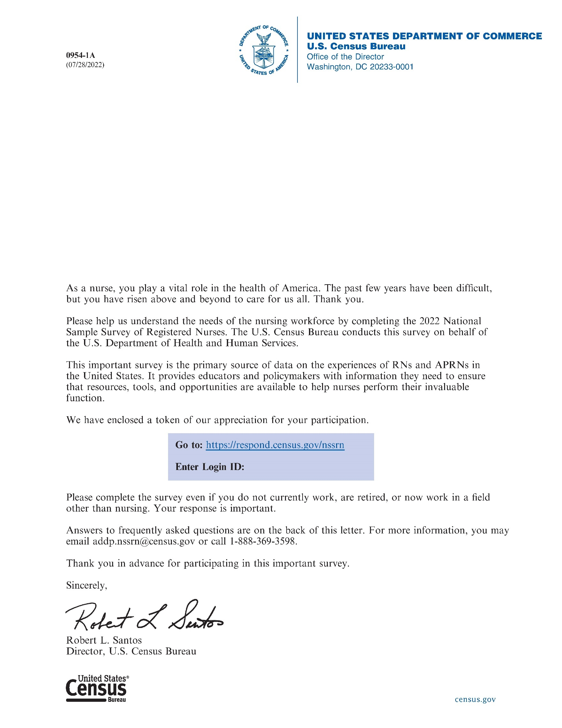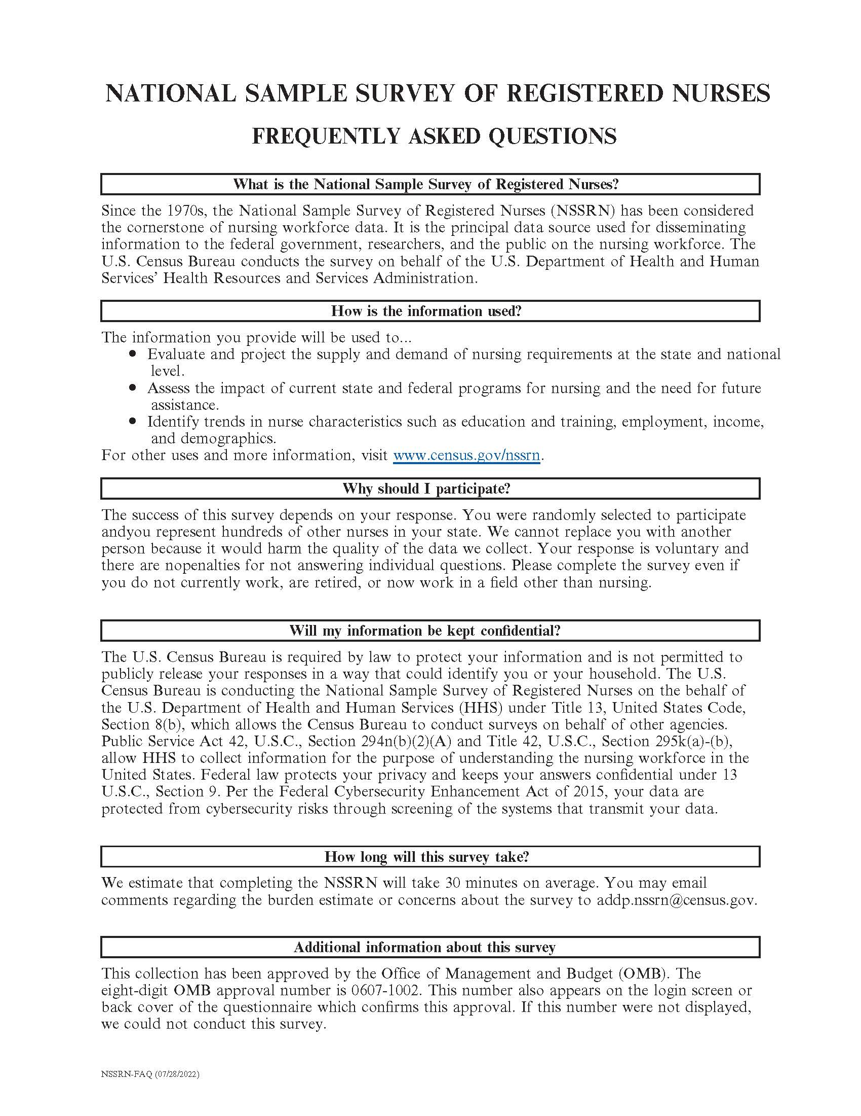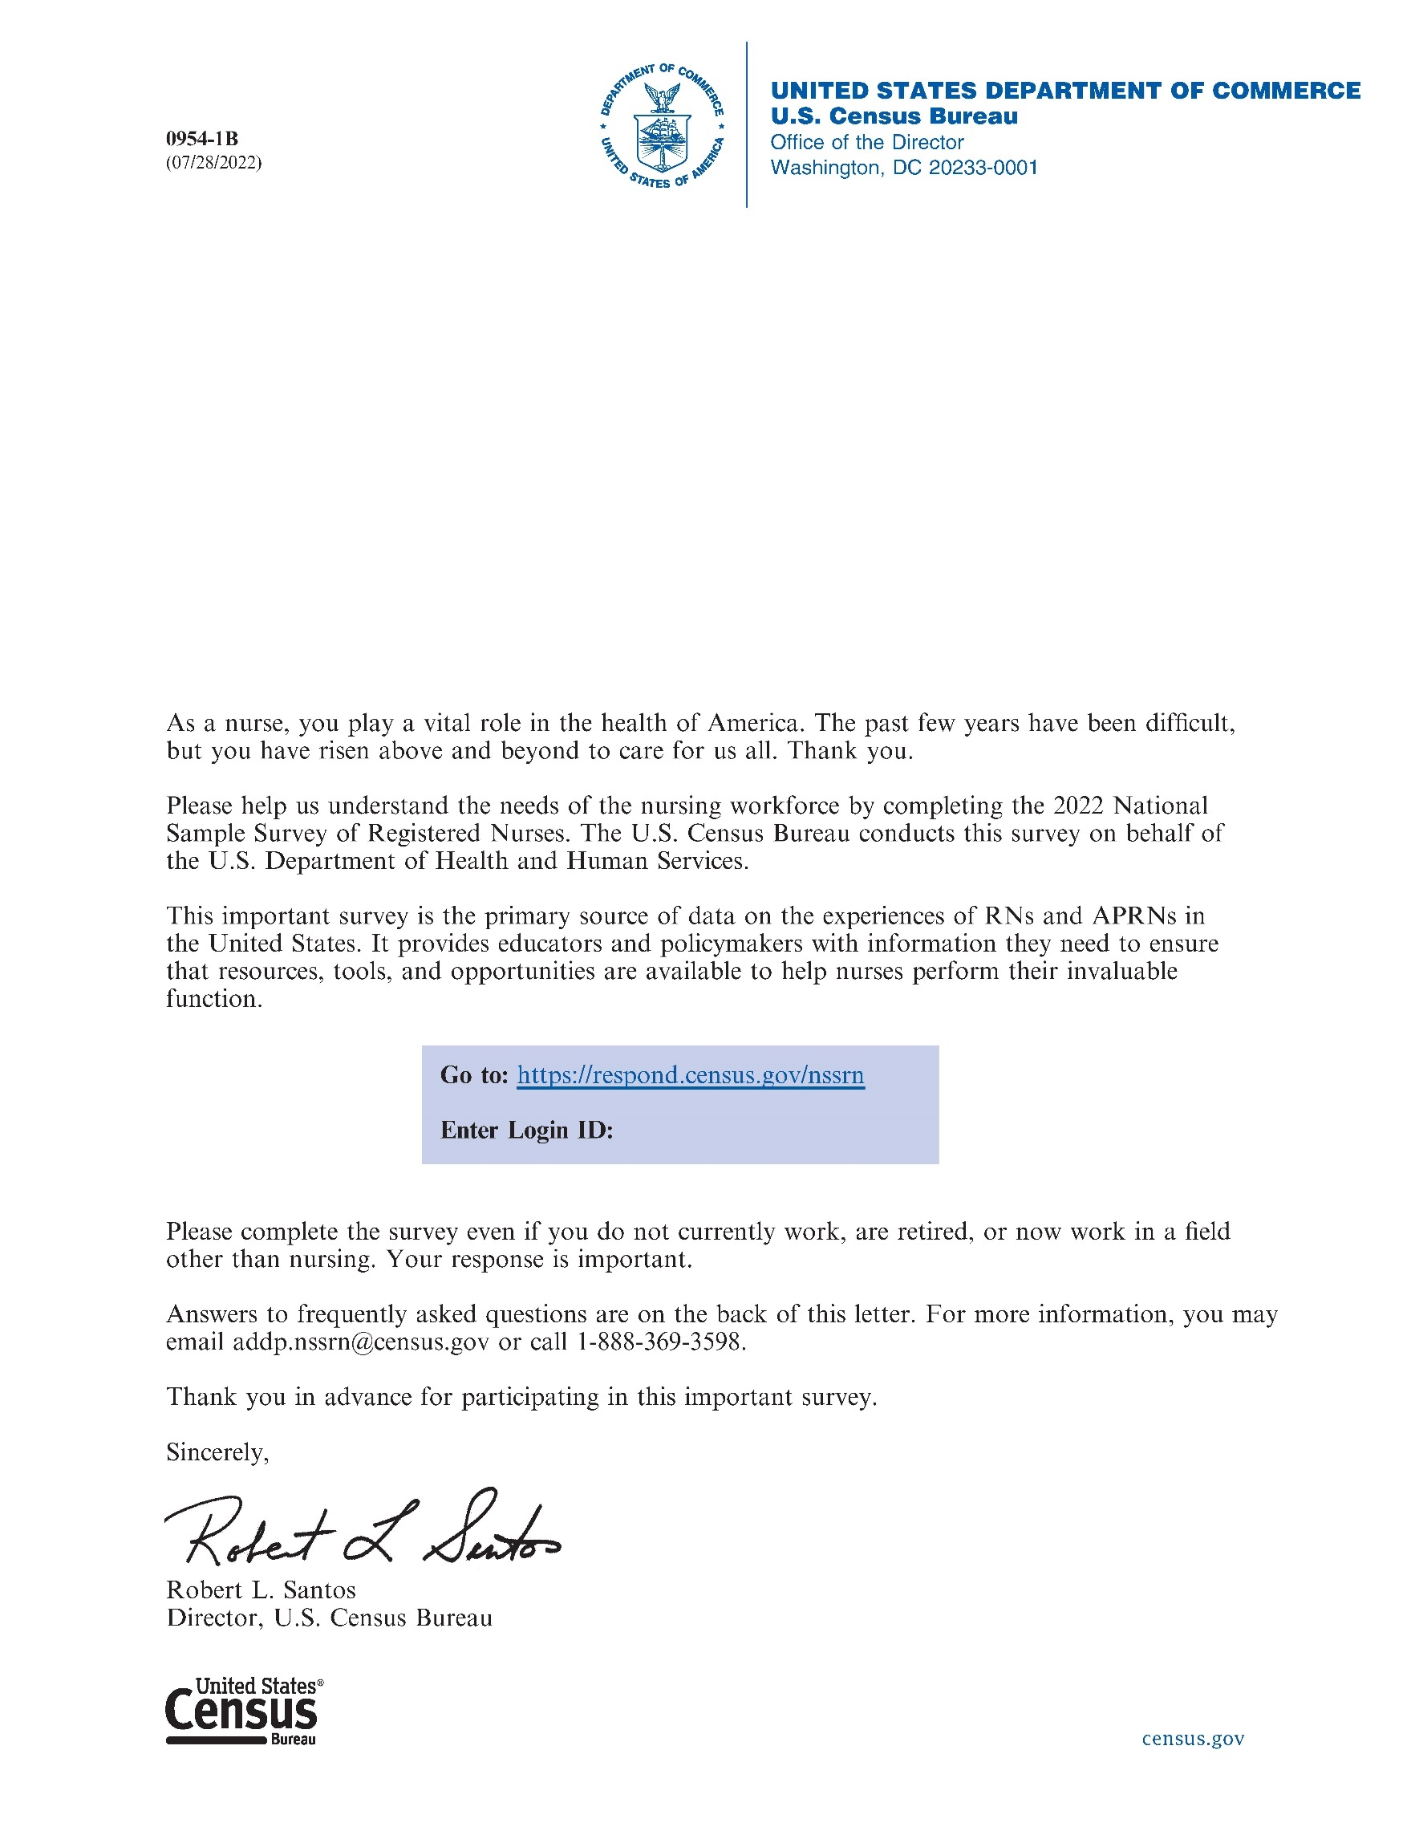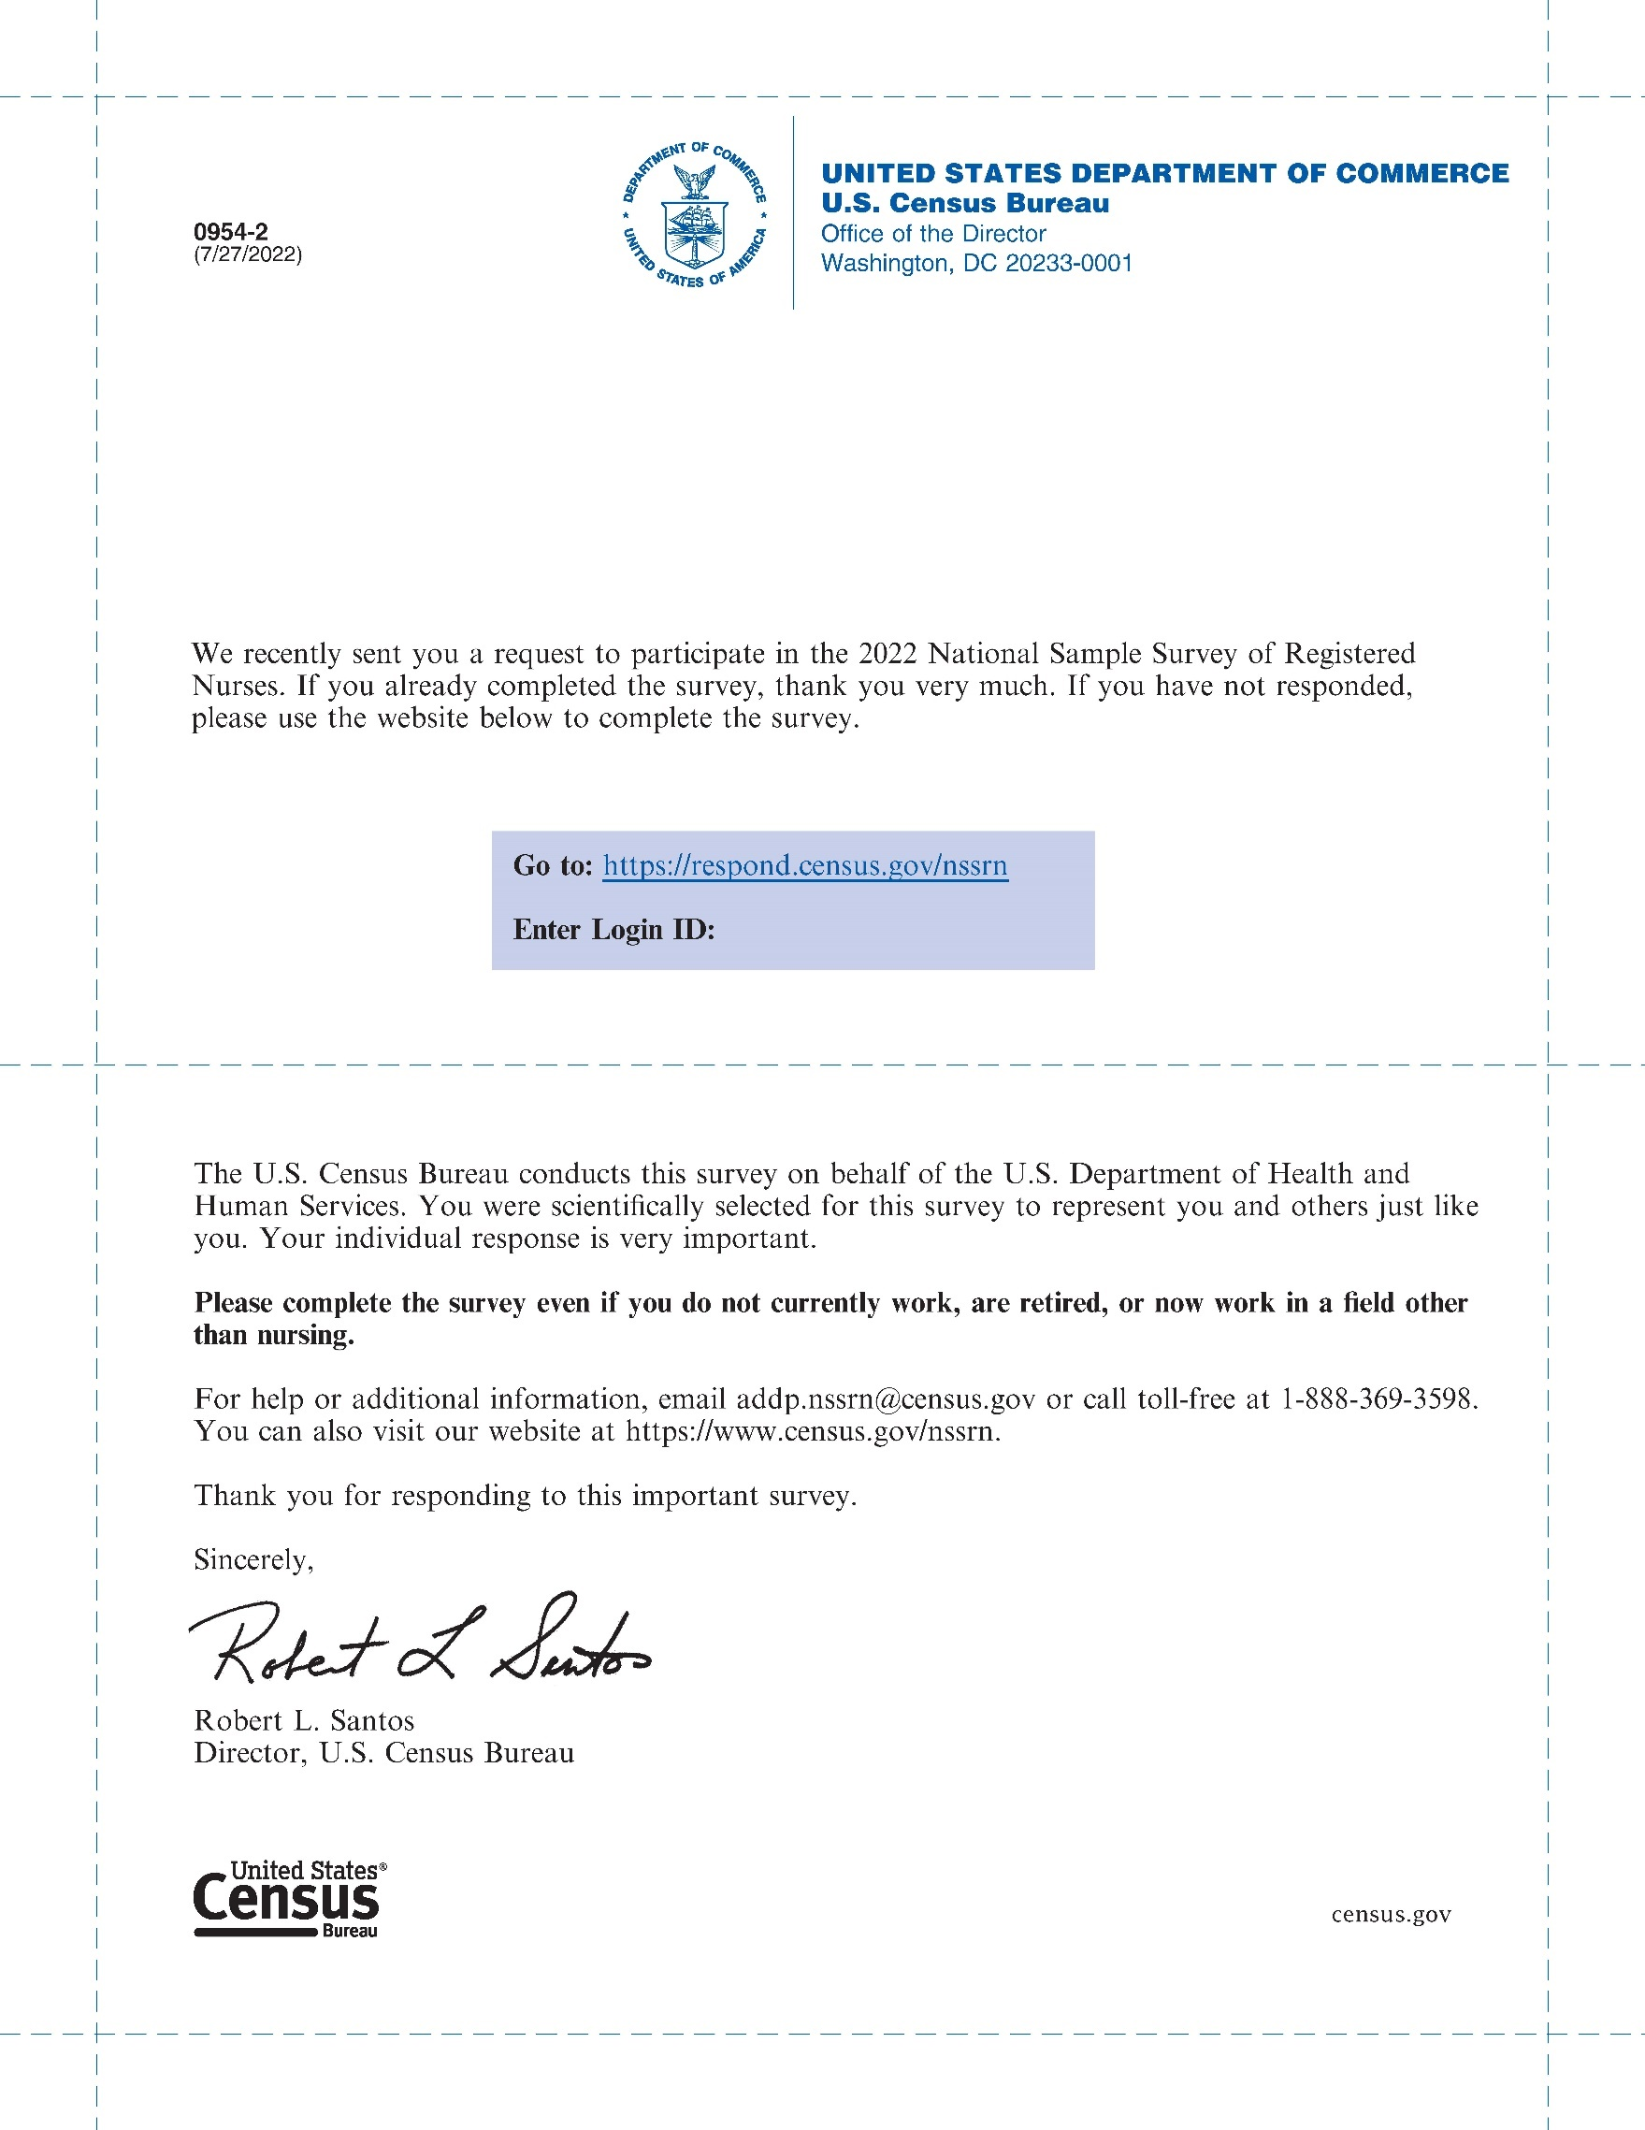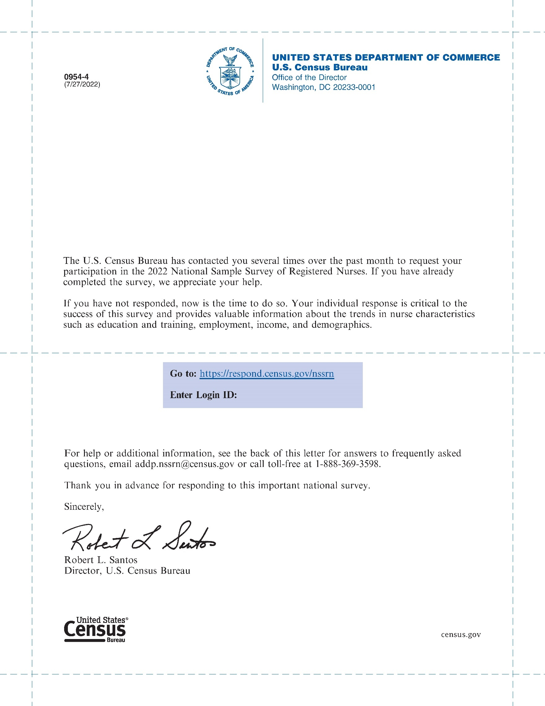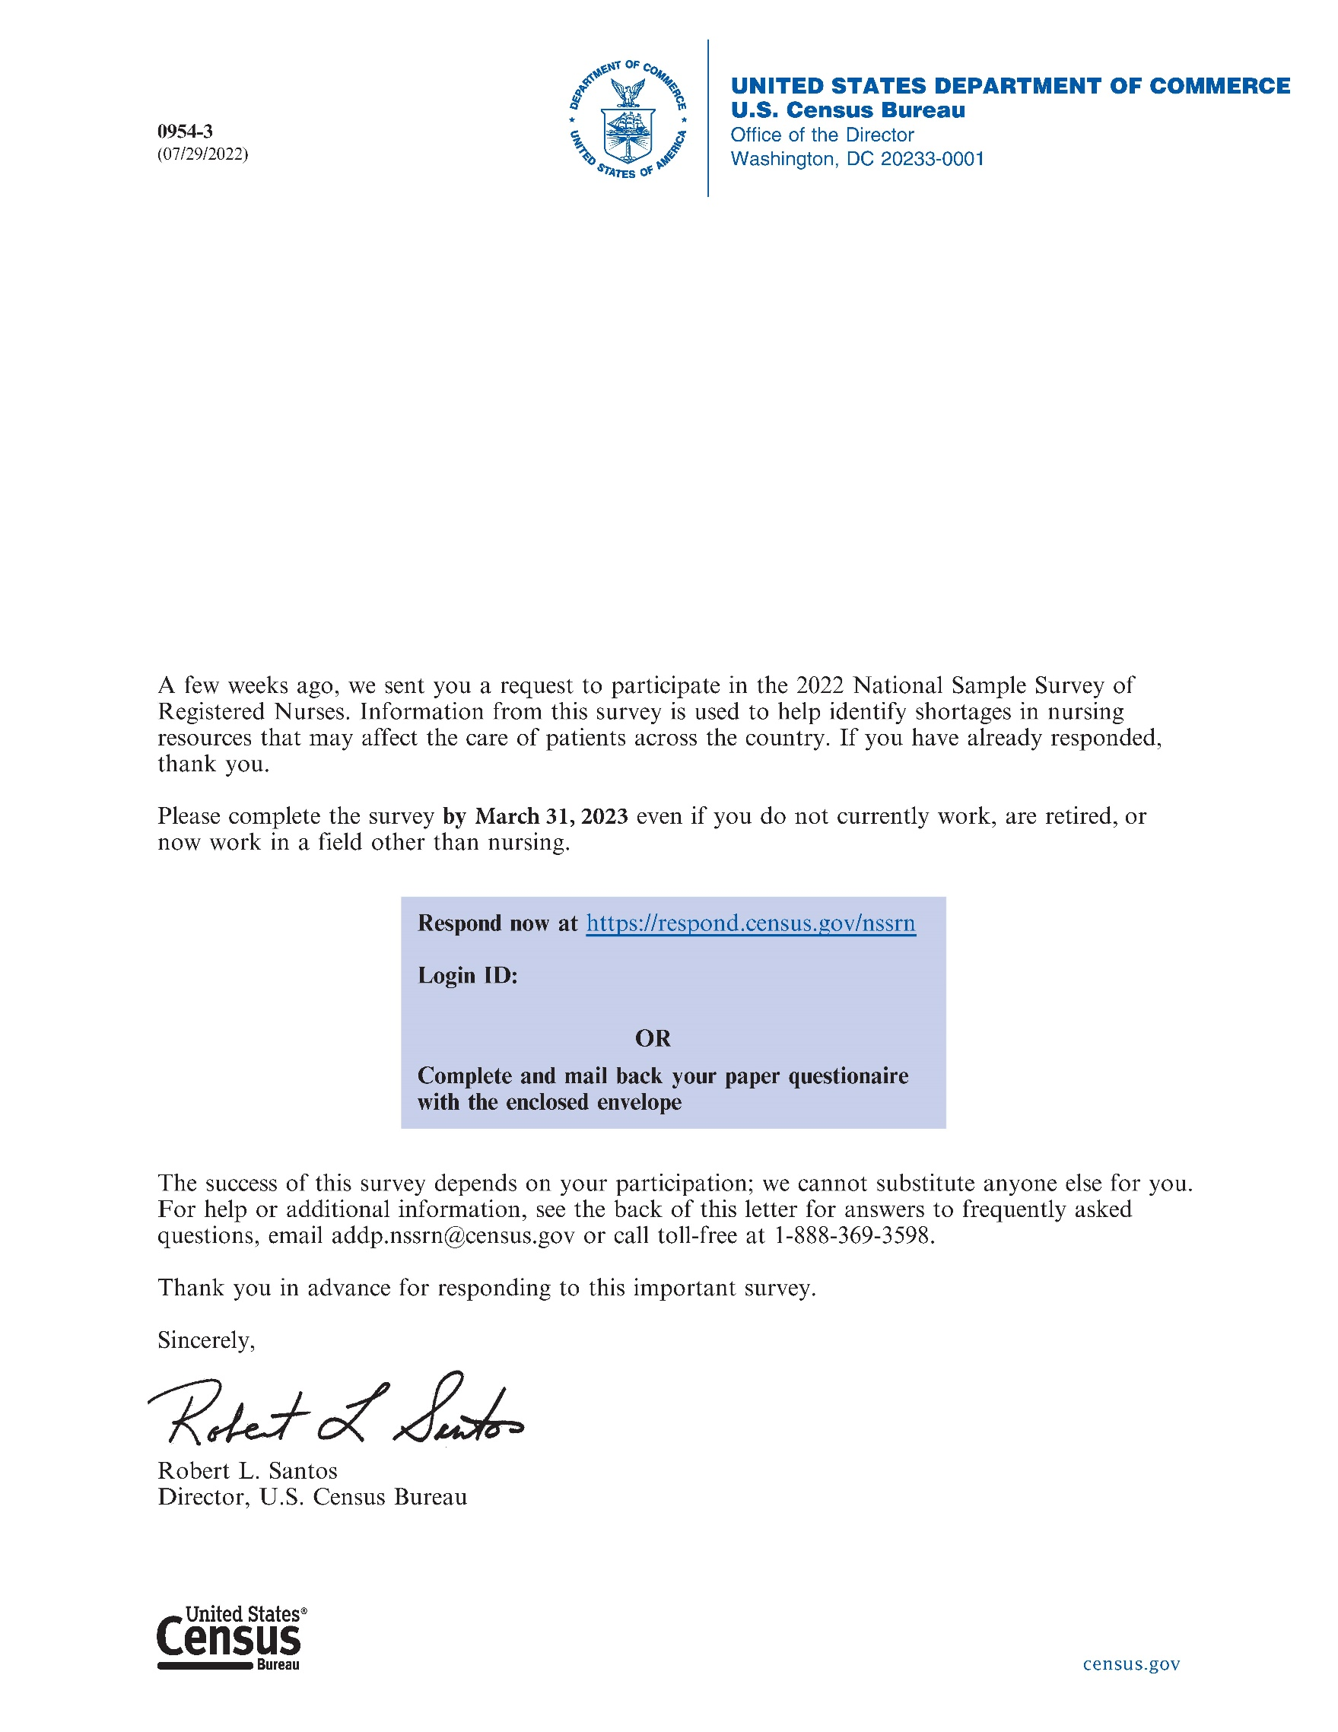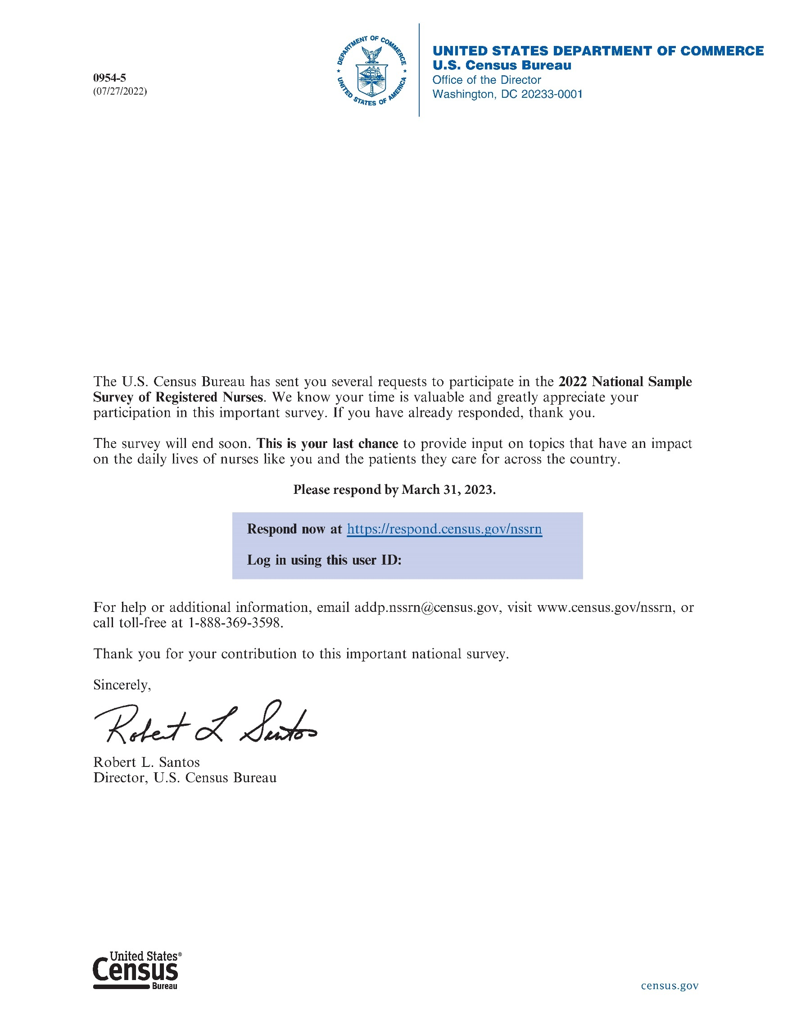

# Appendix B – Questionnaire

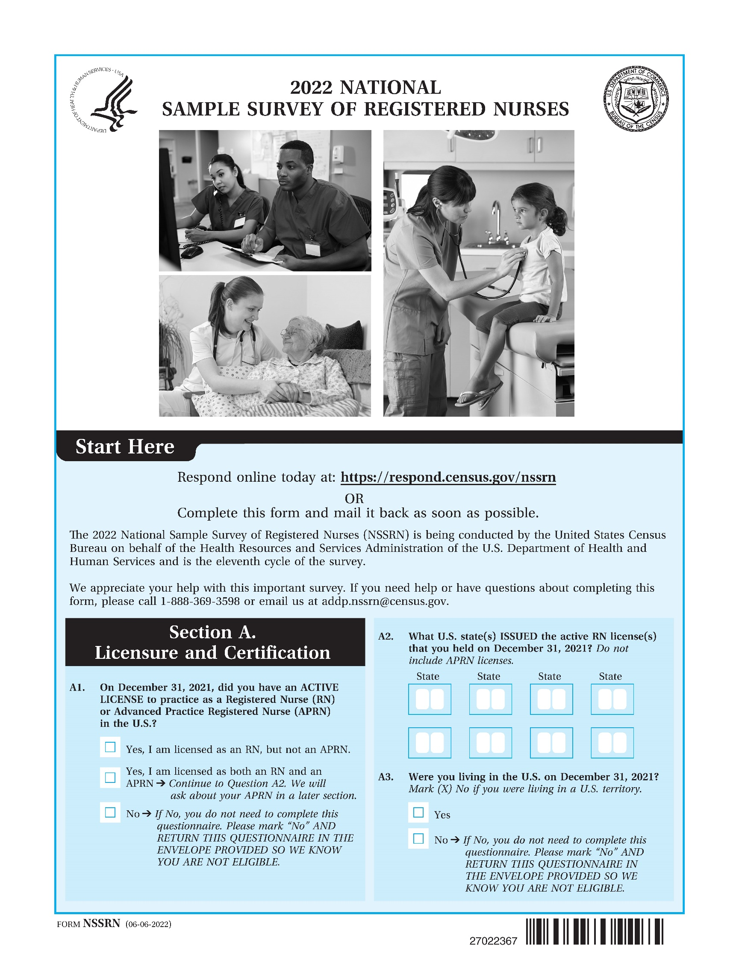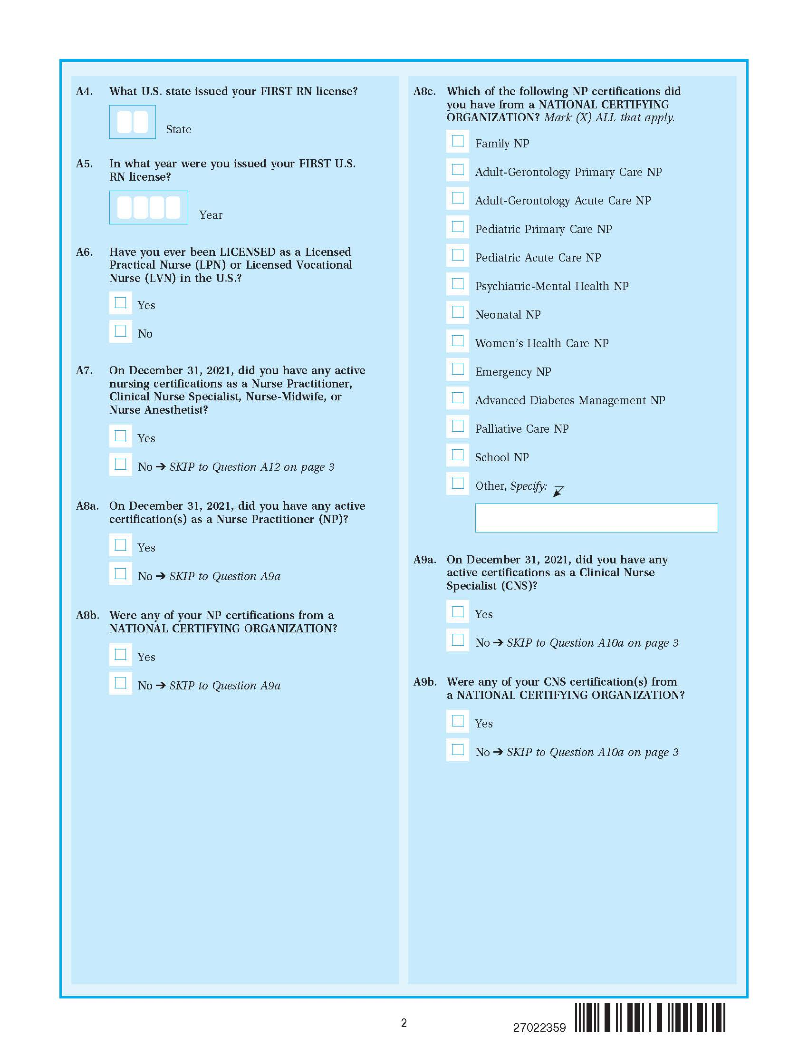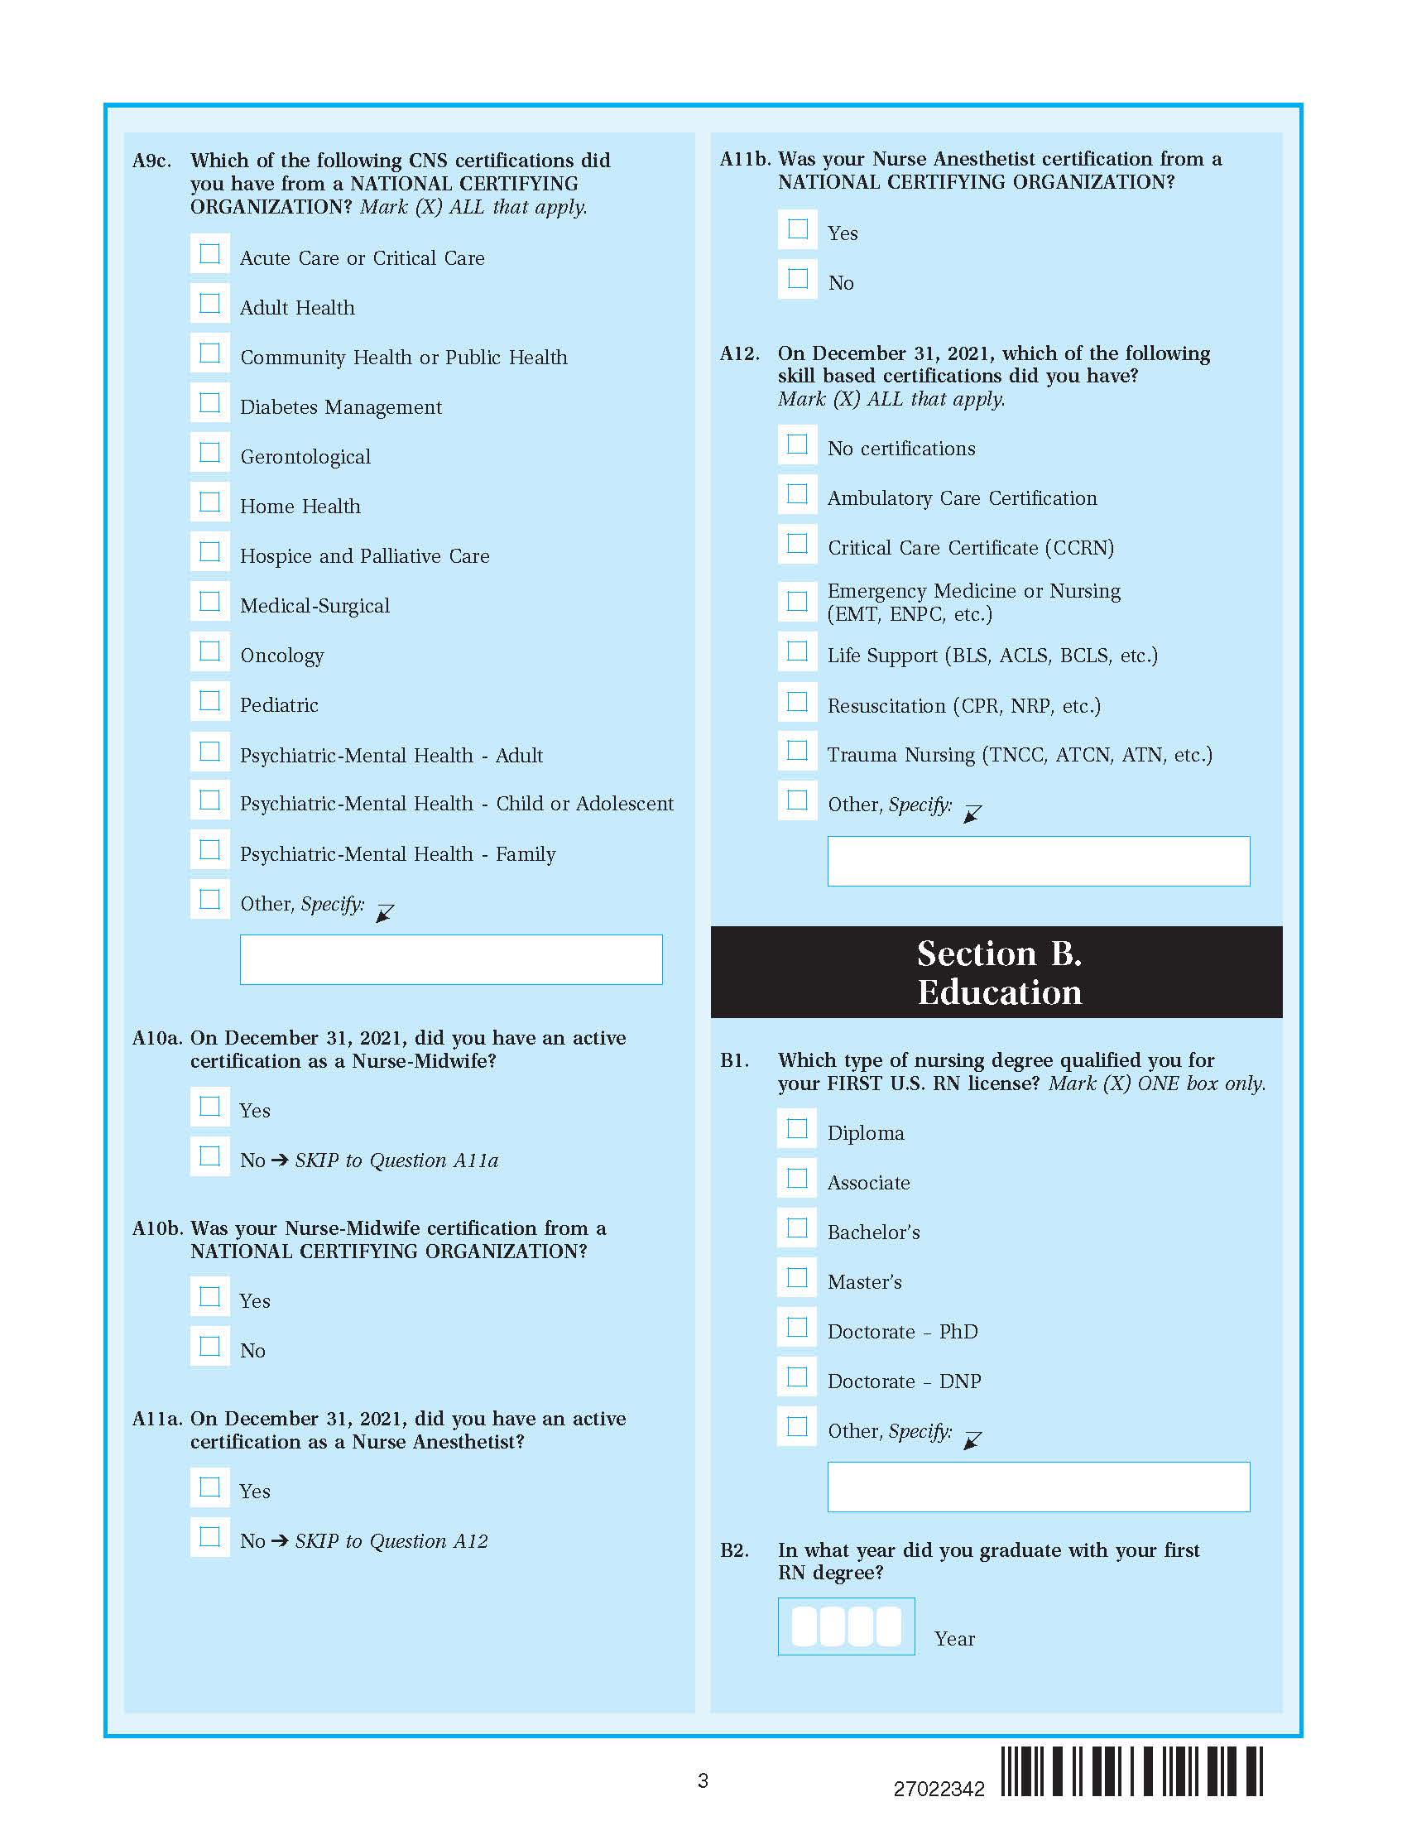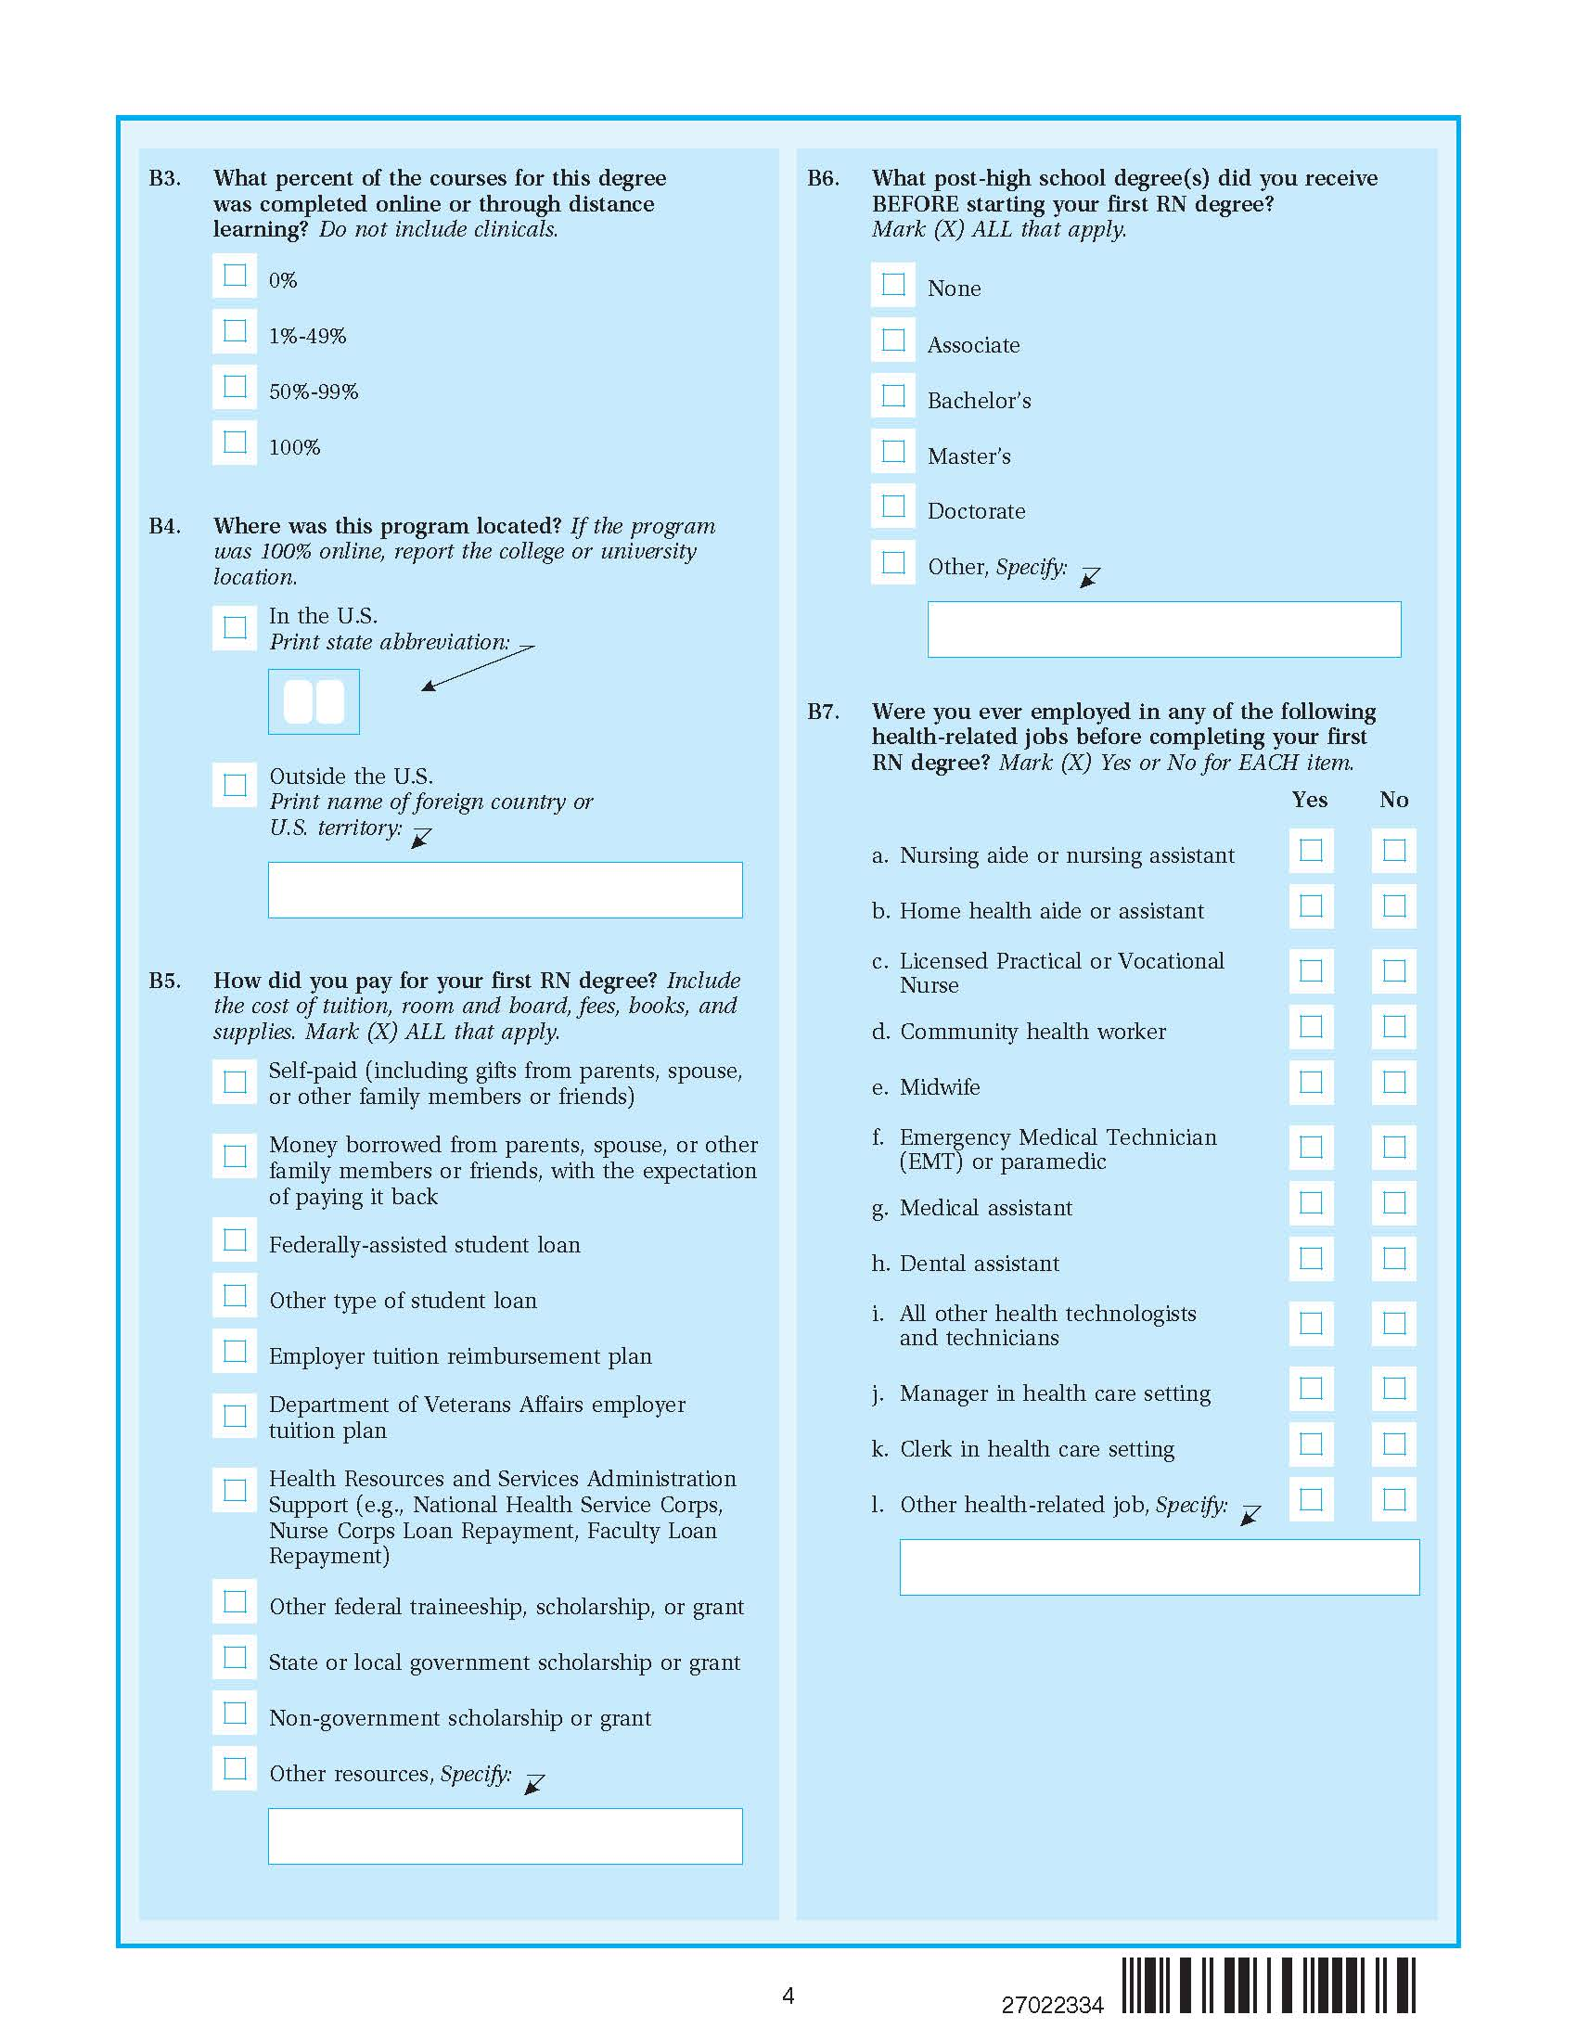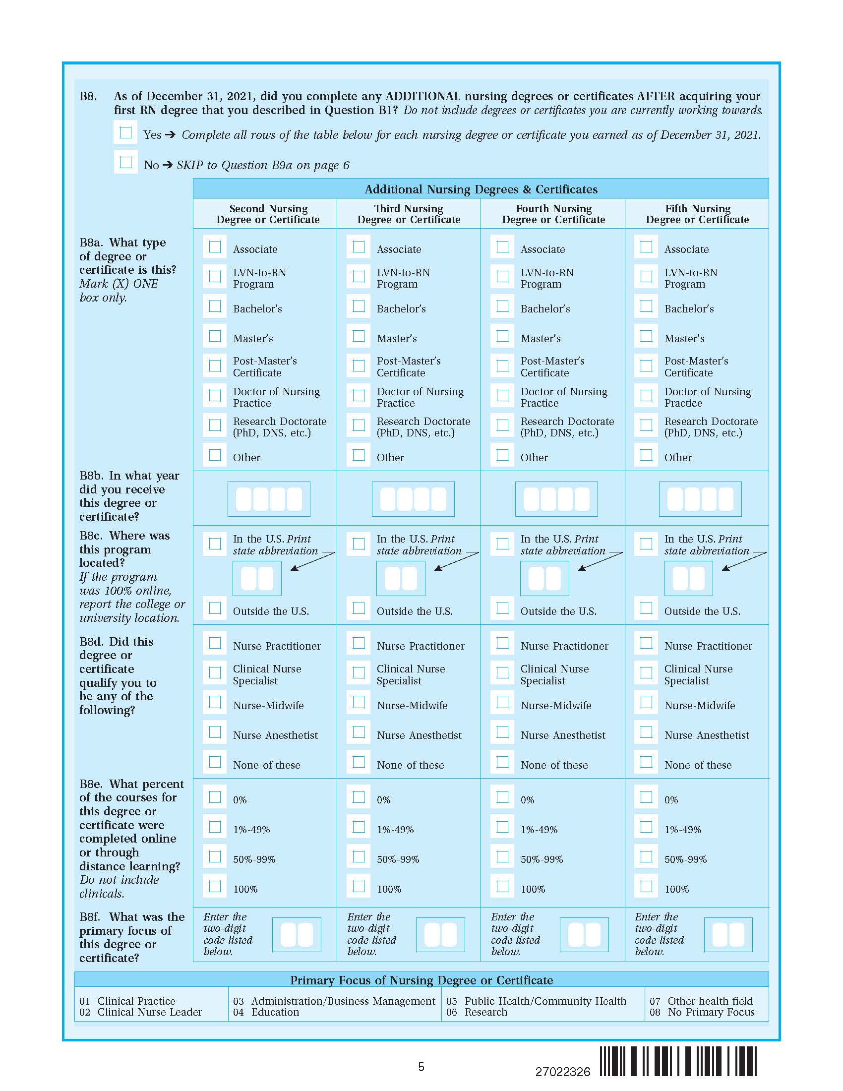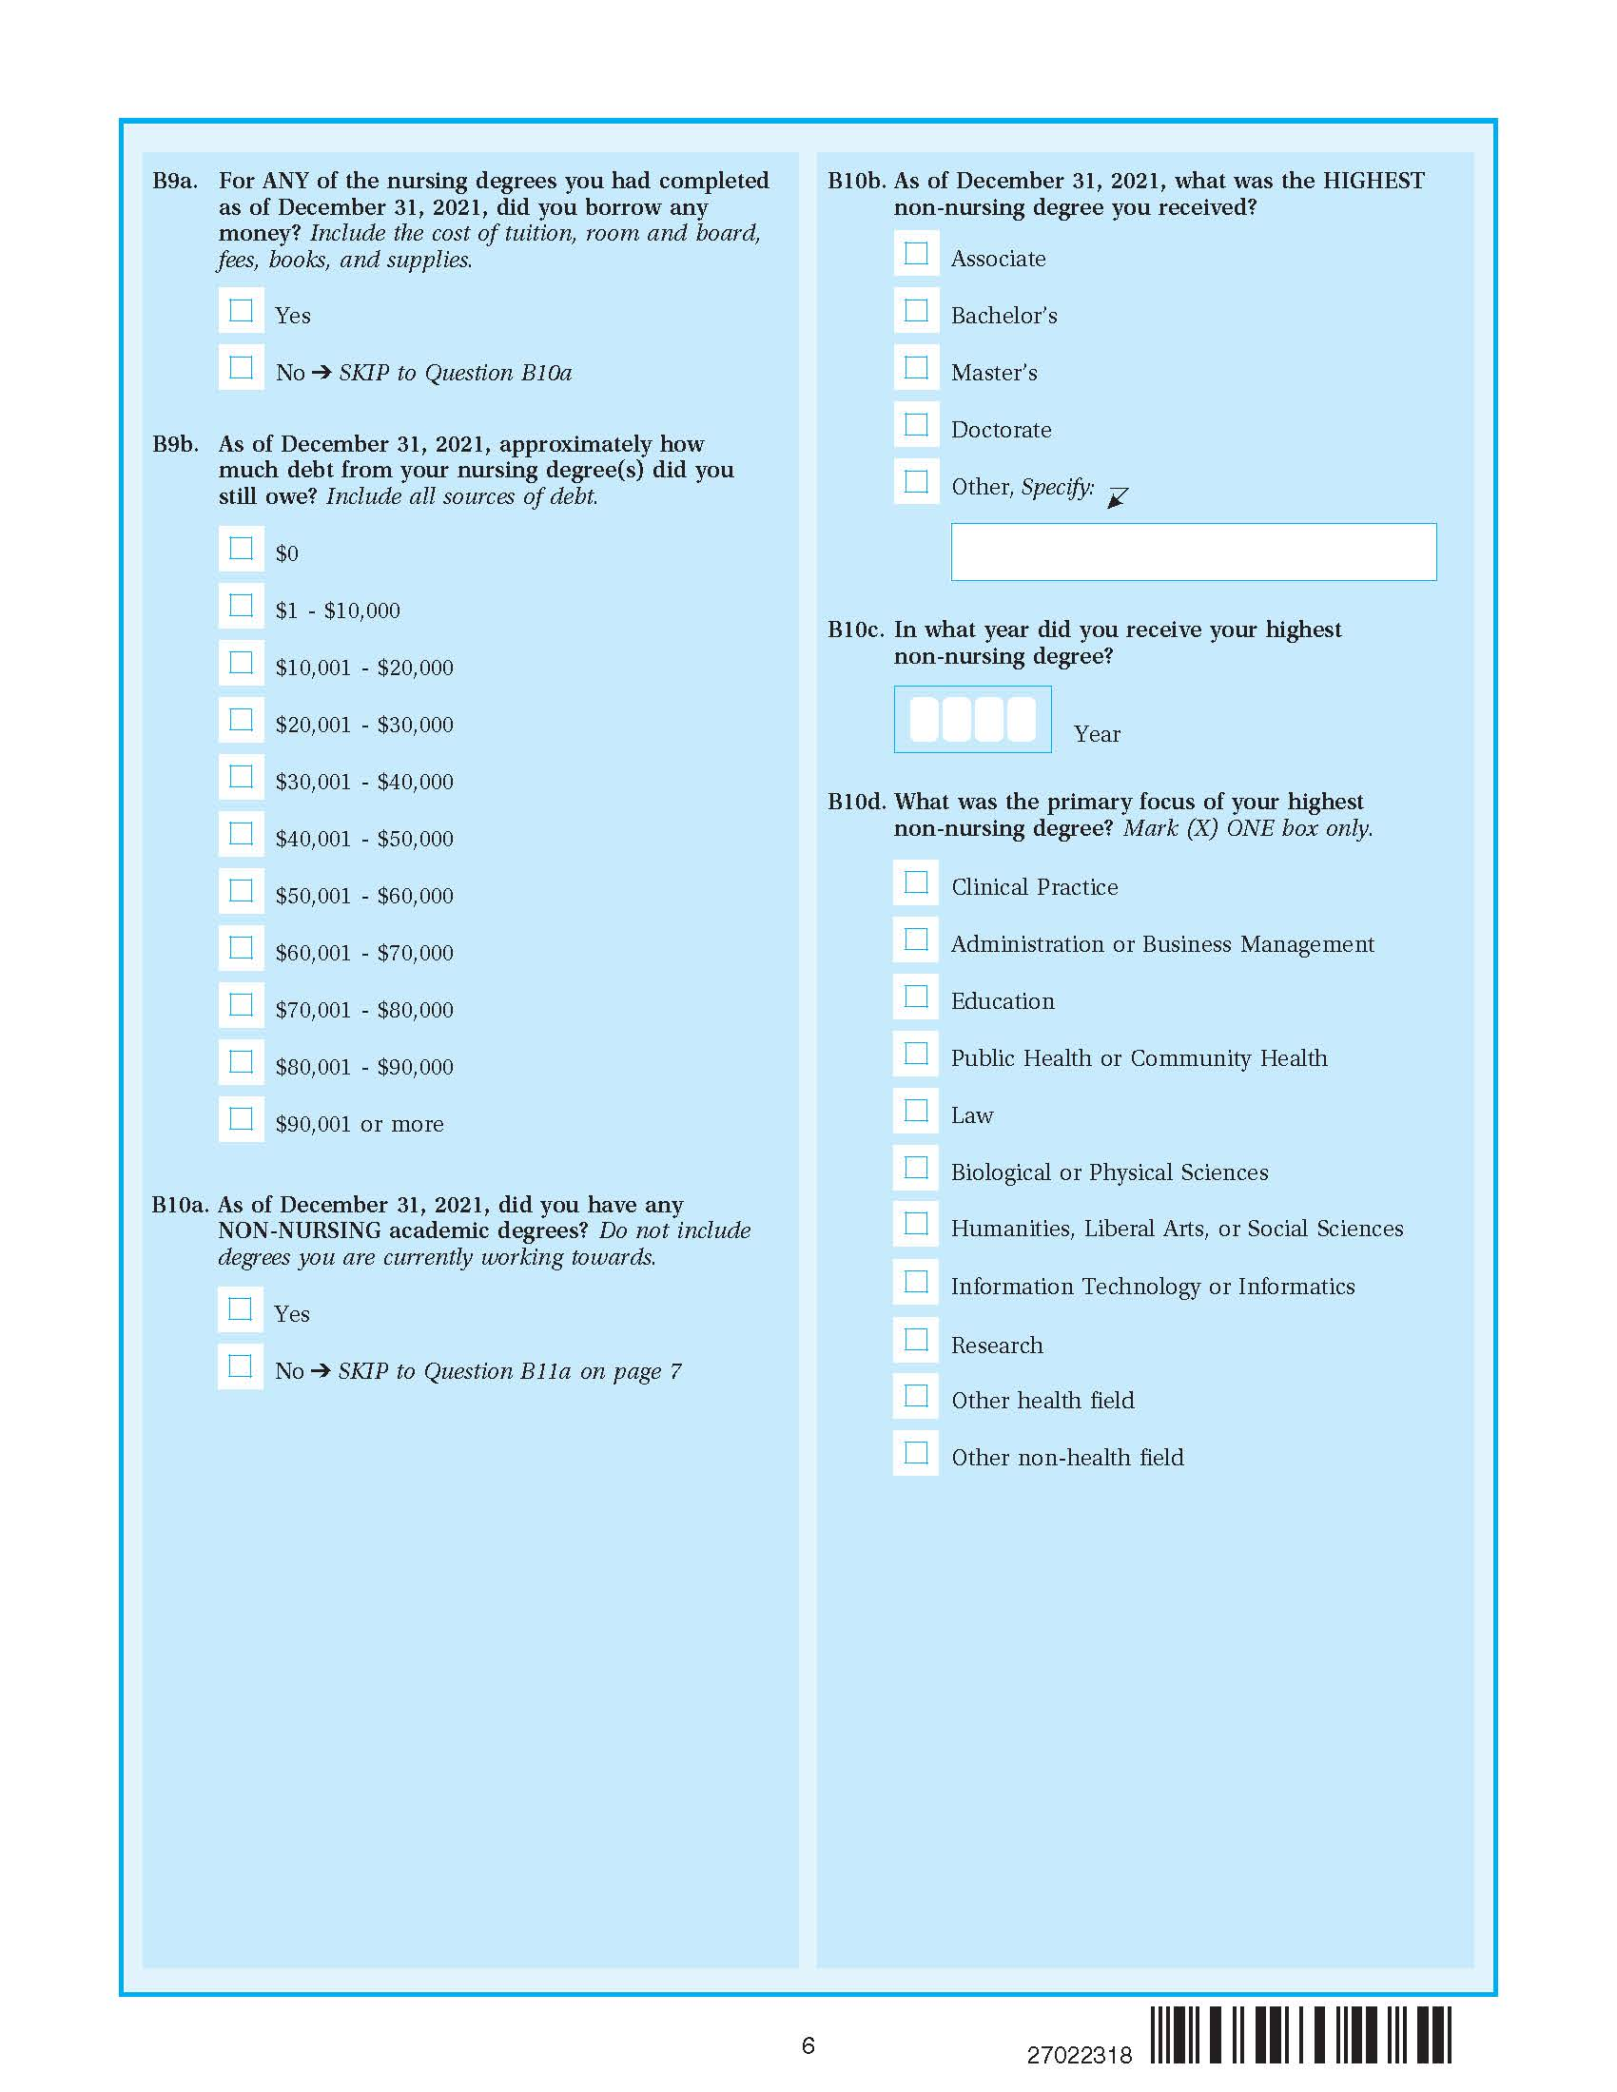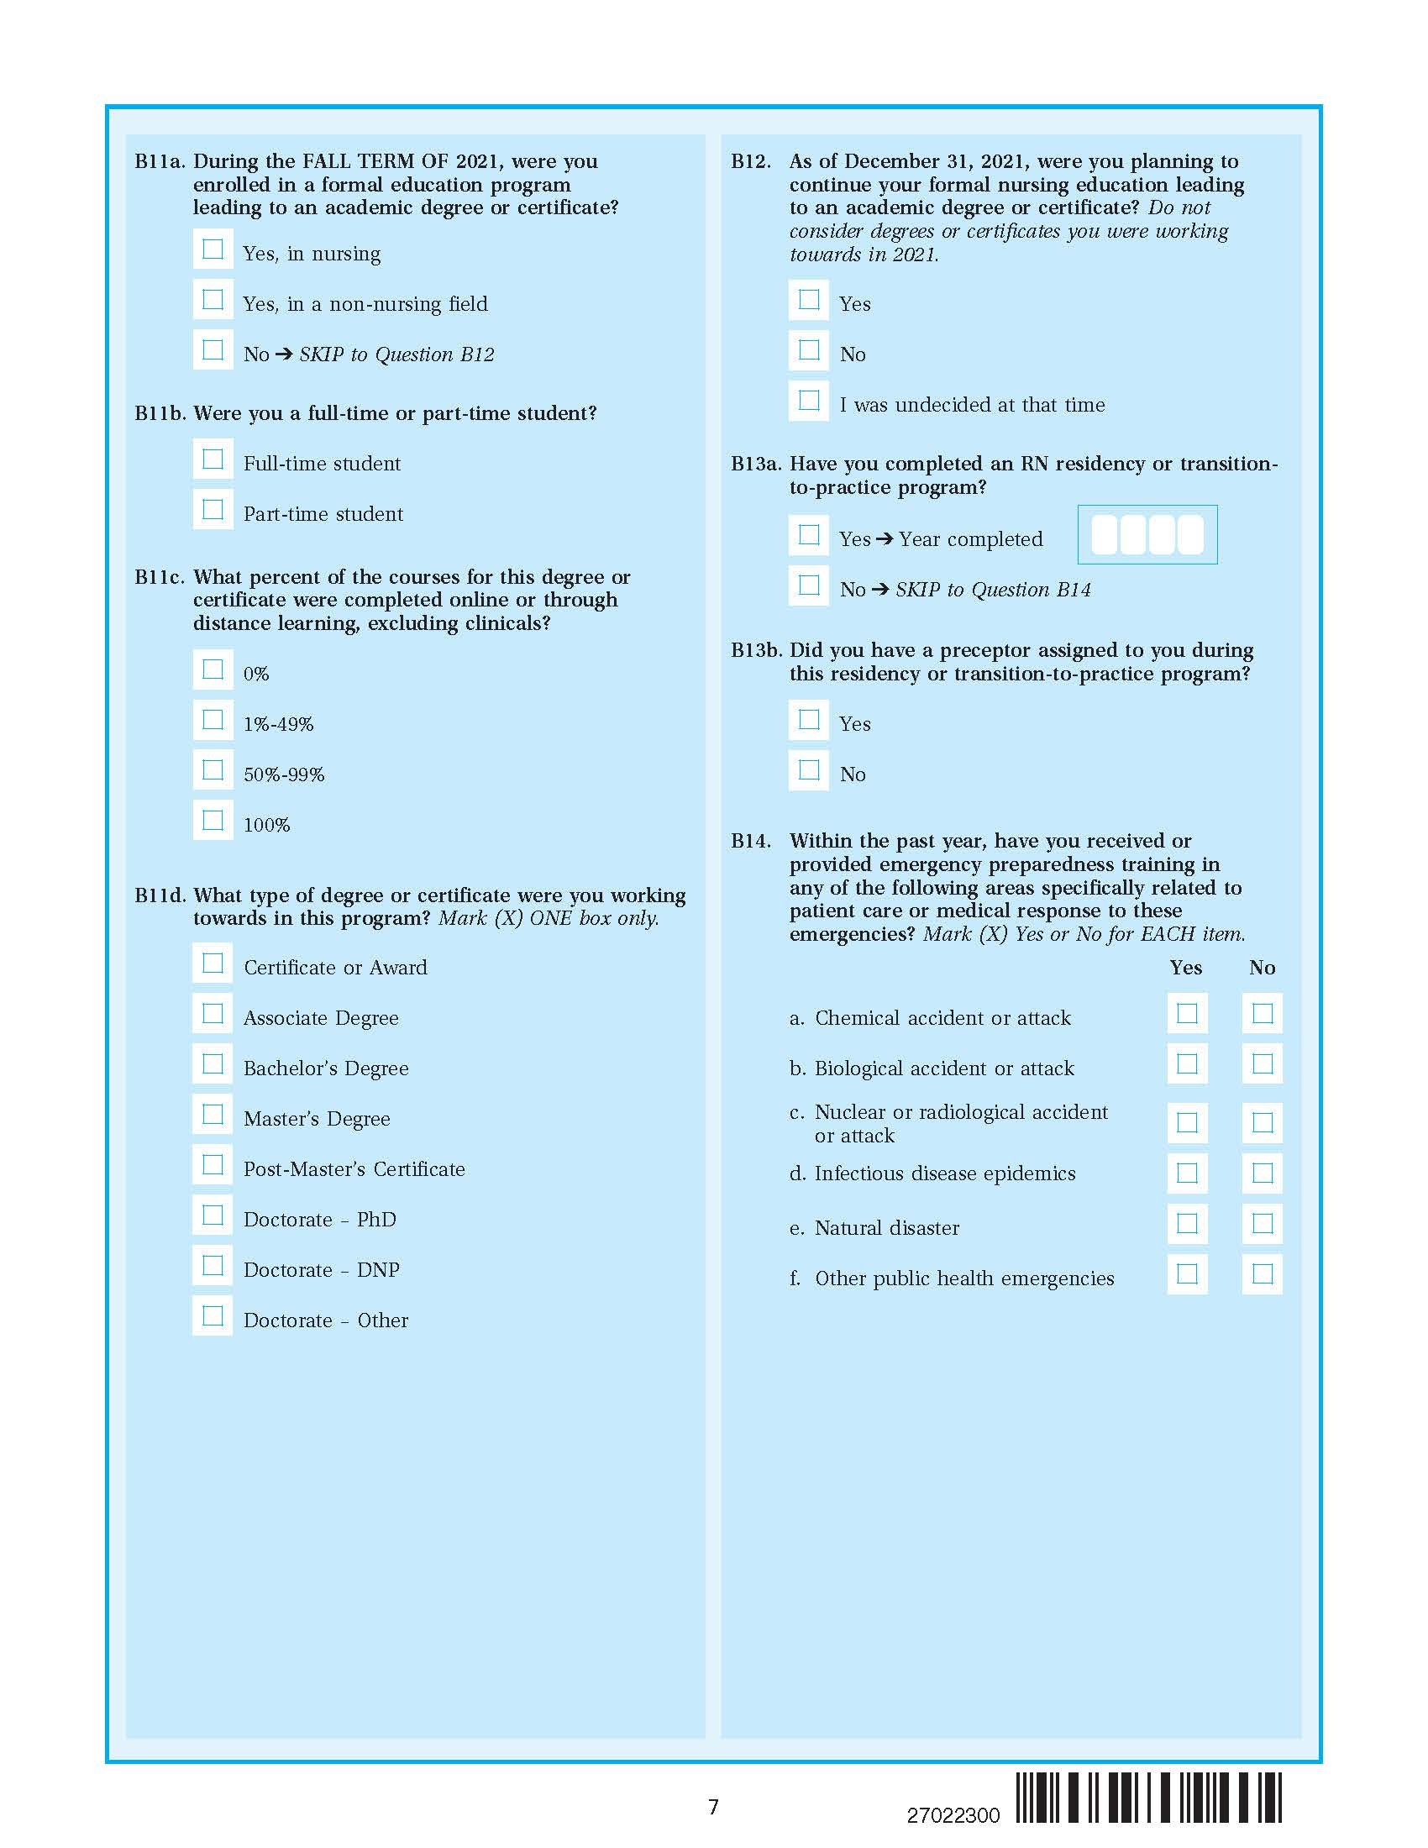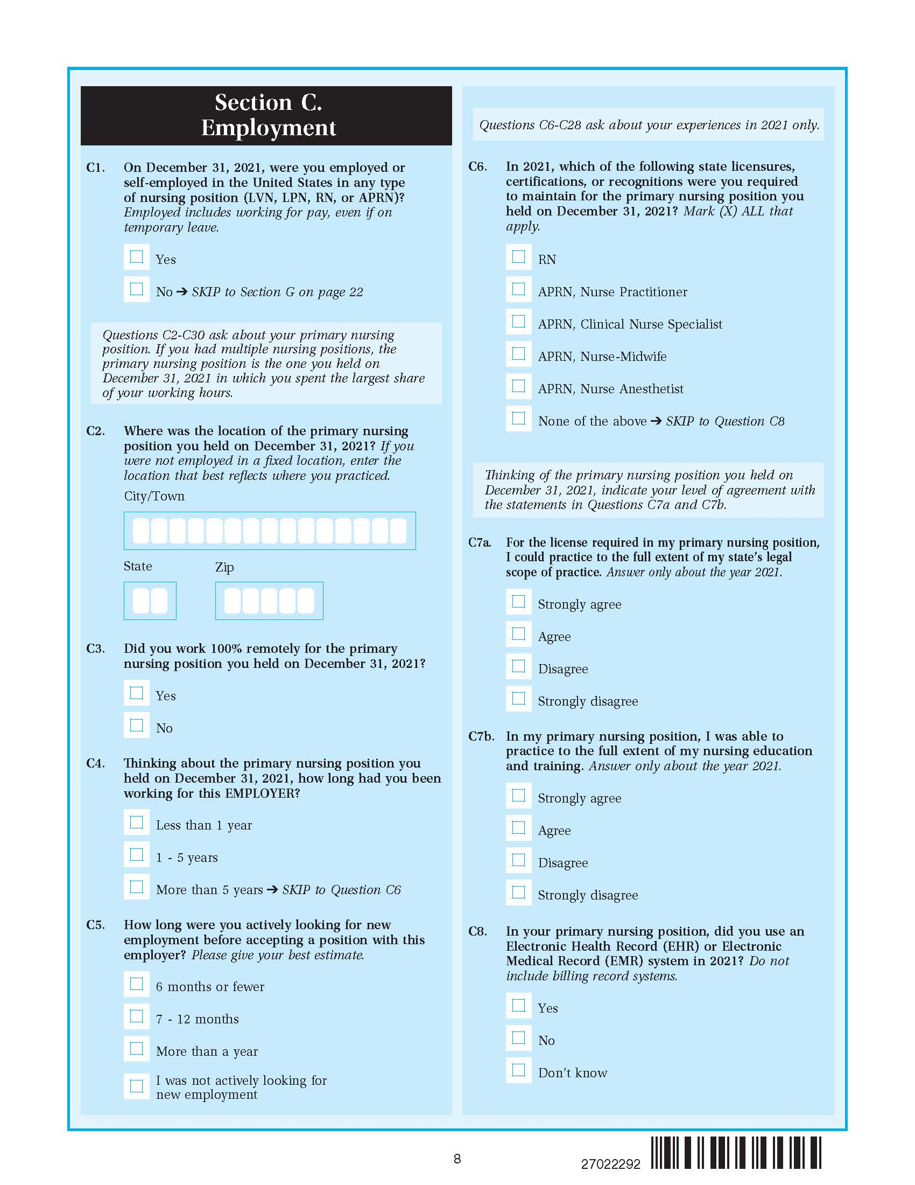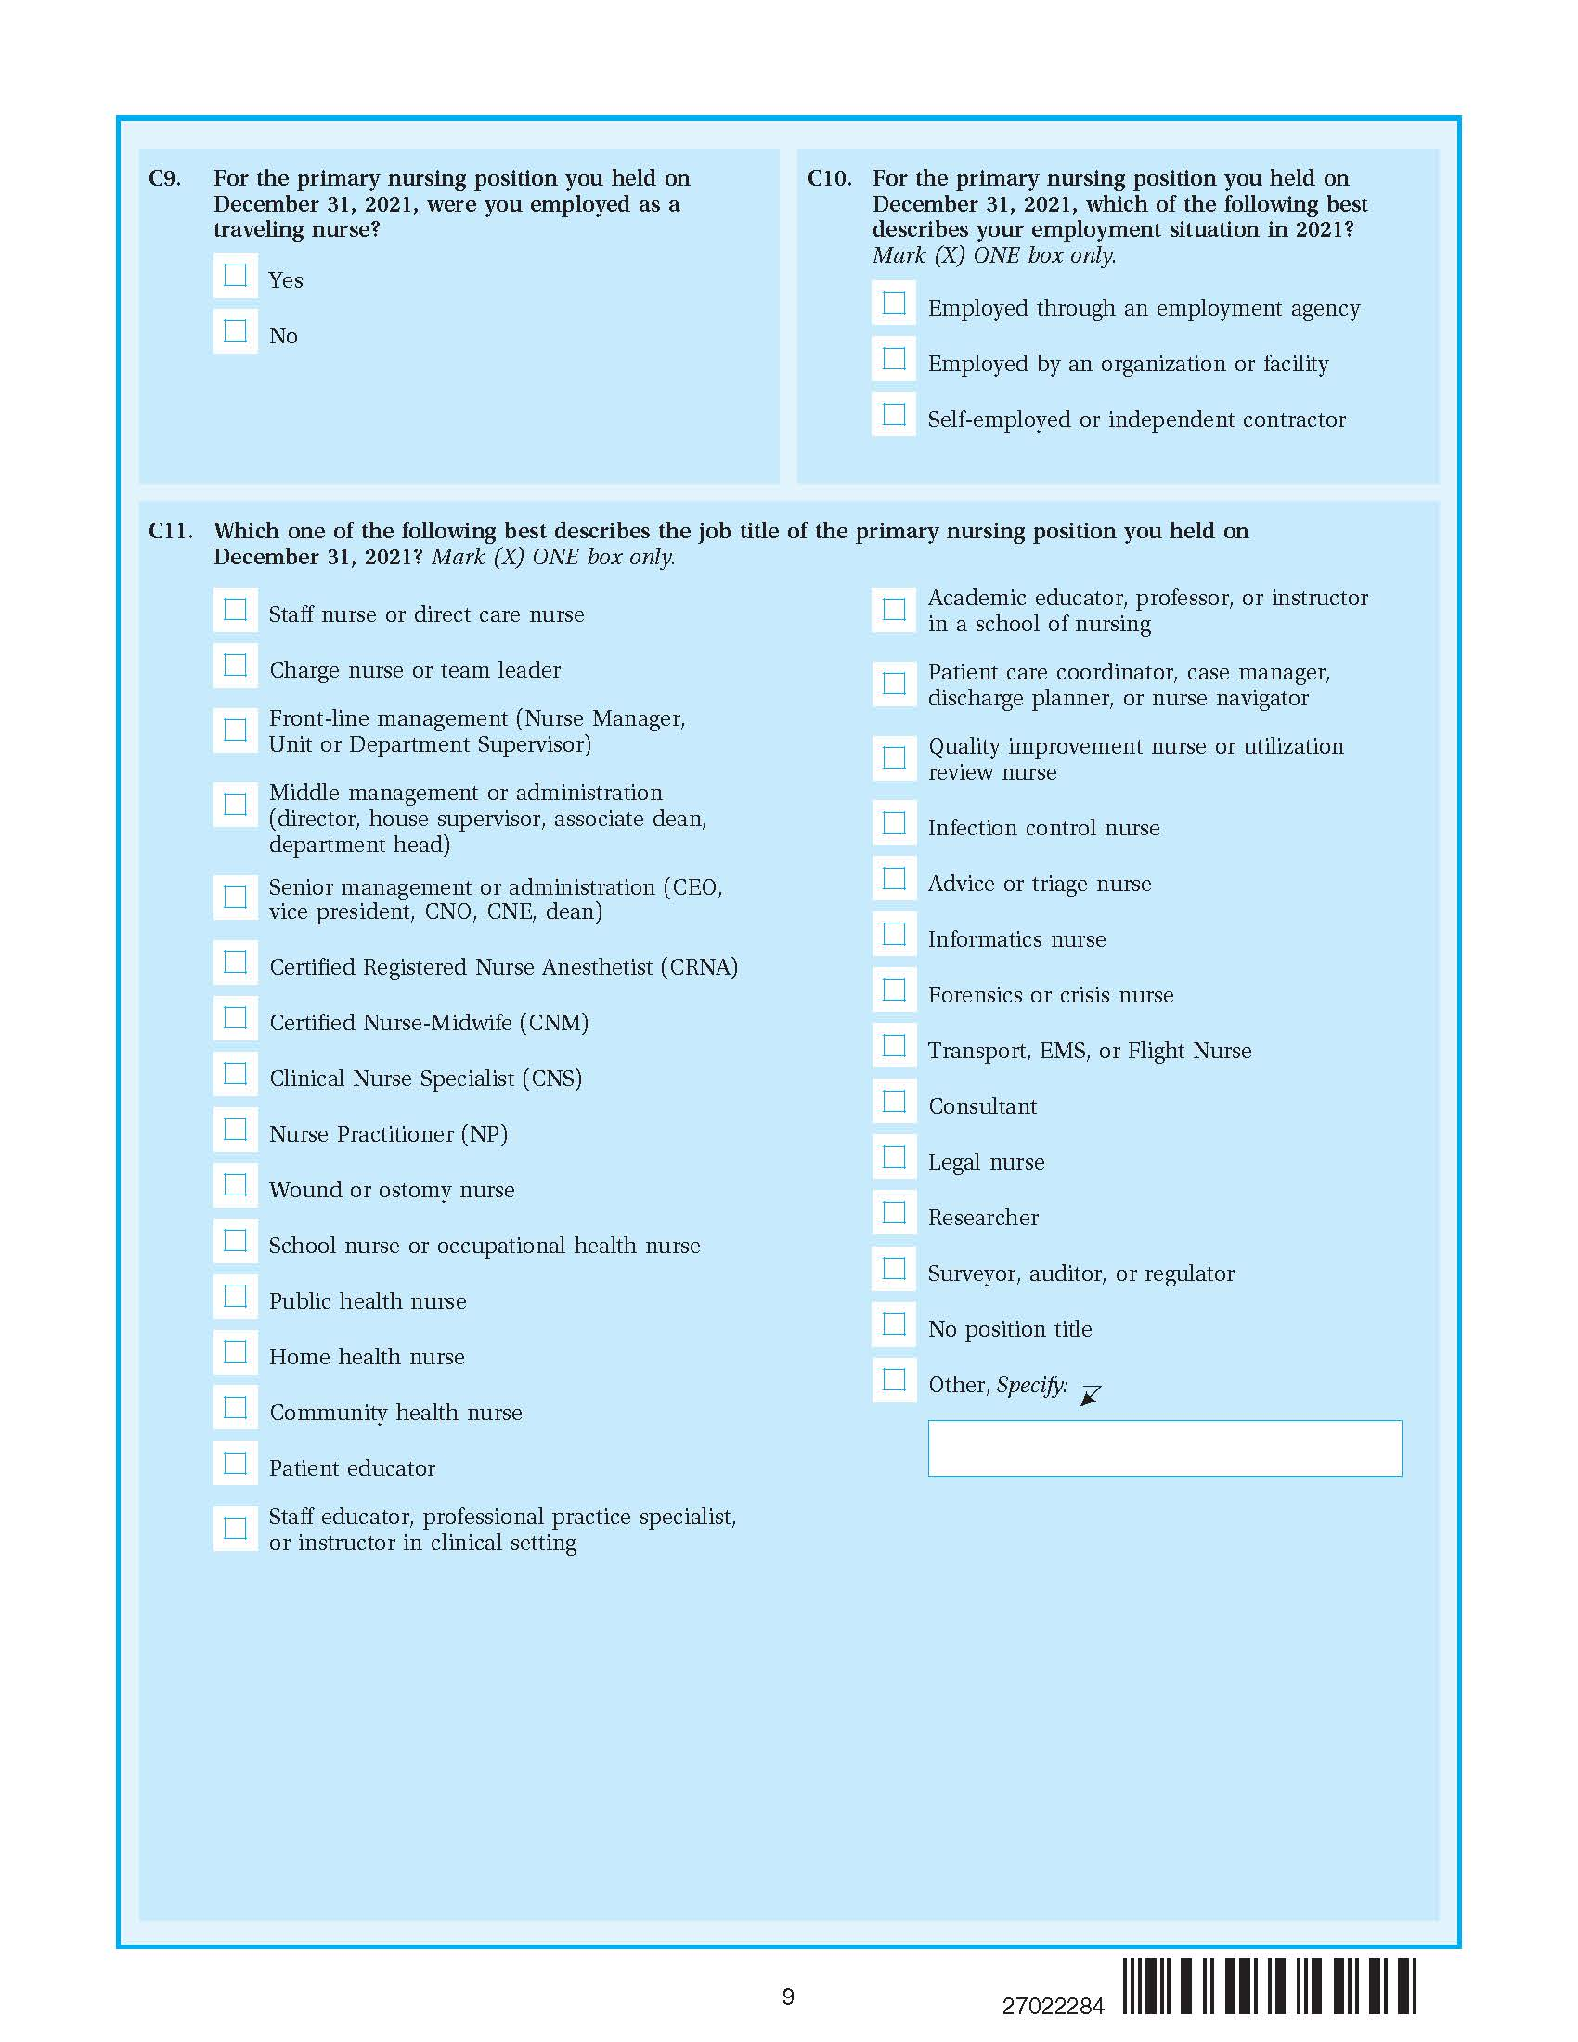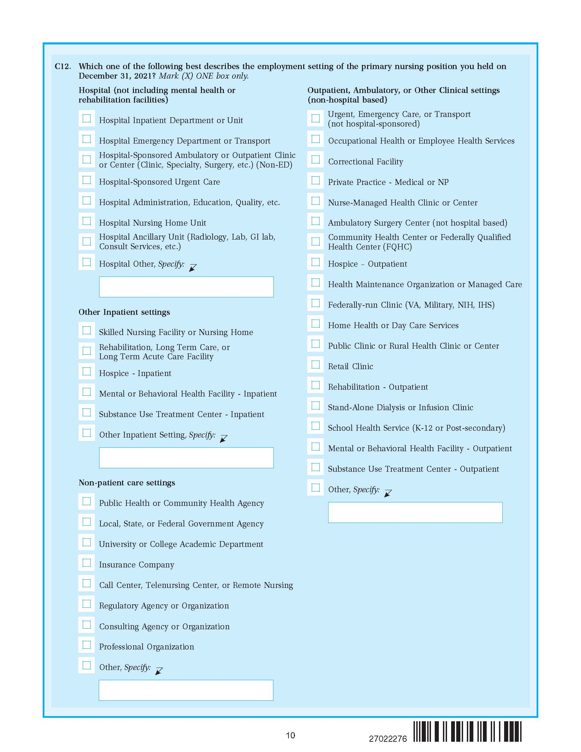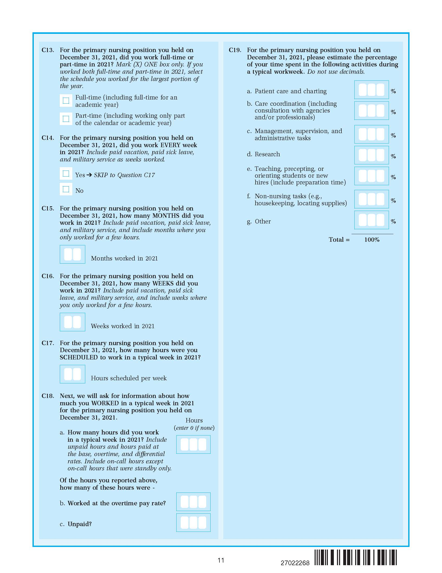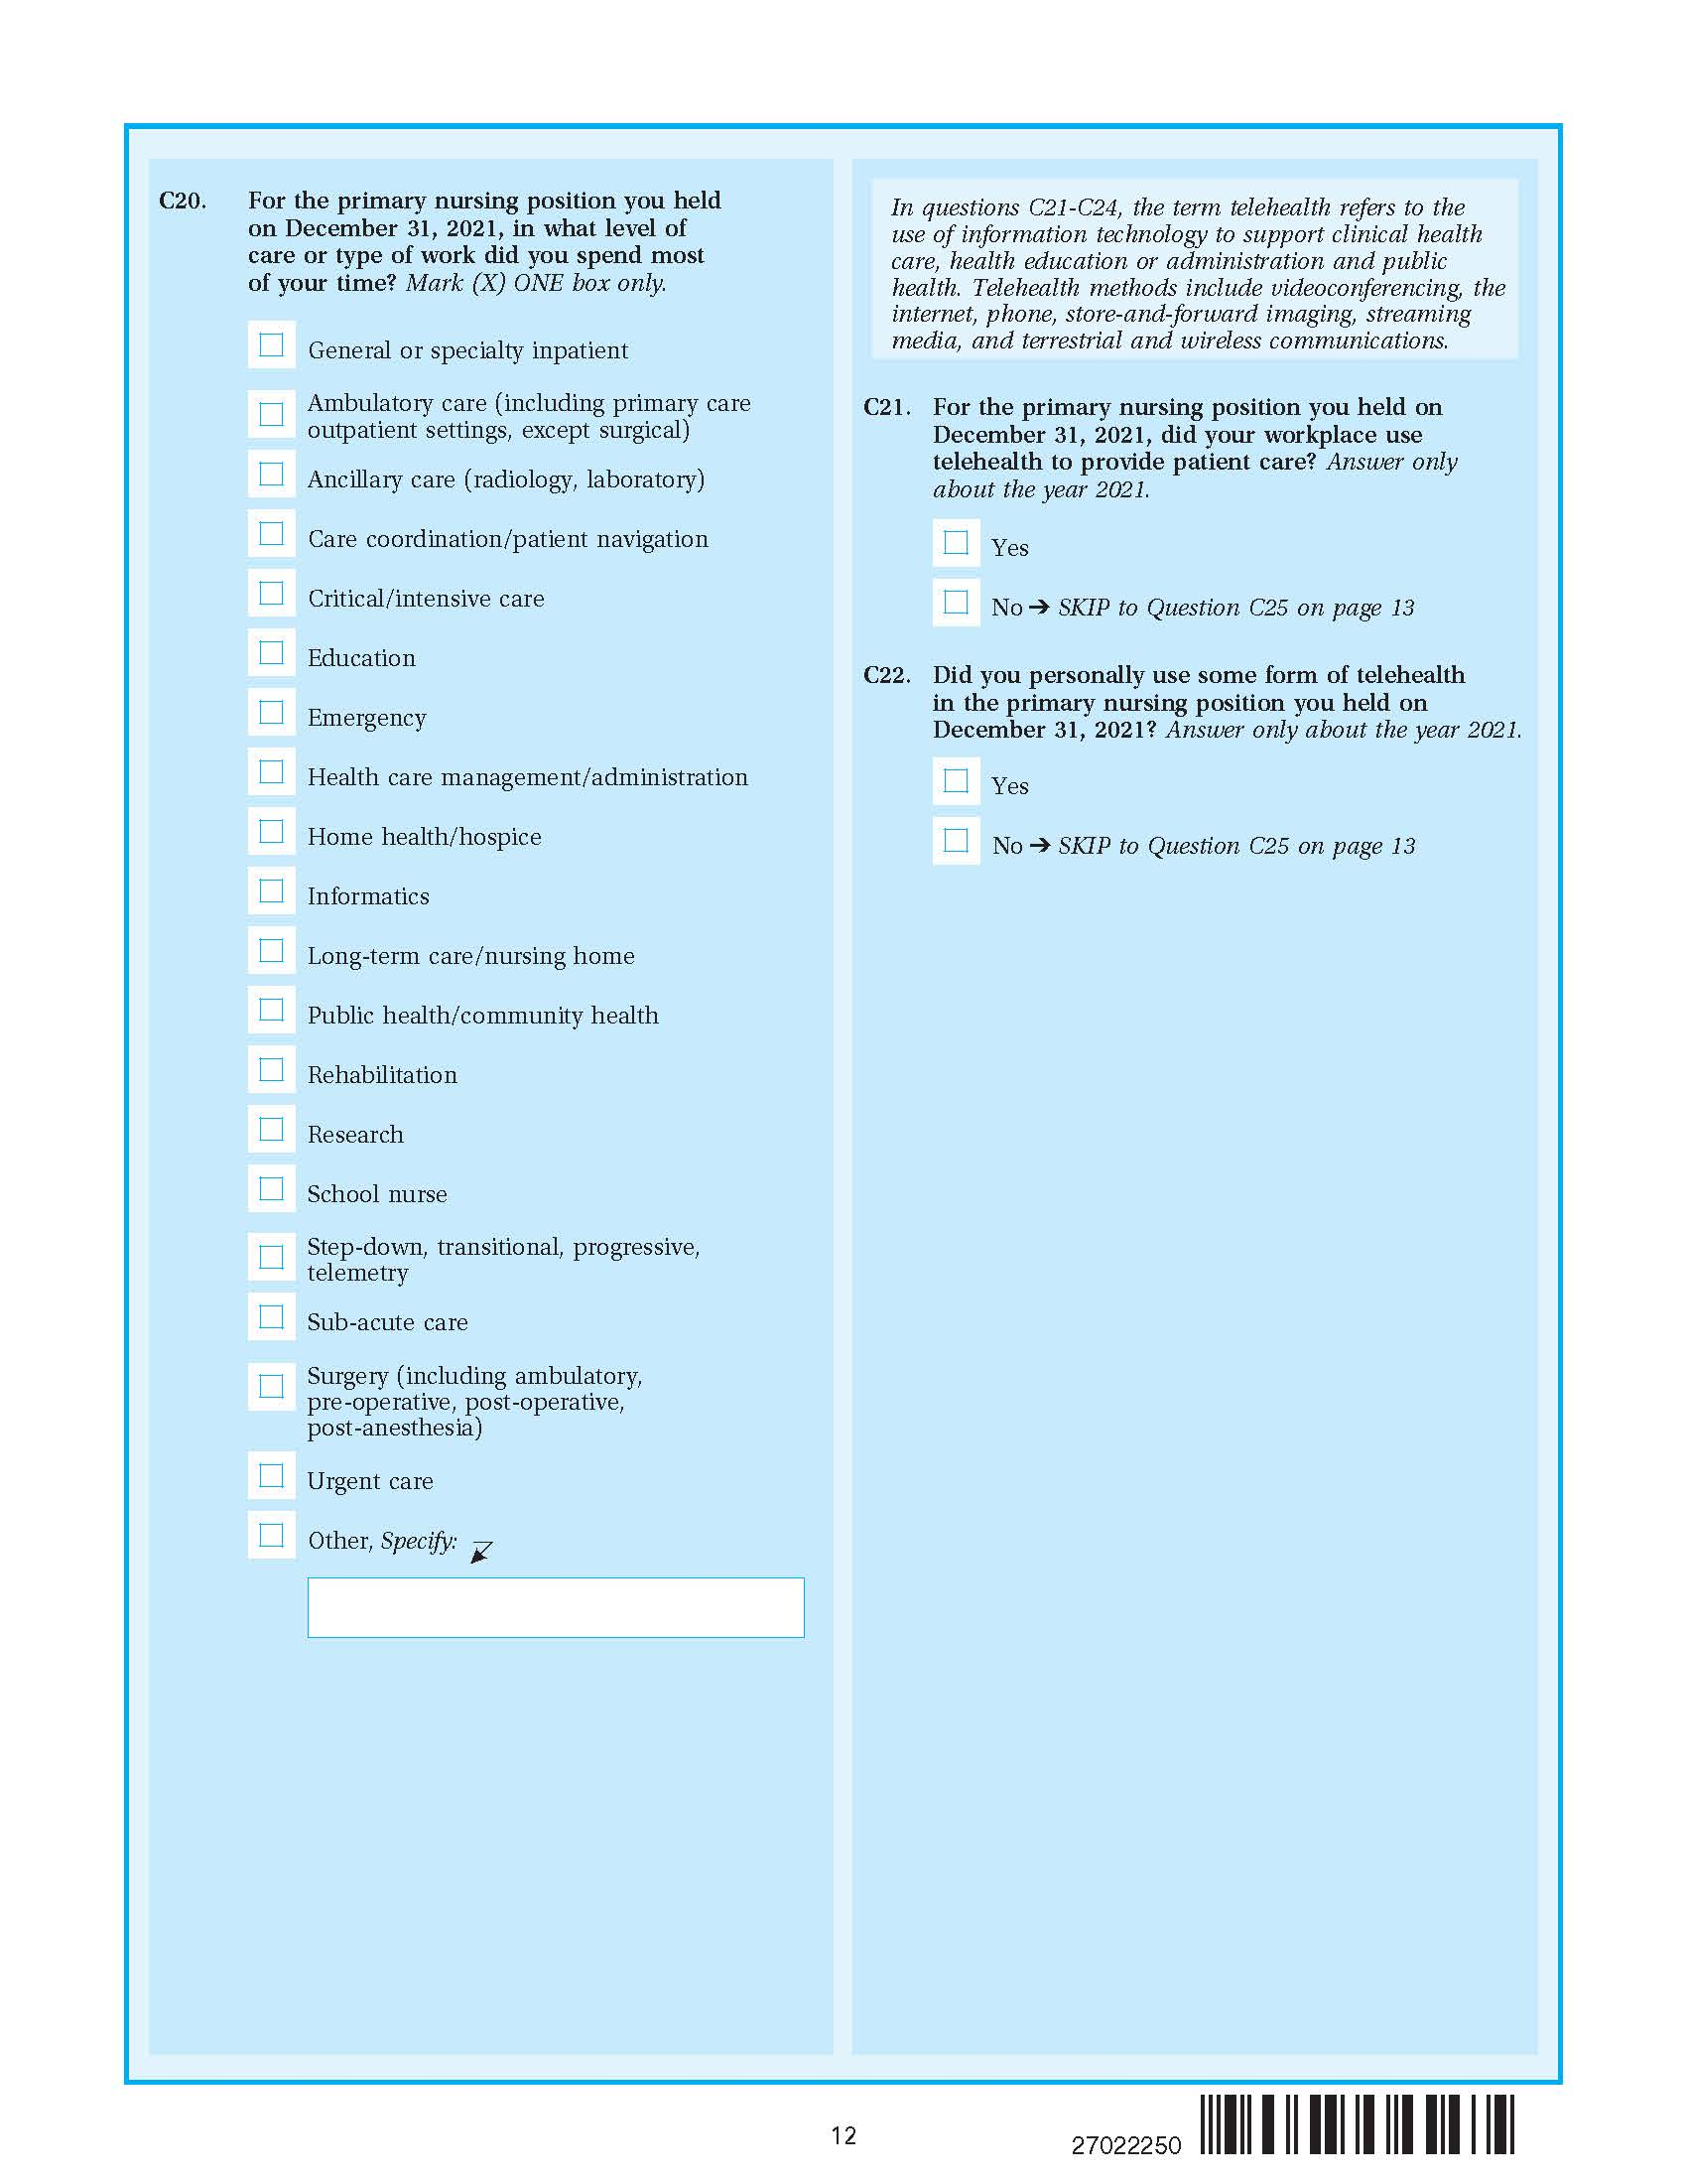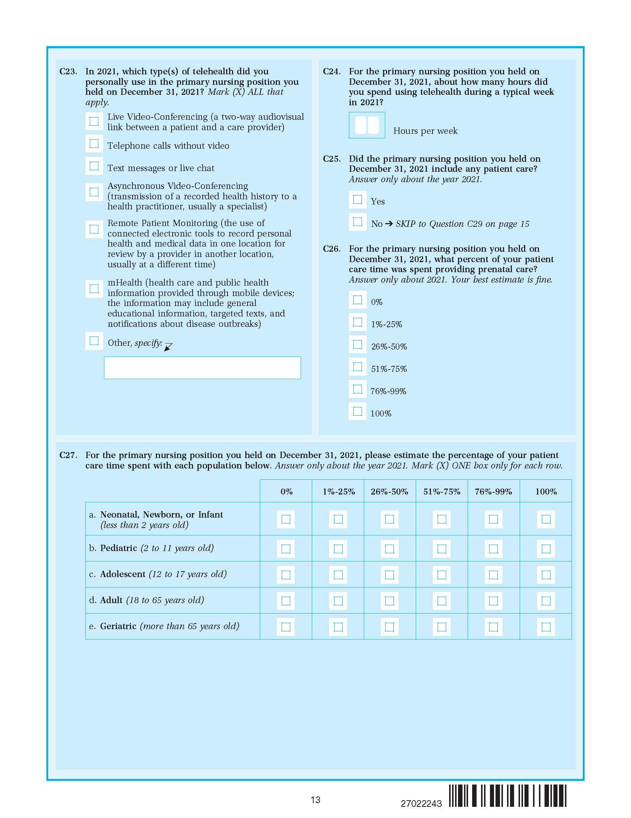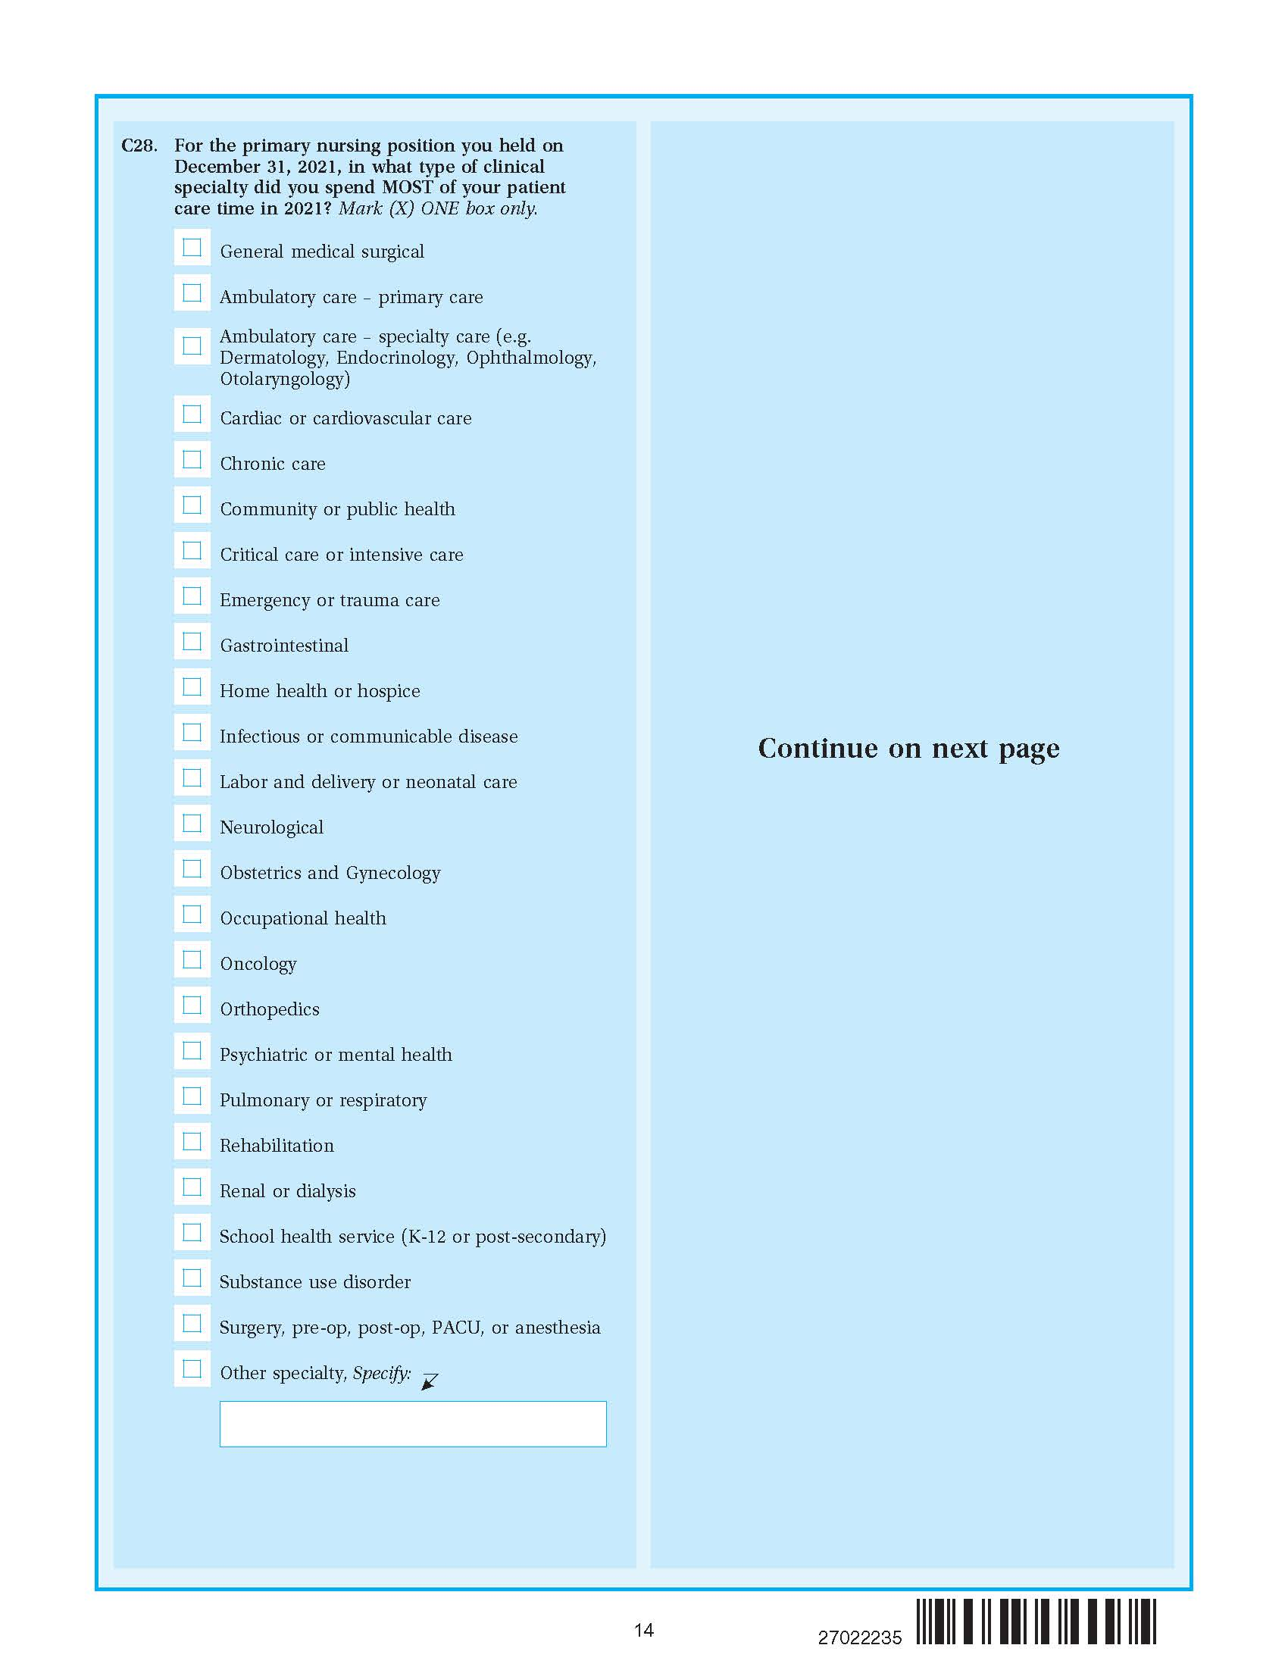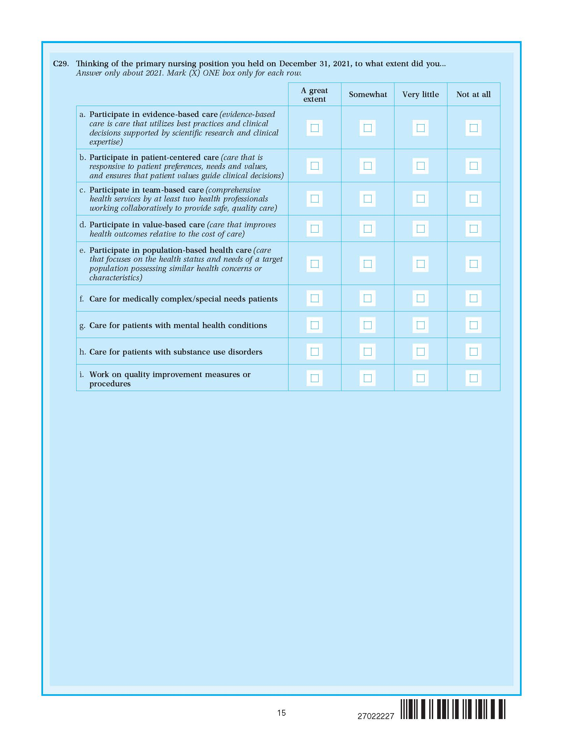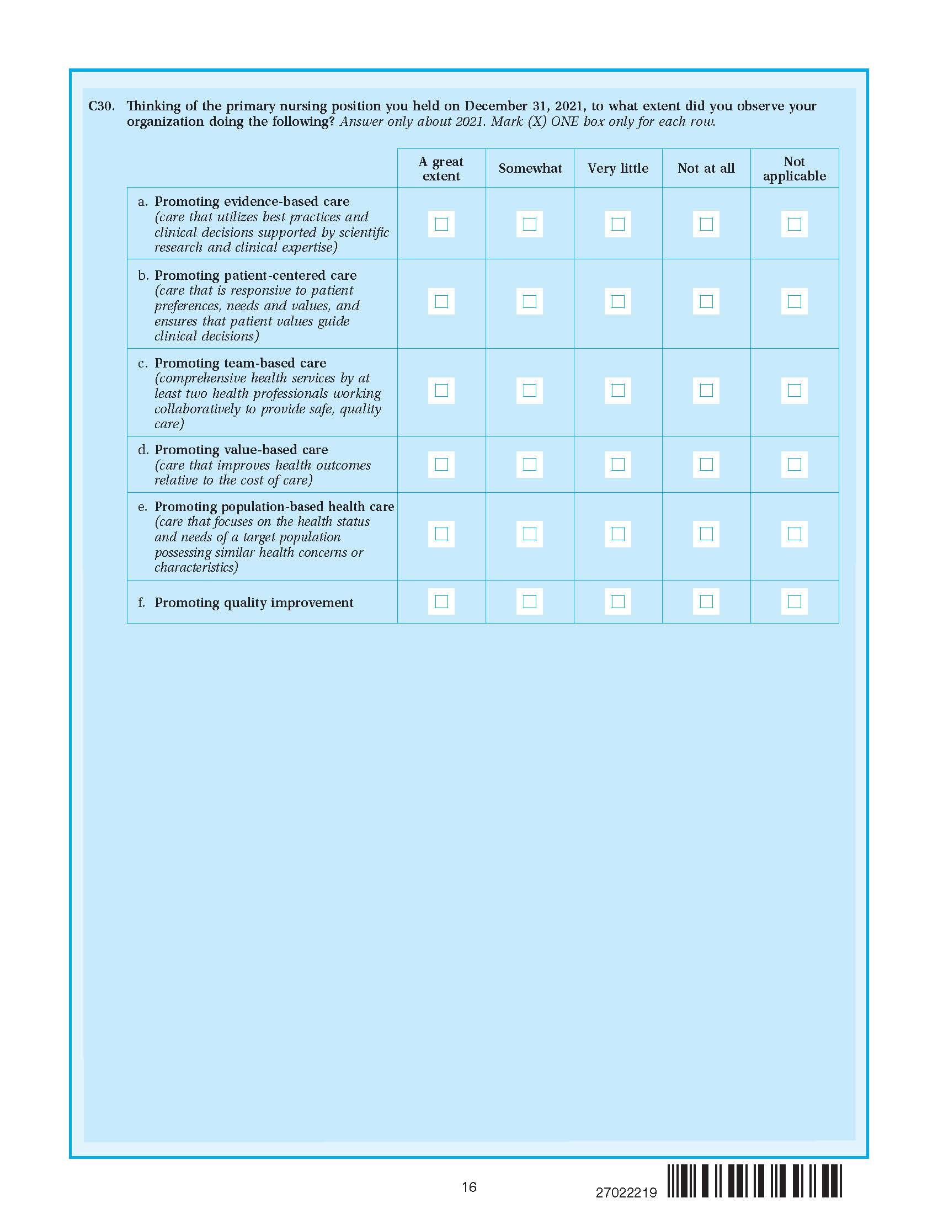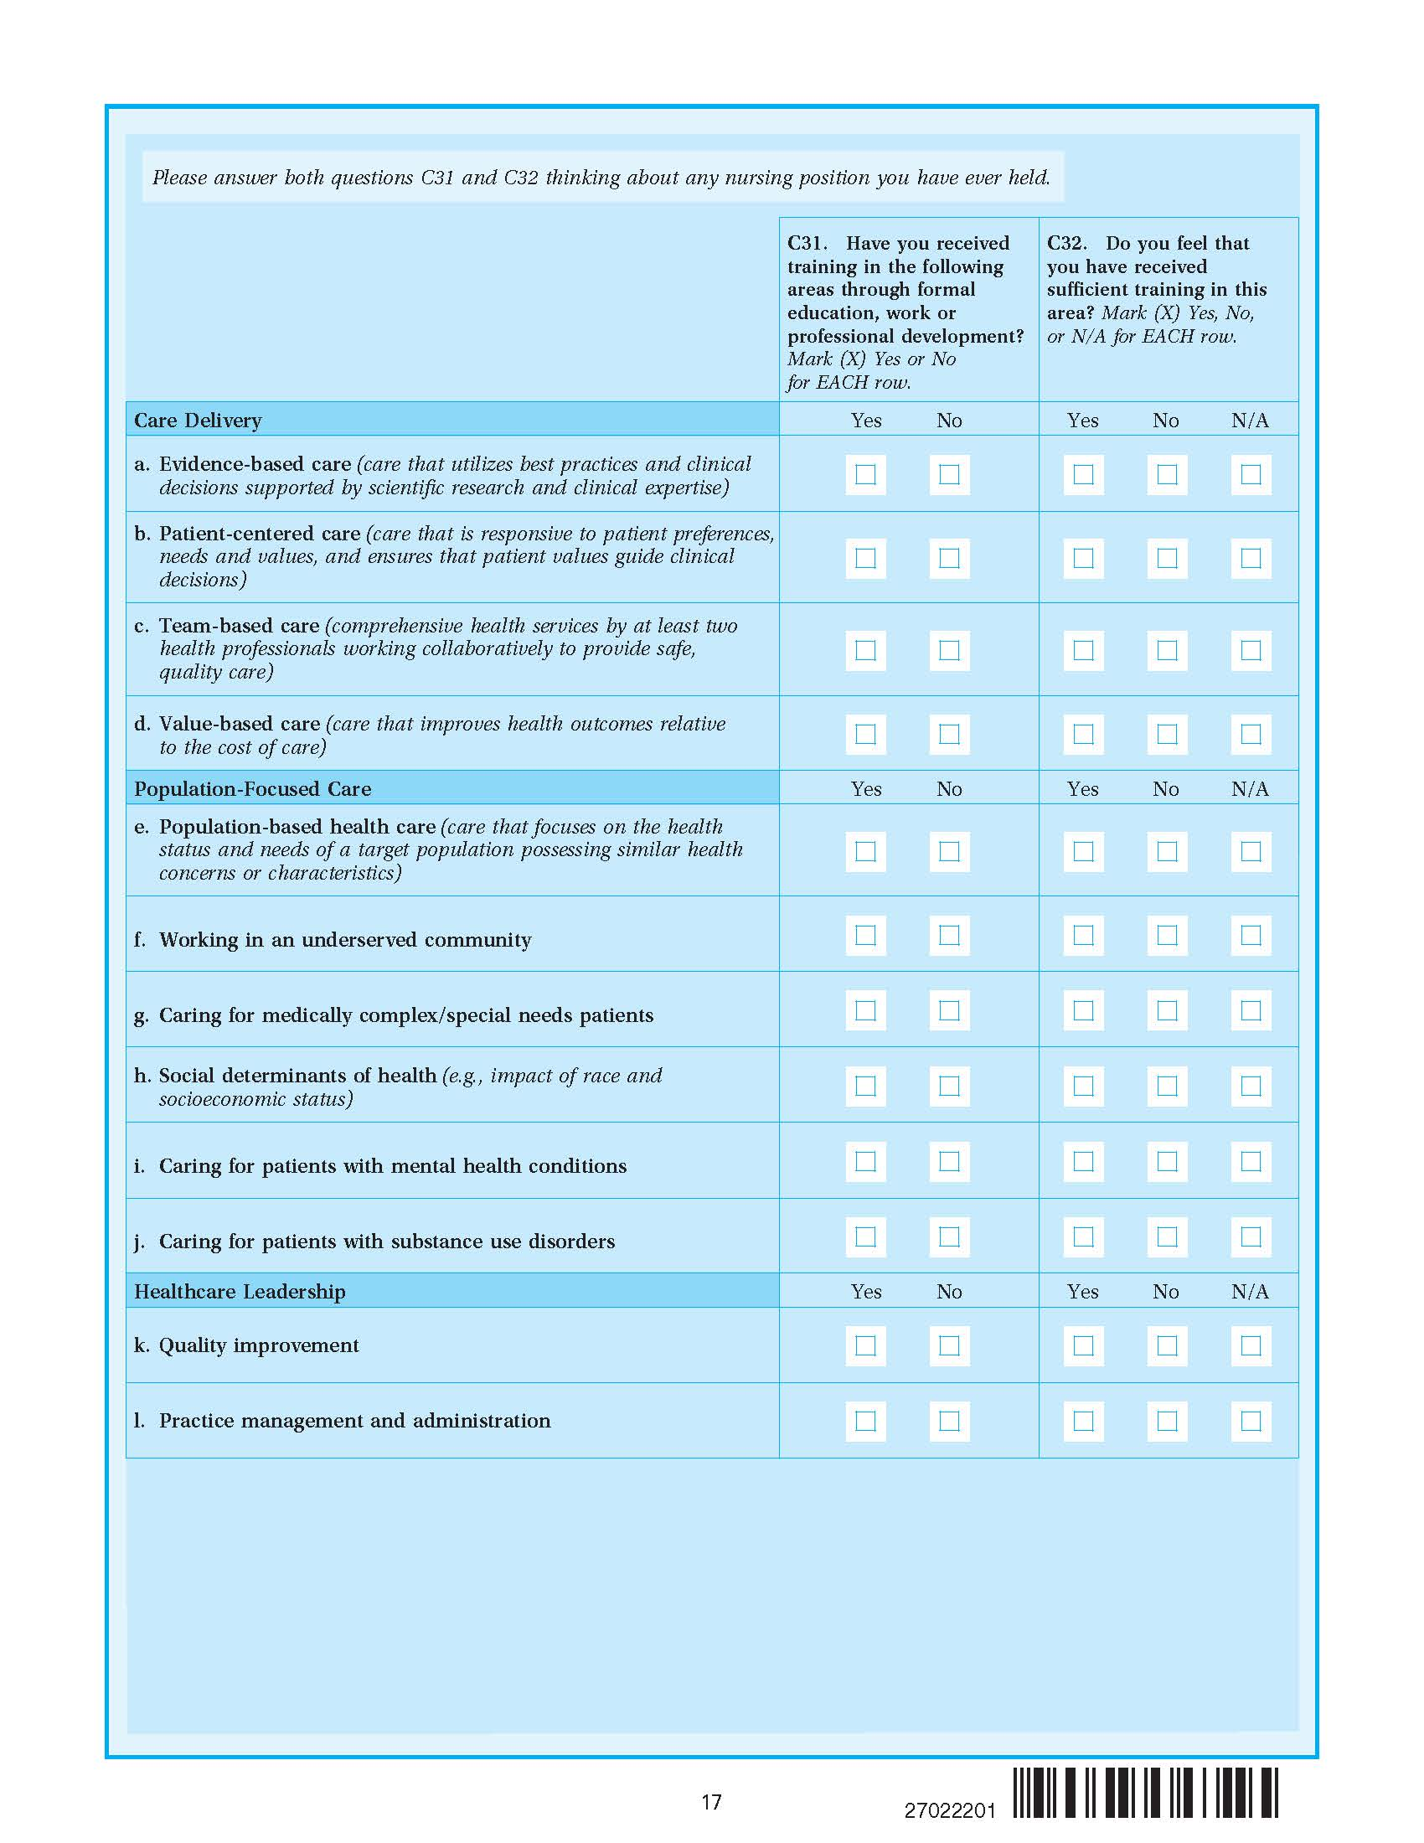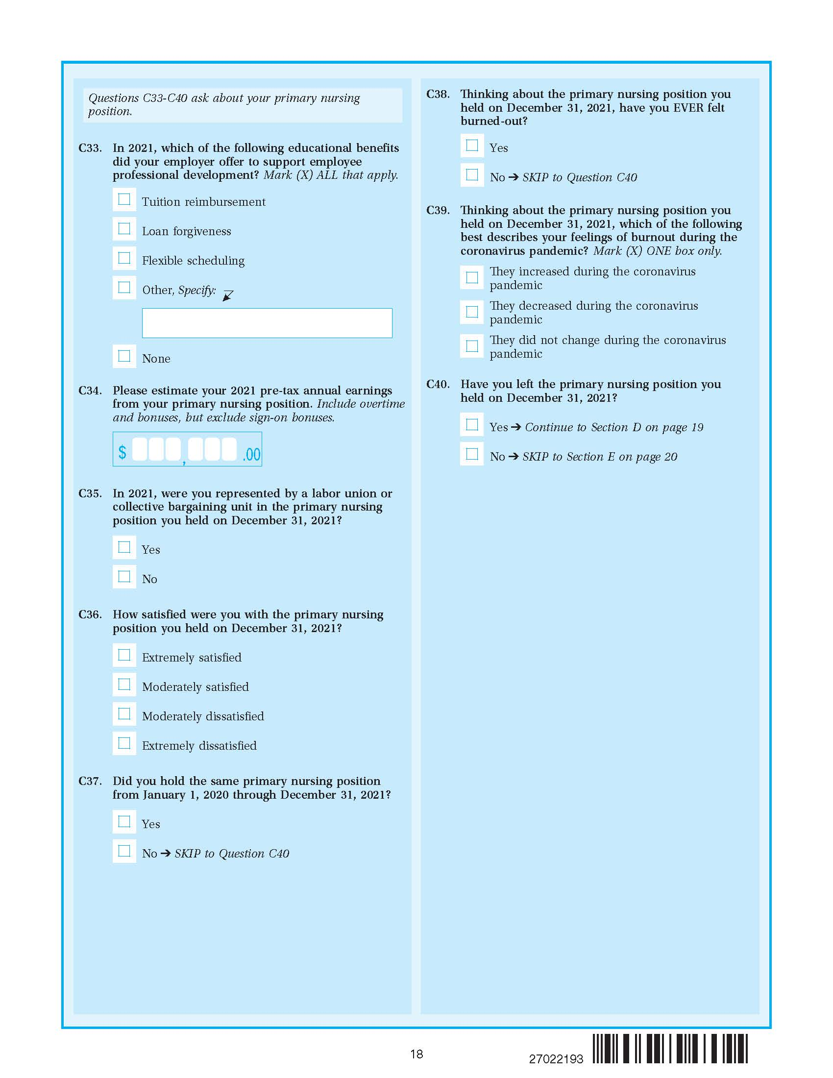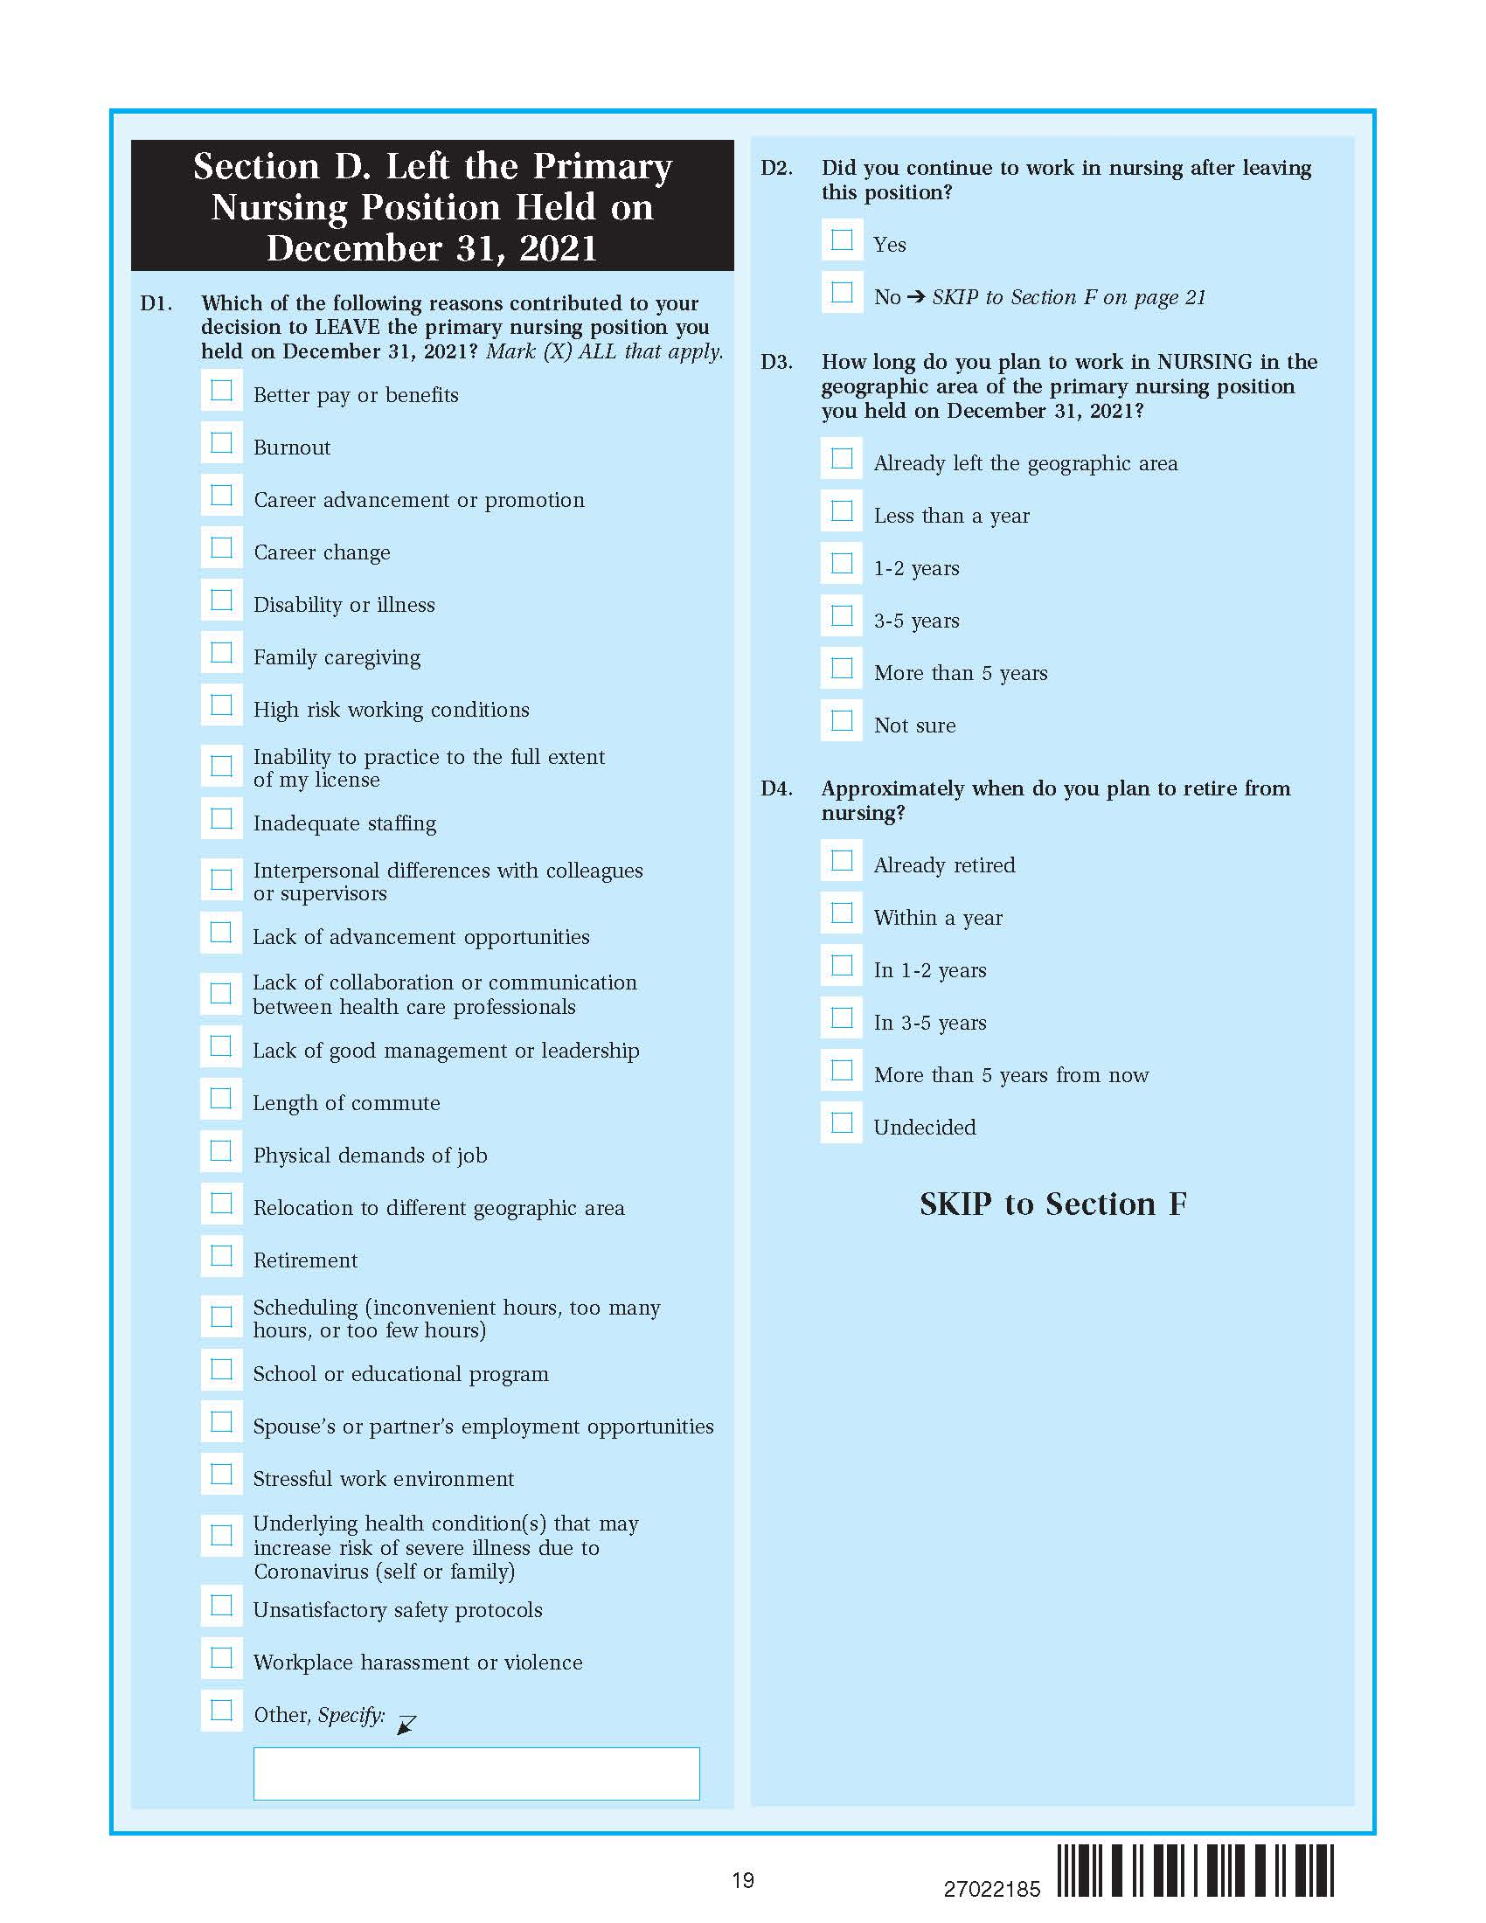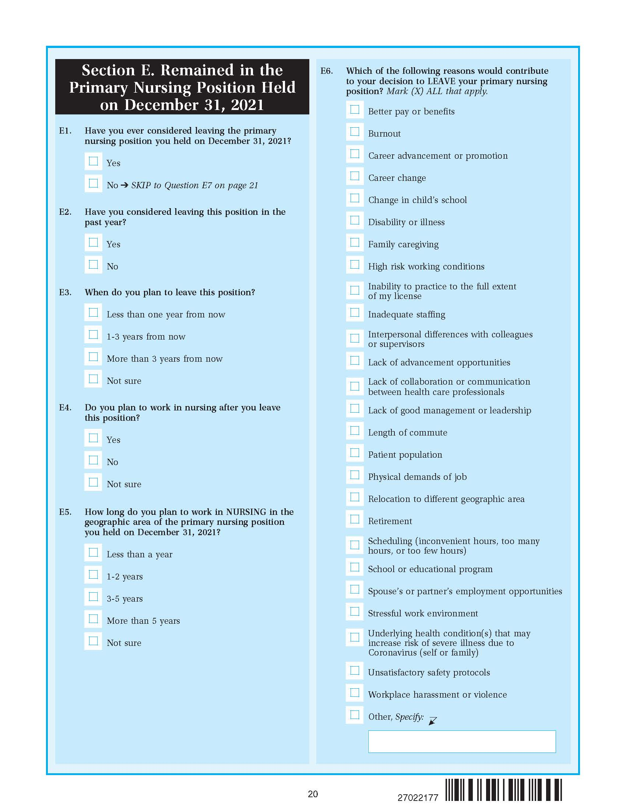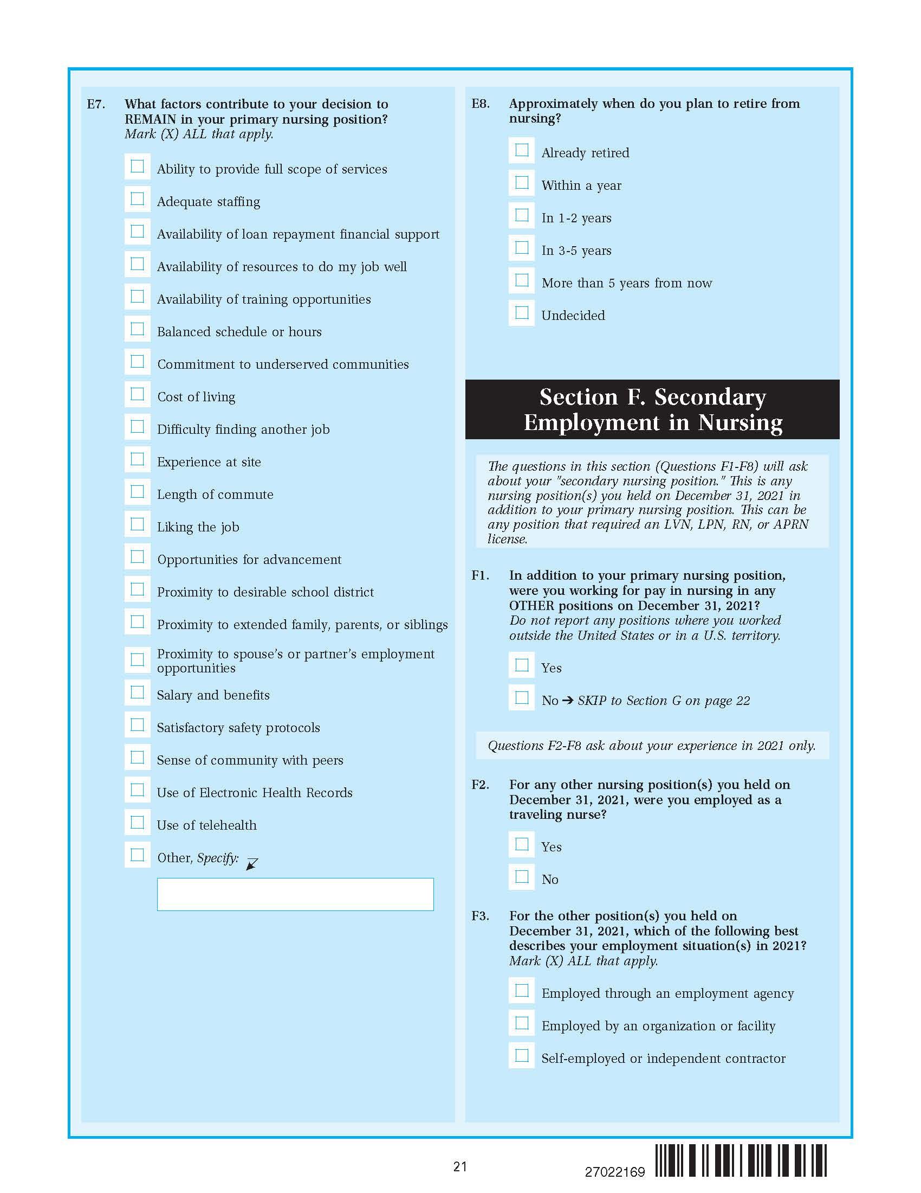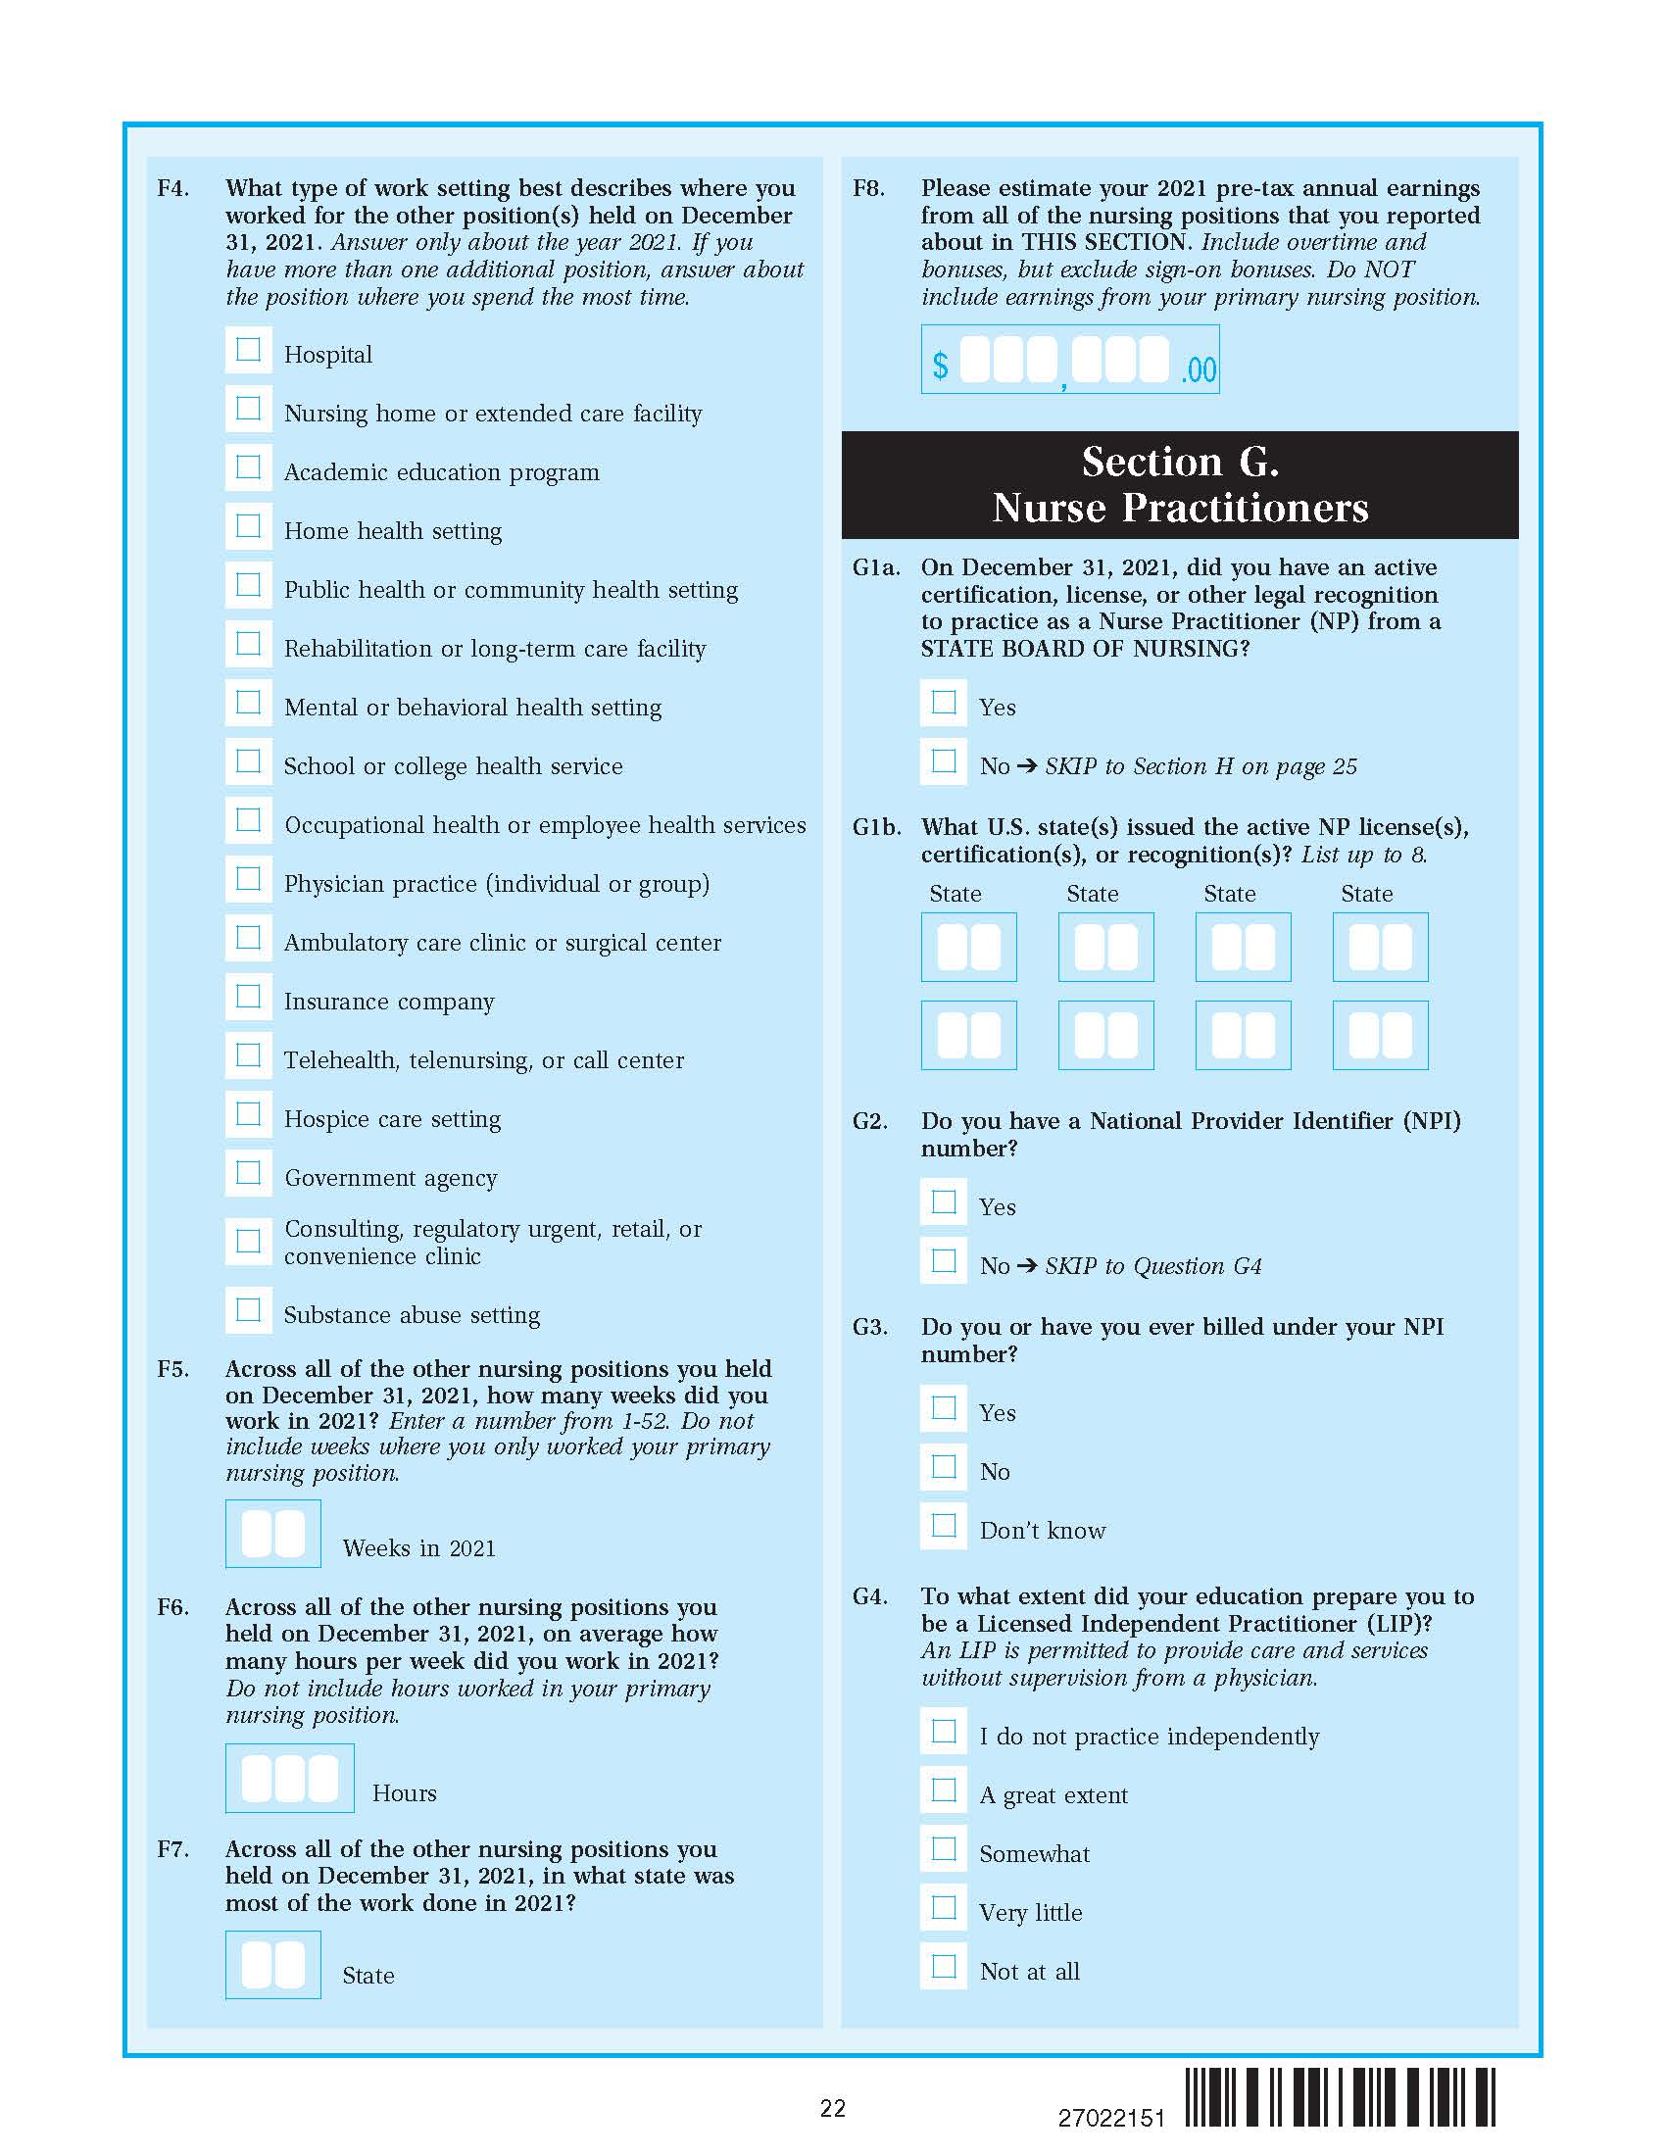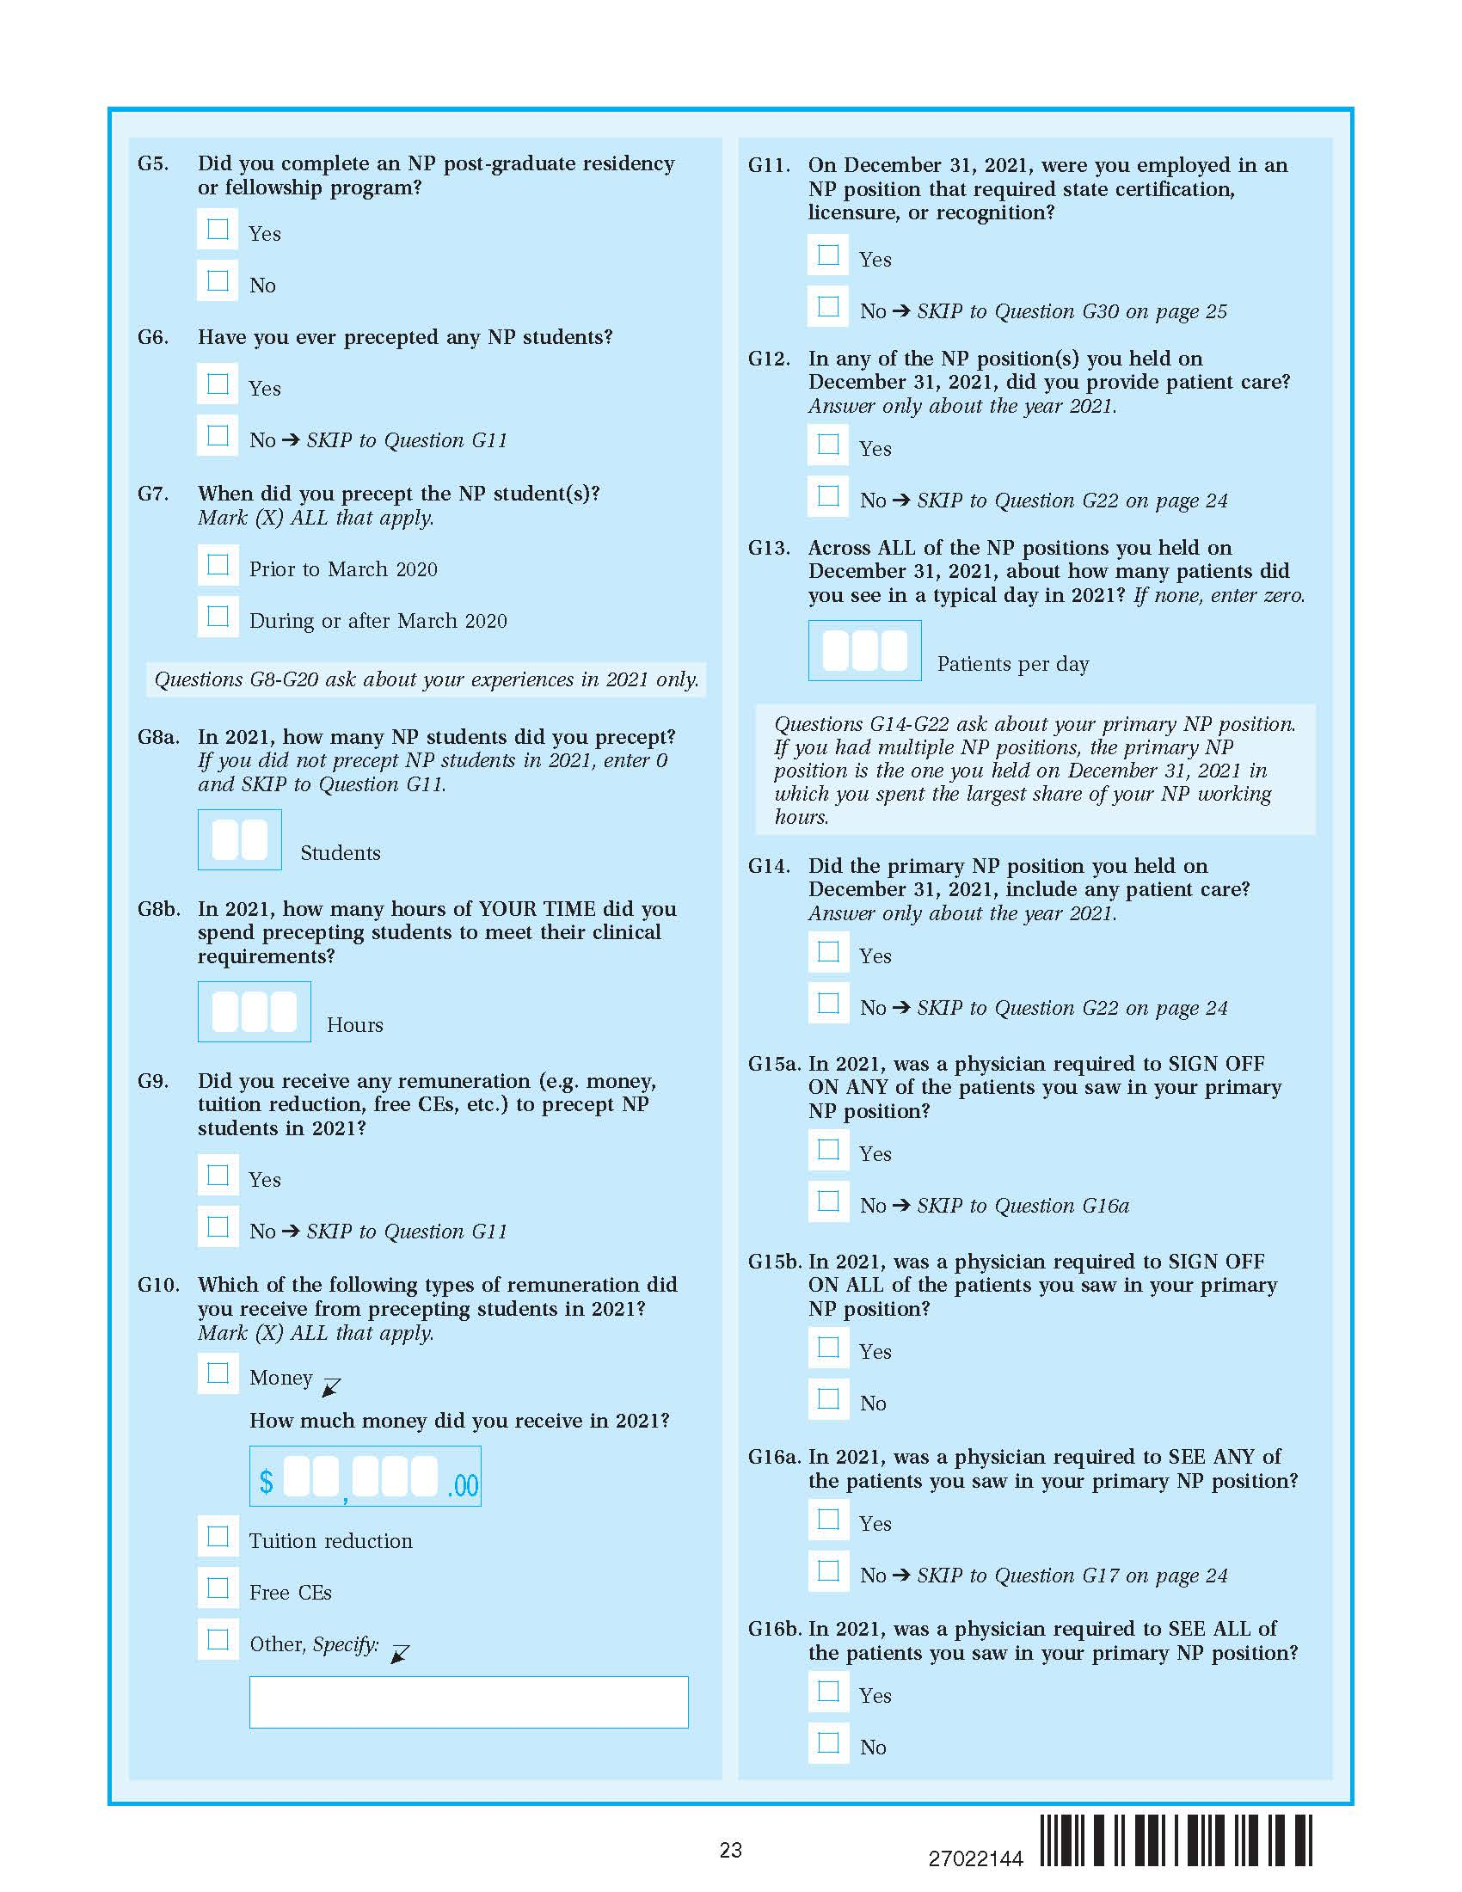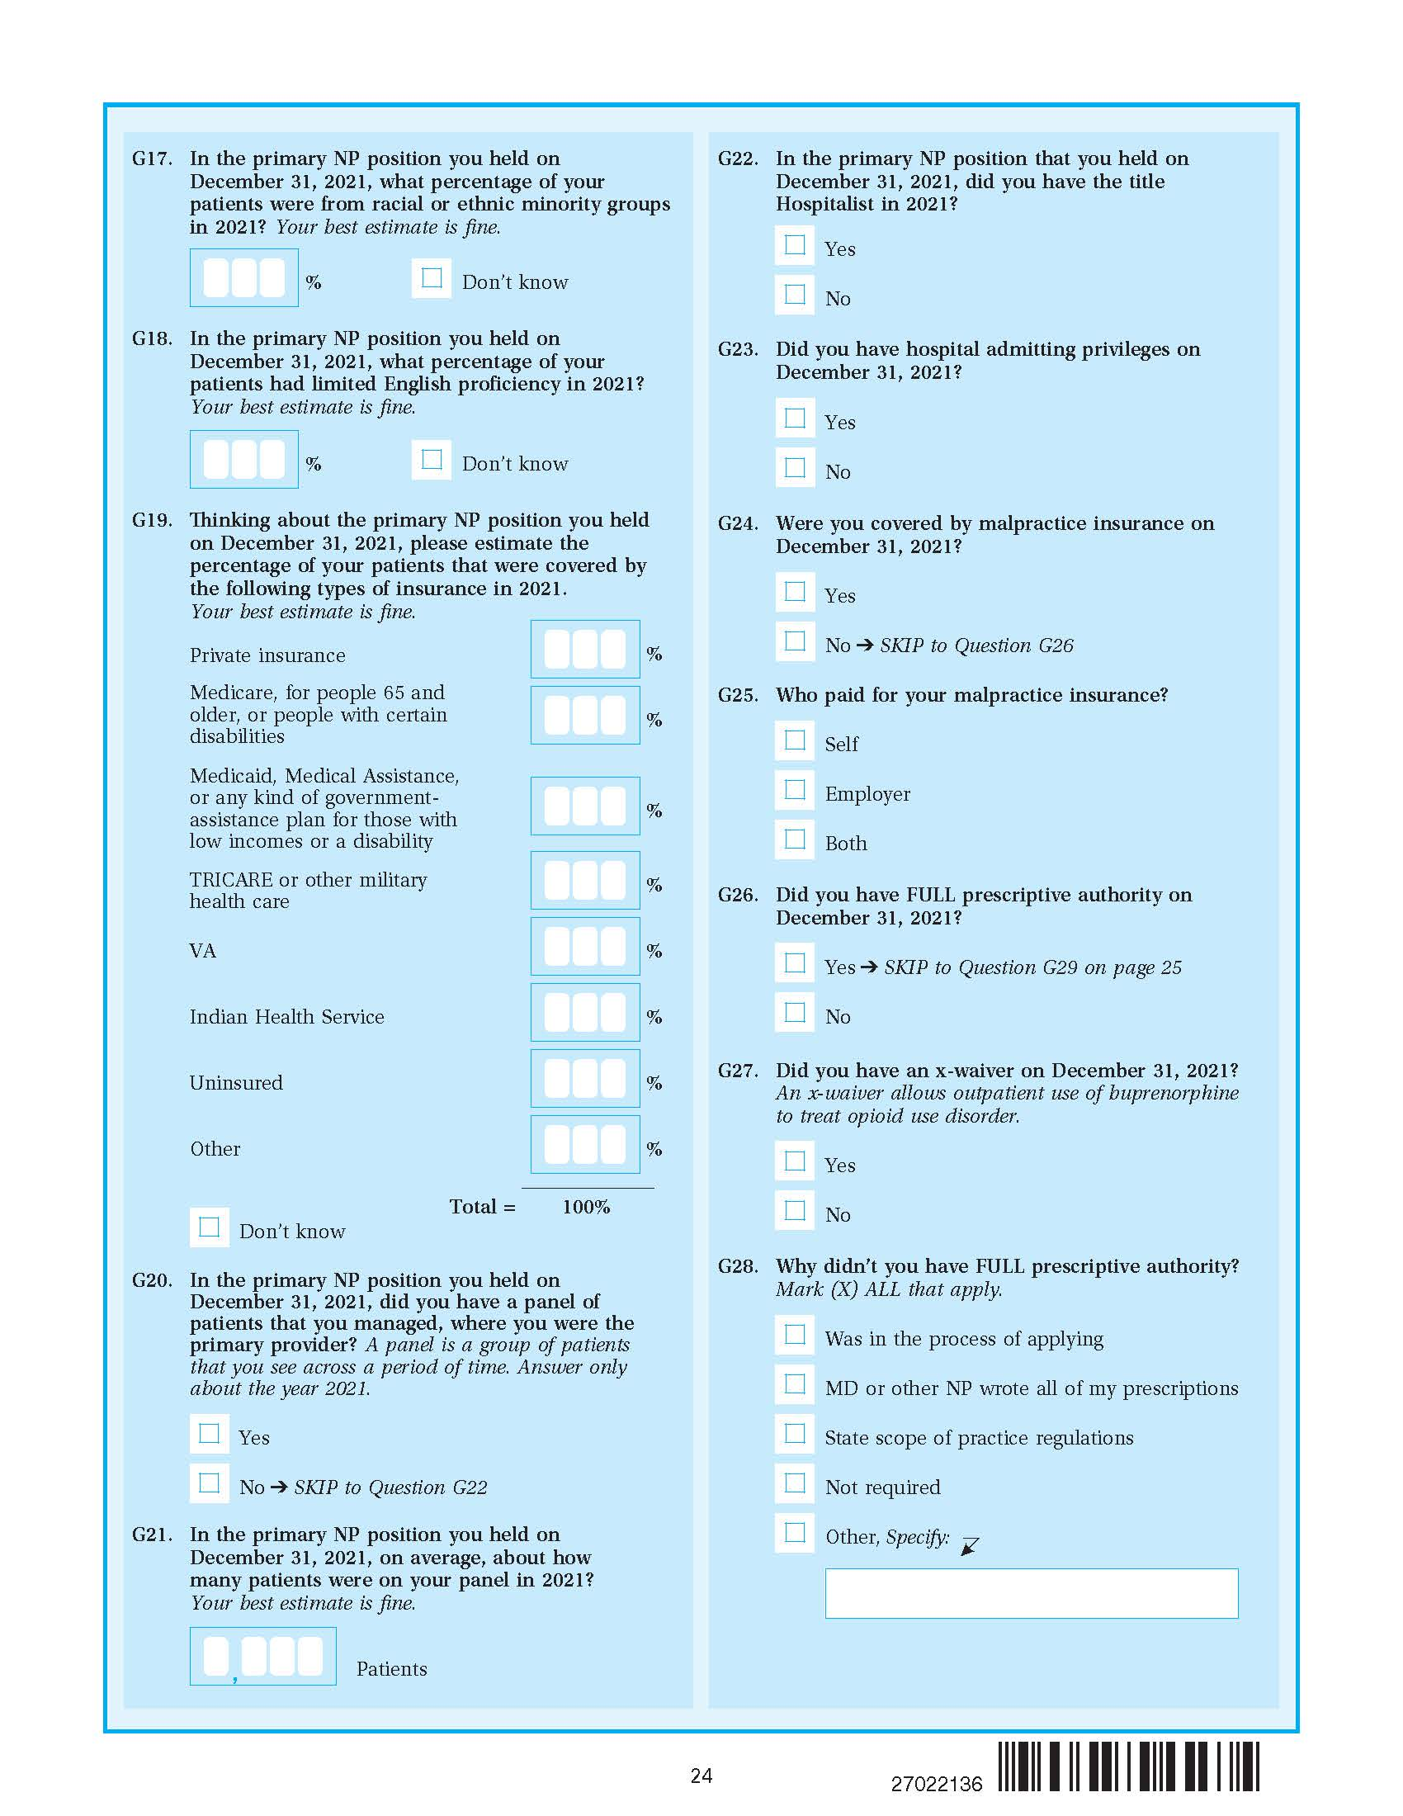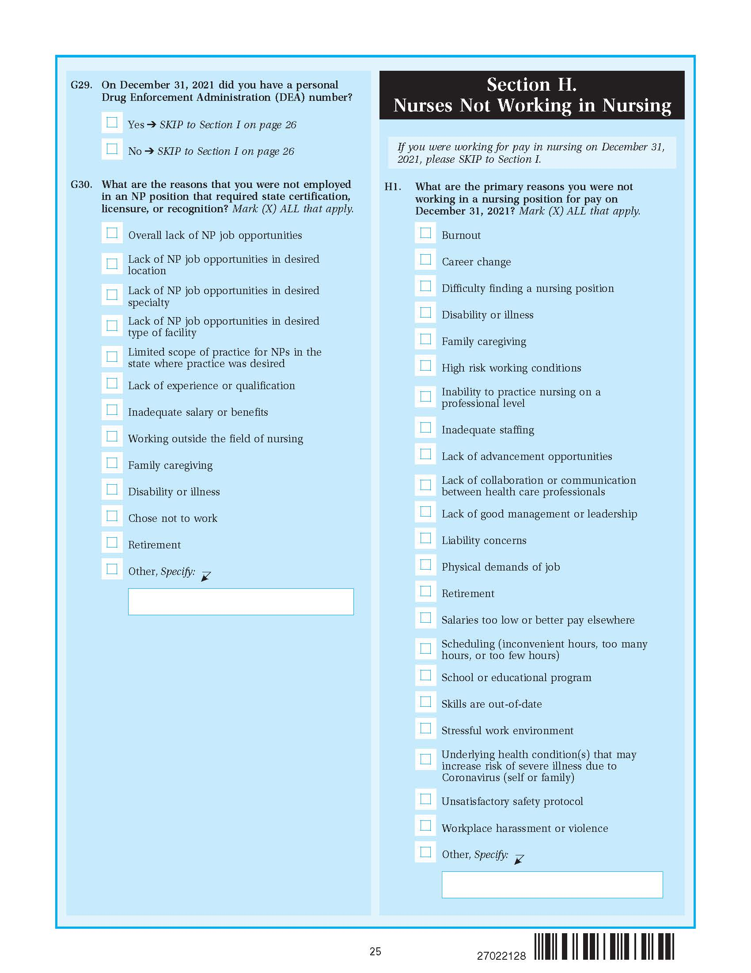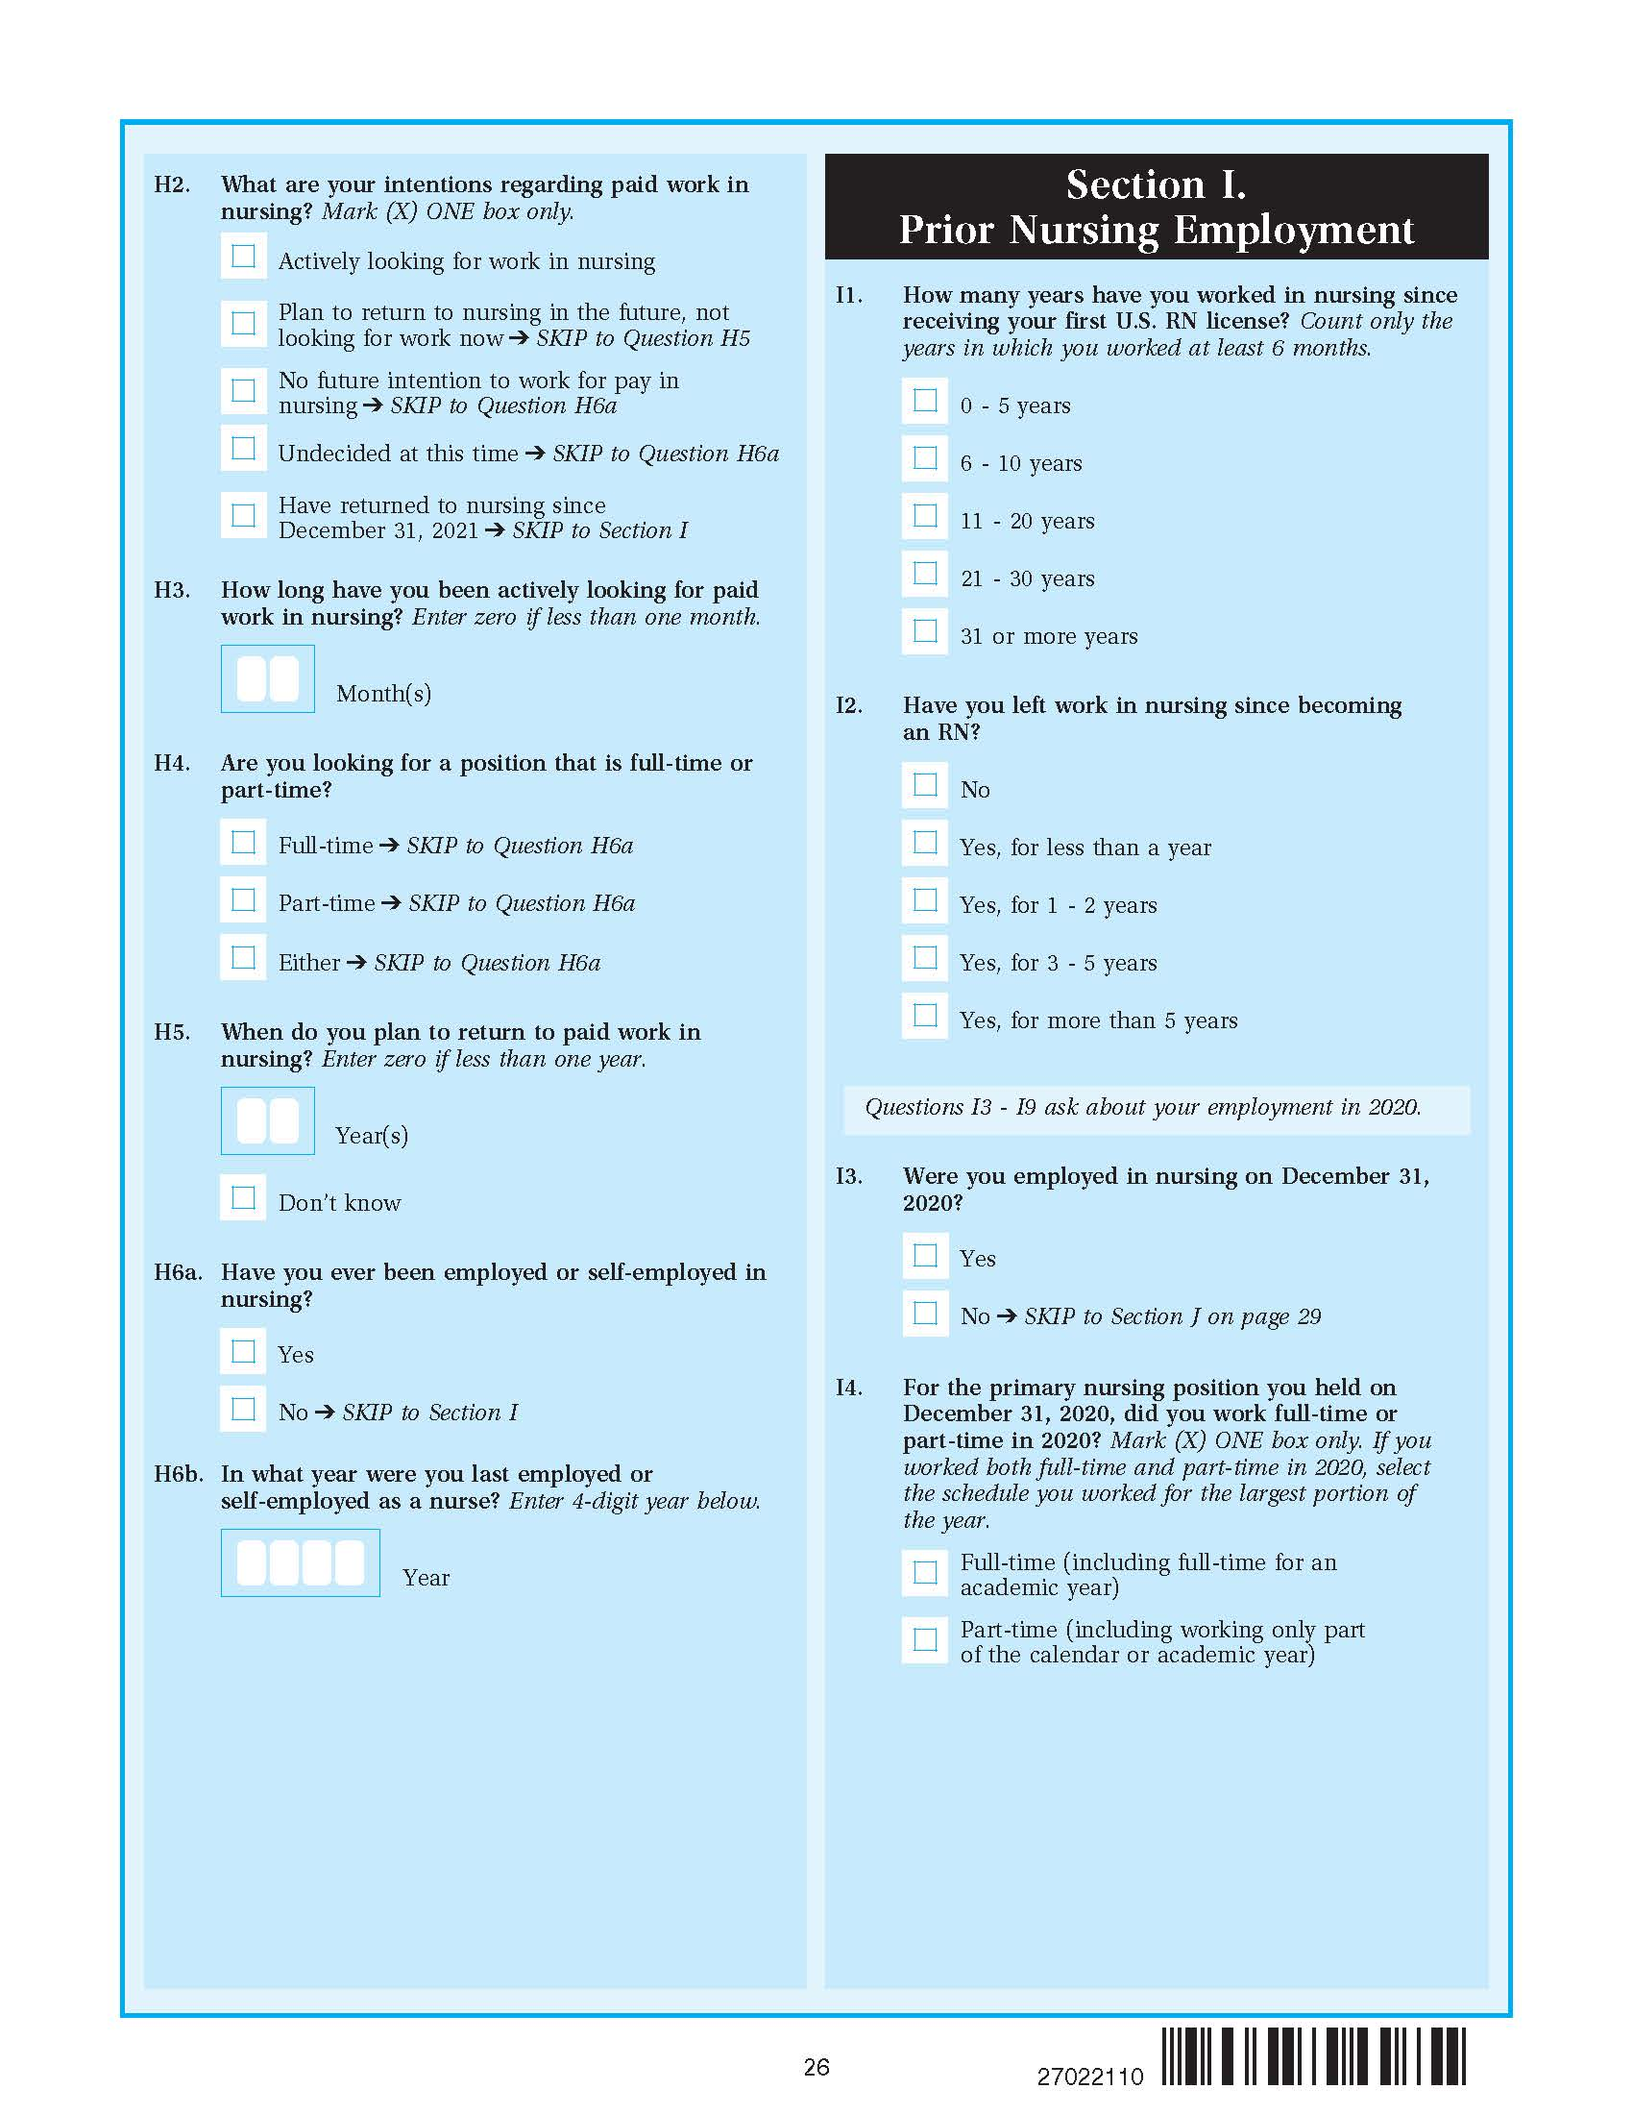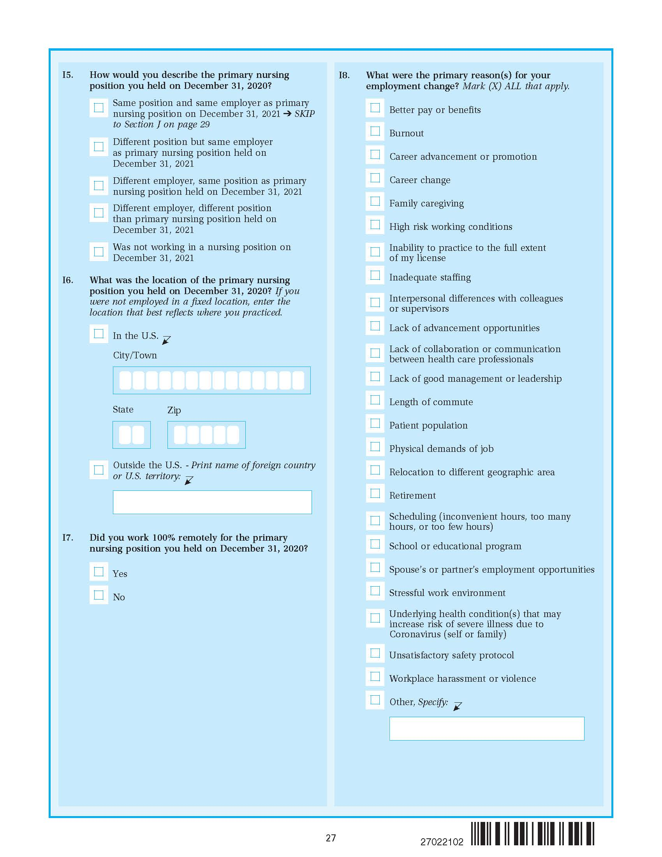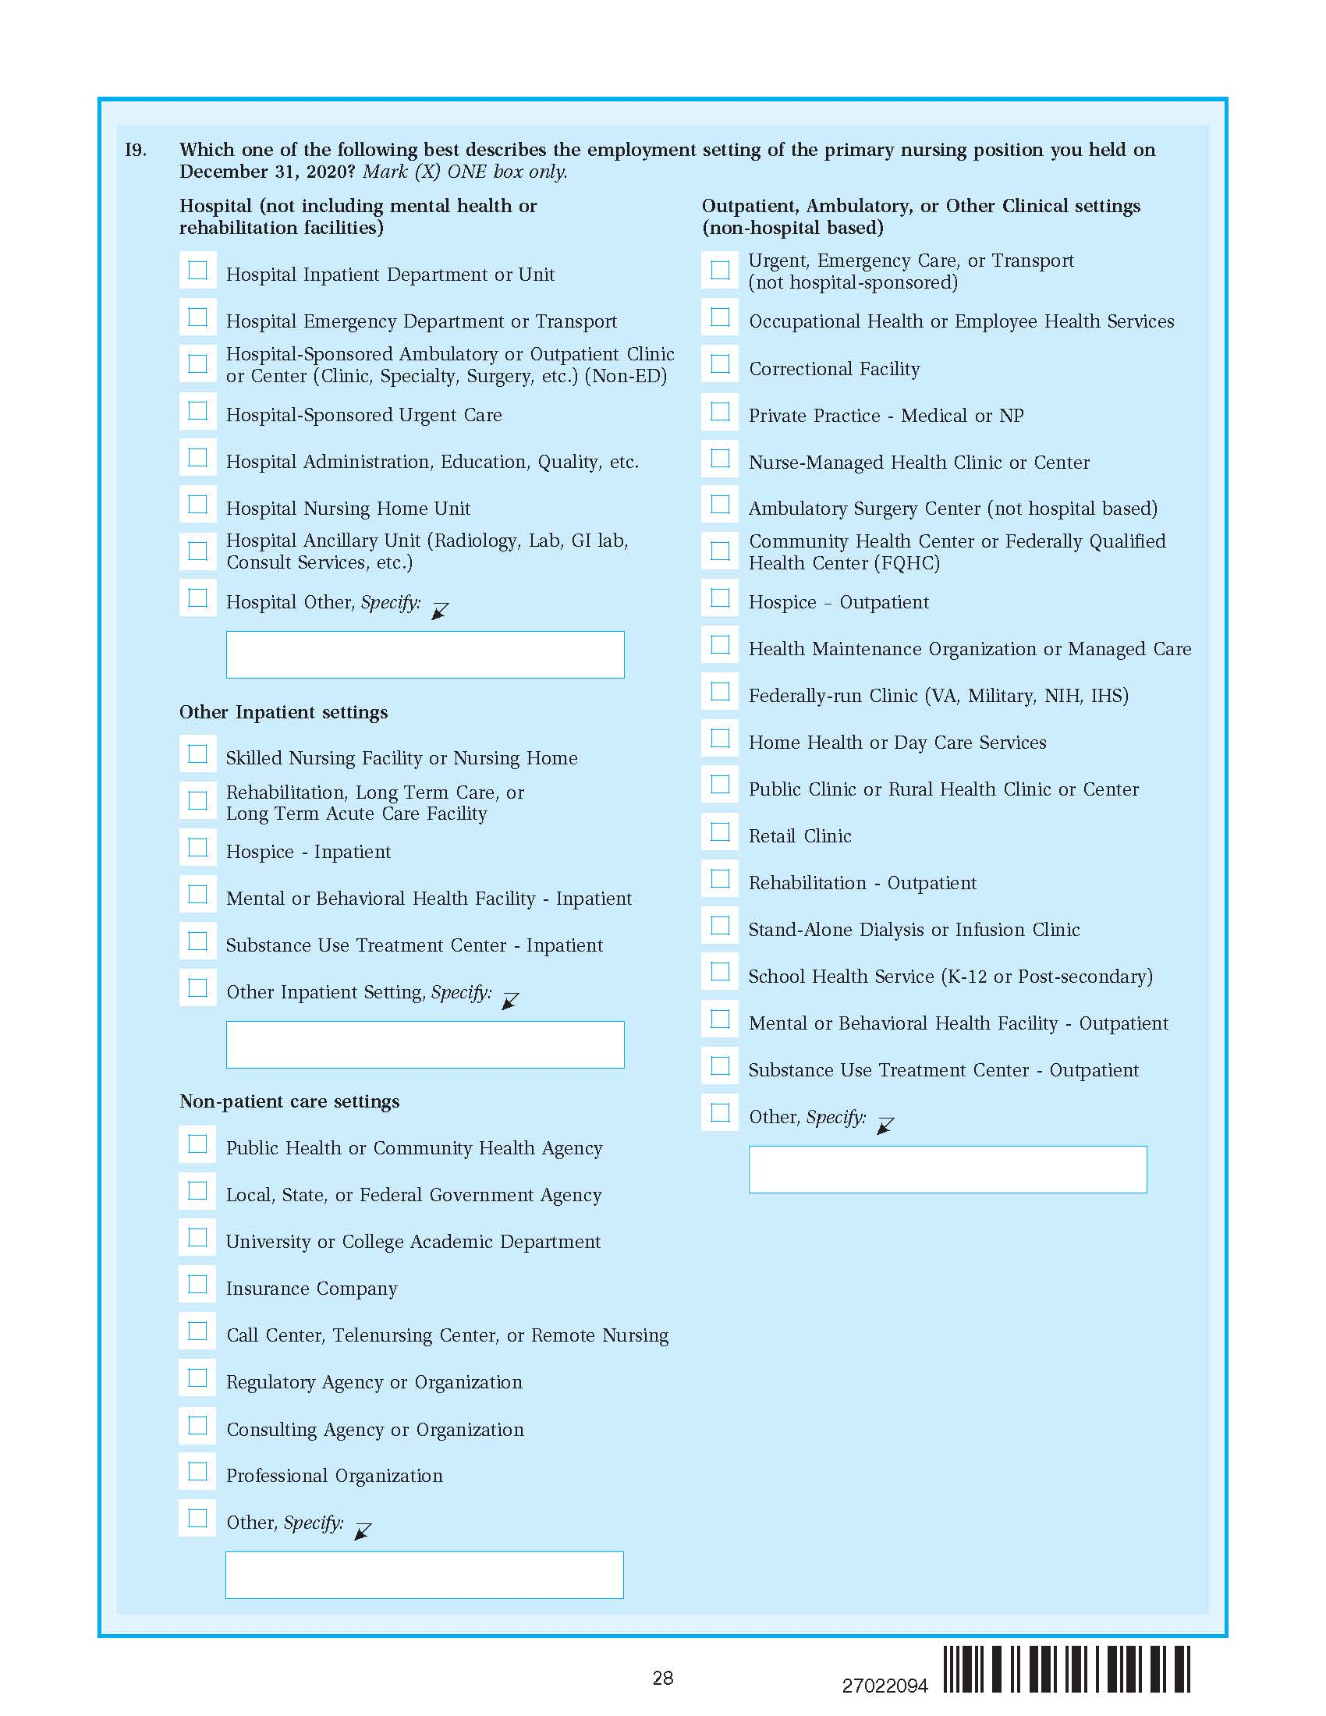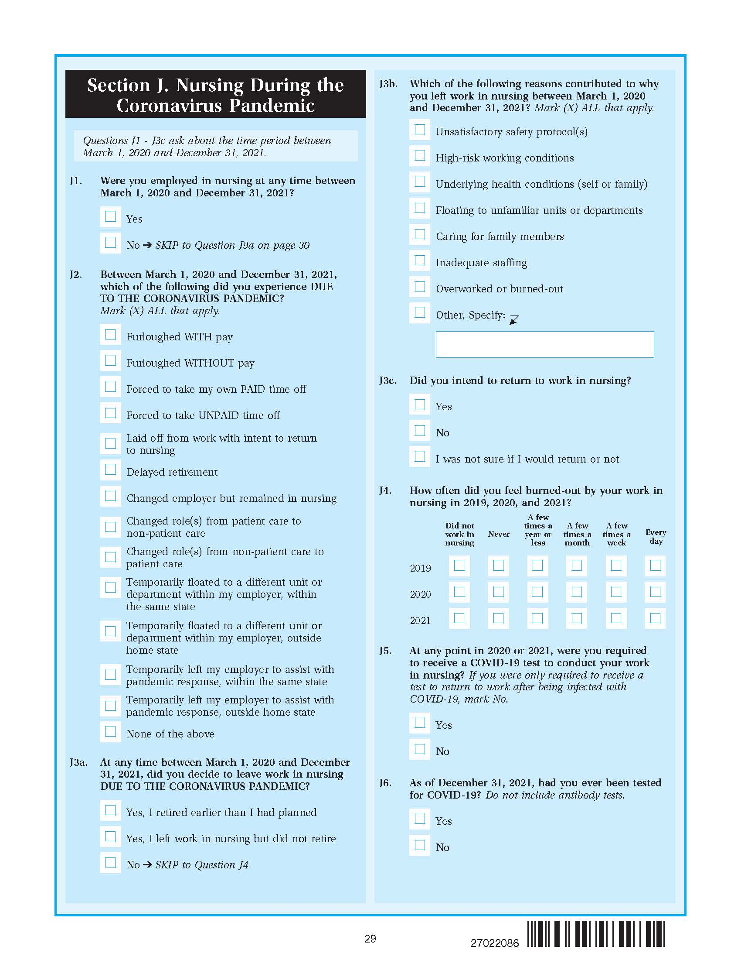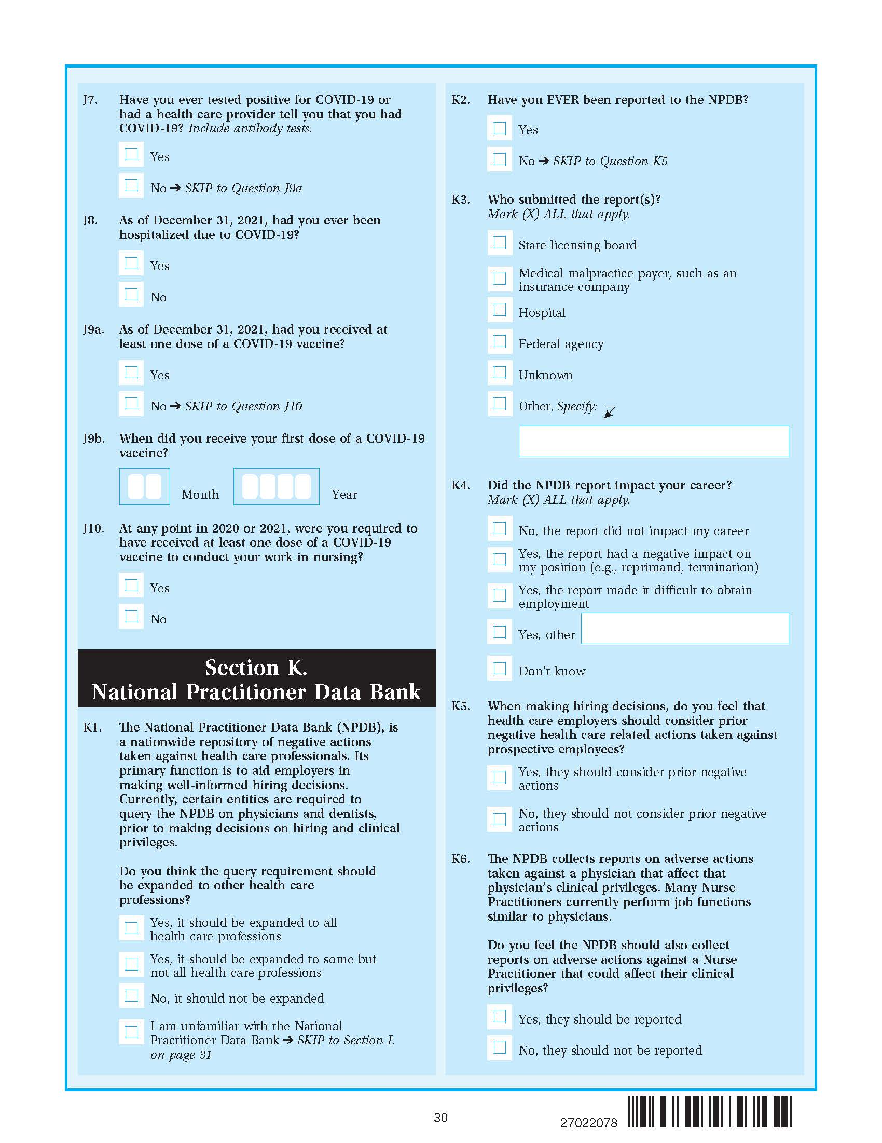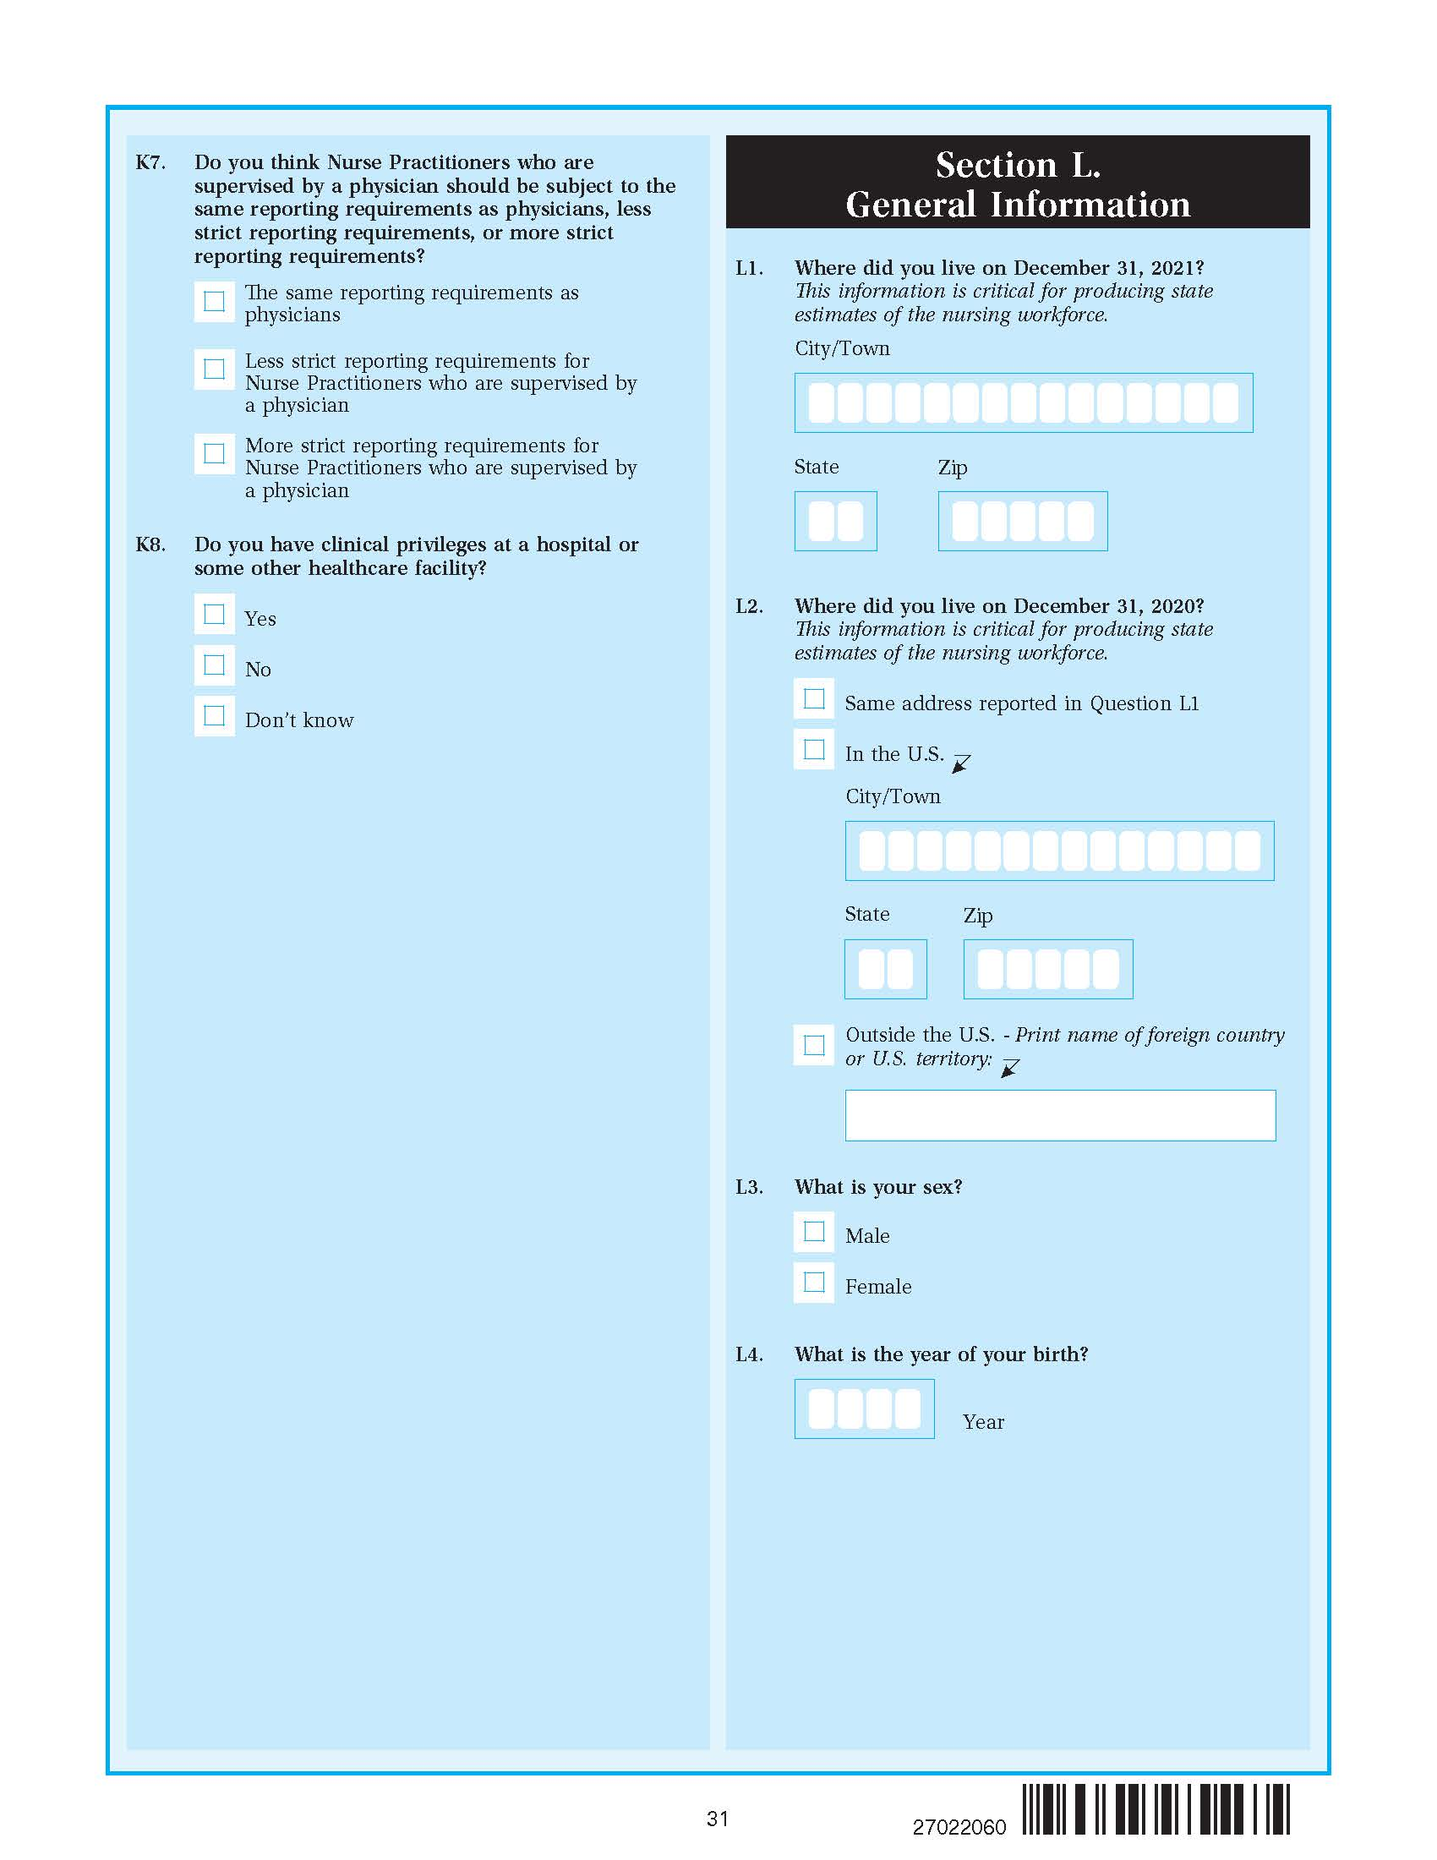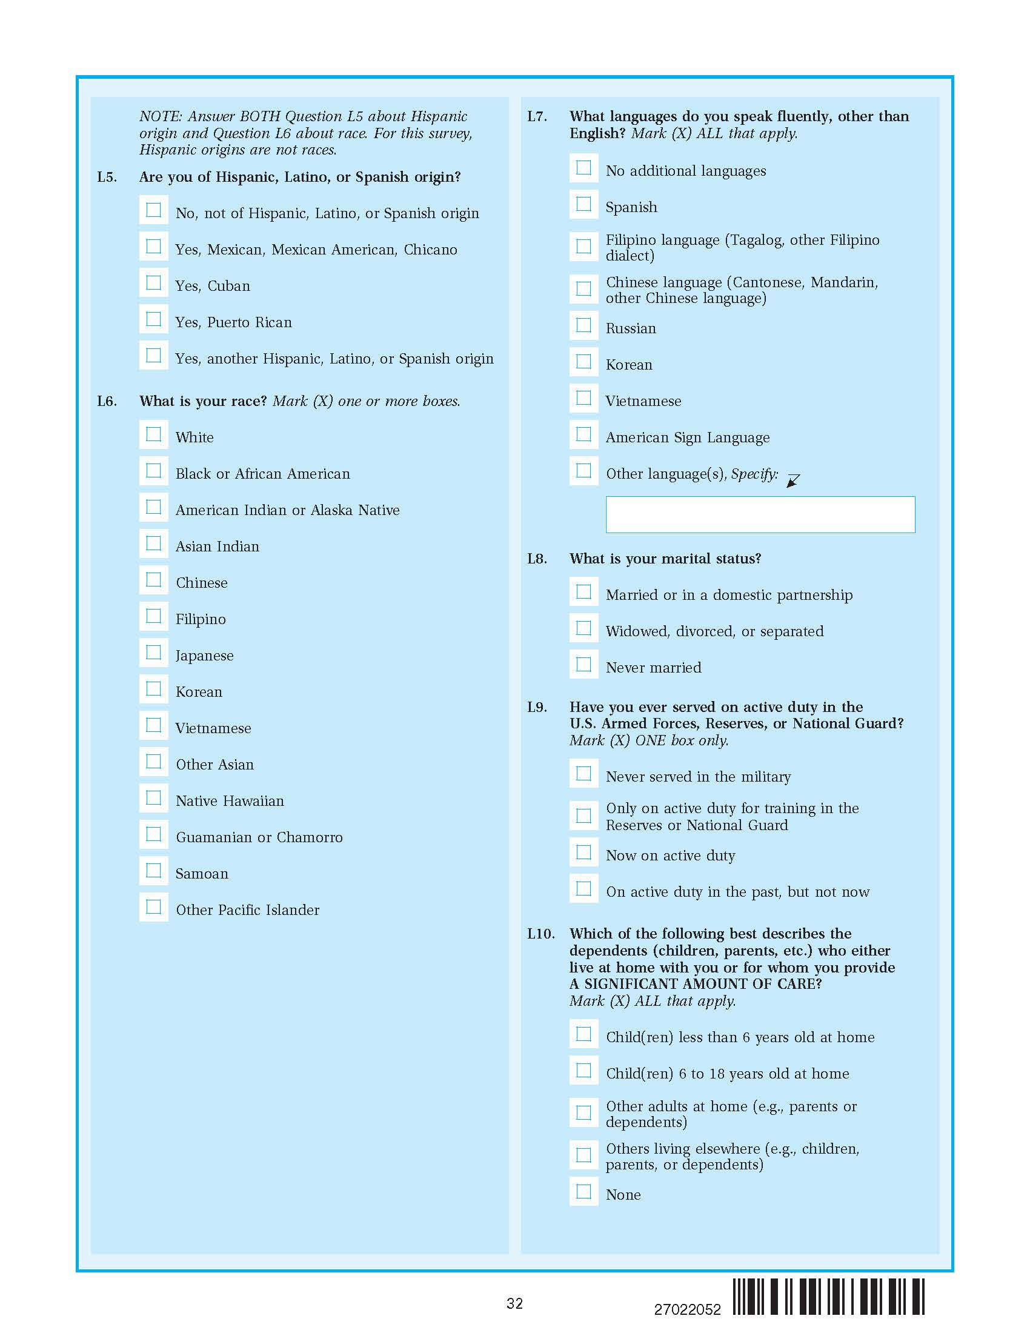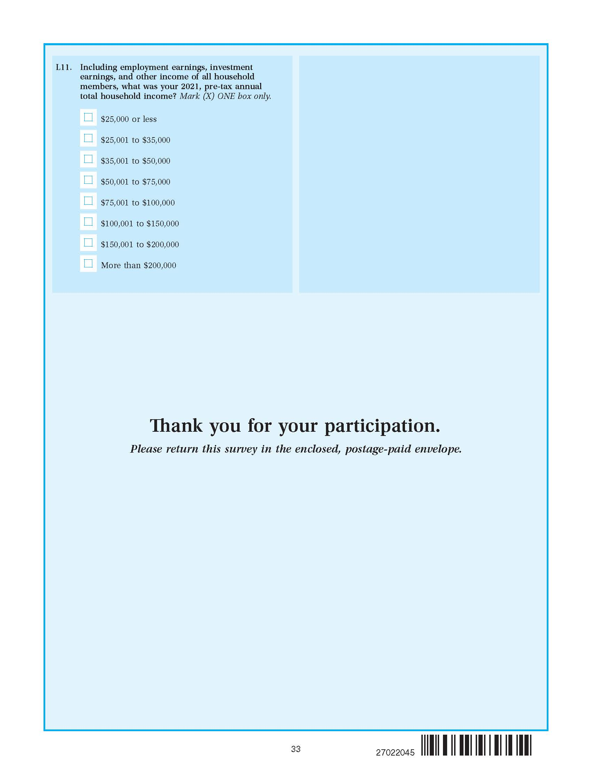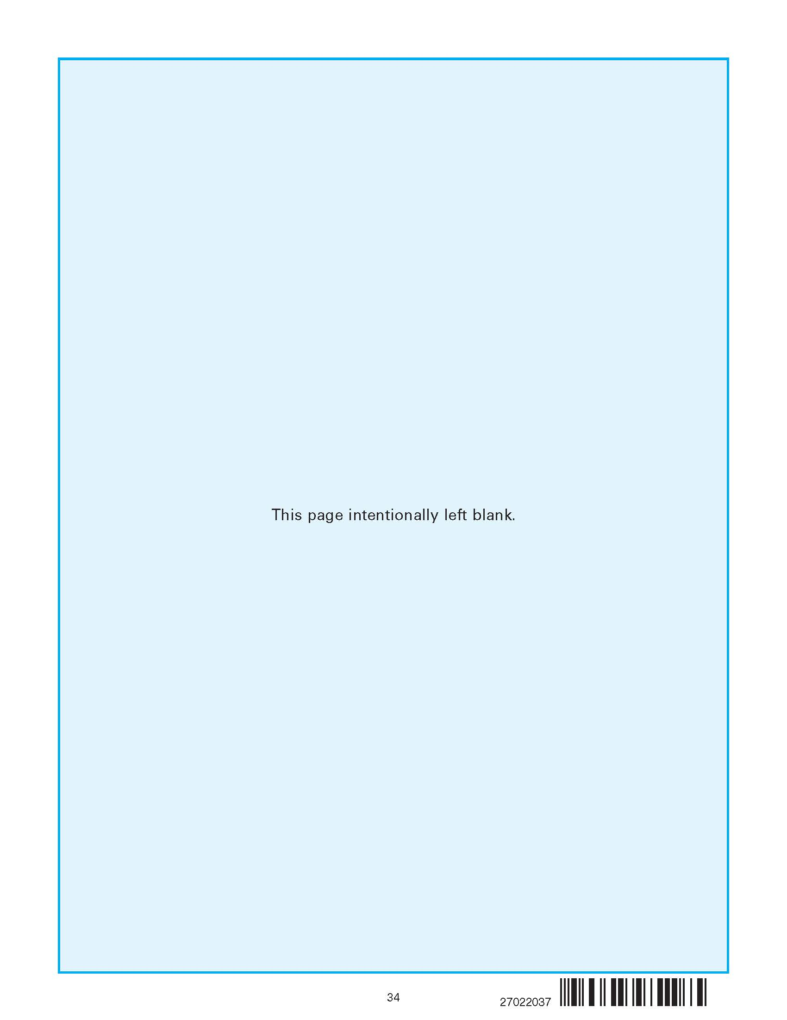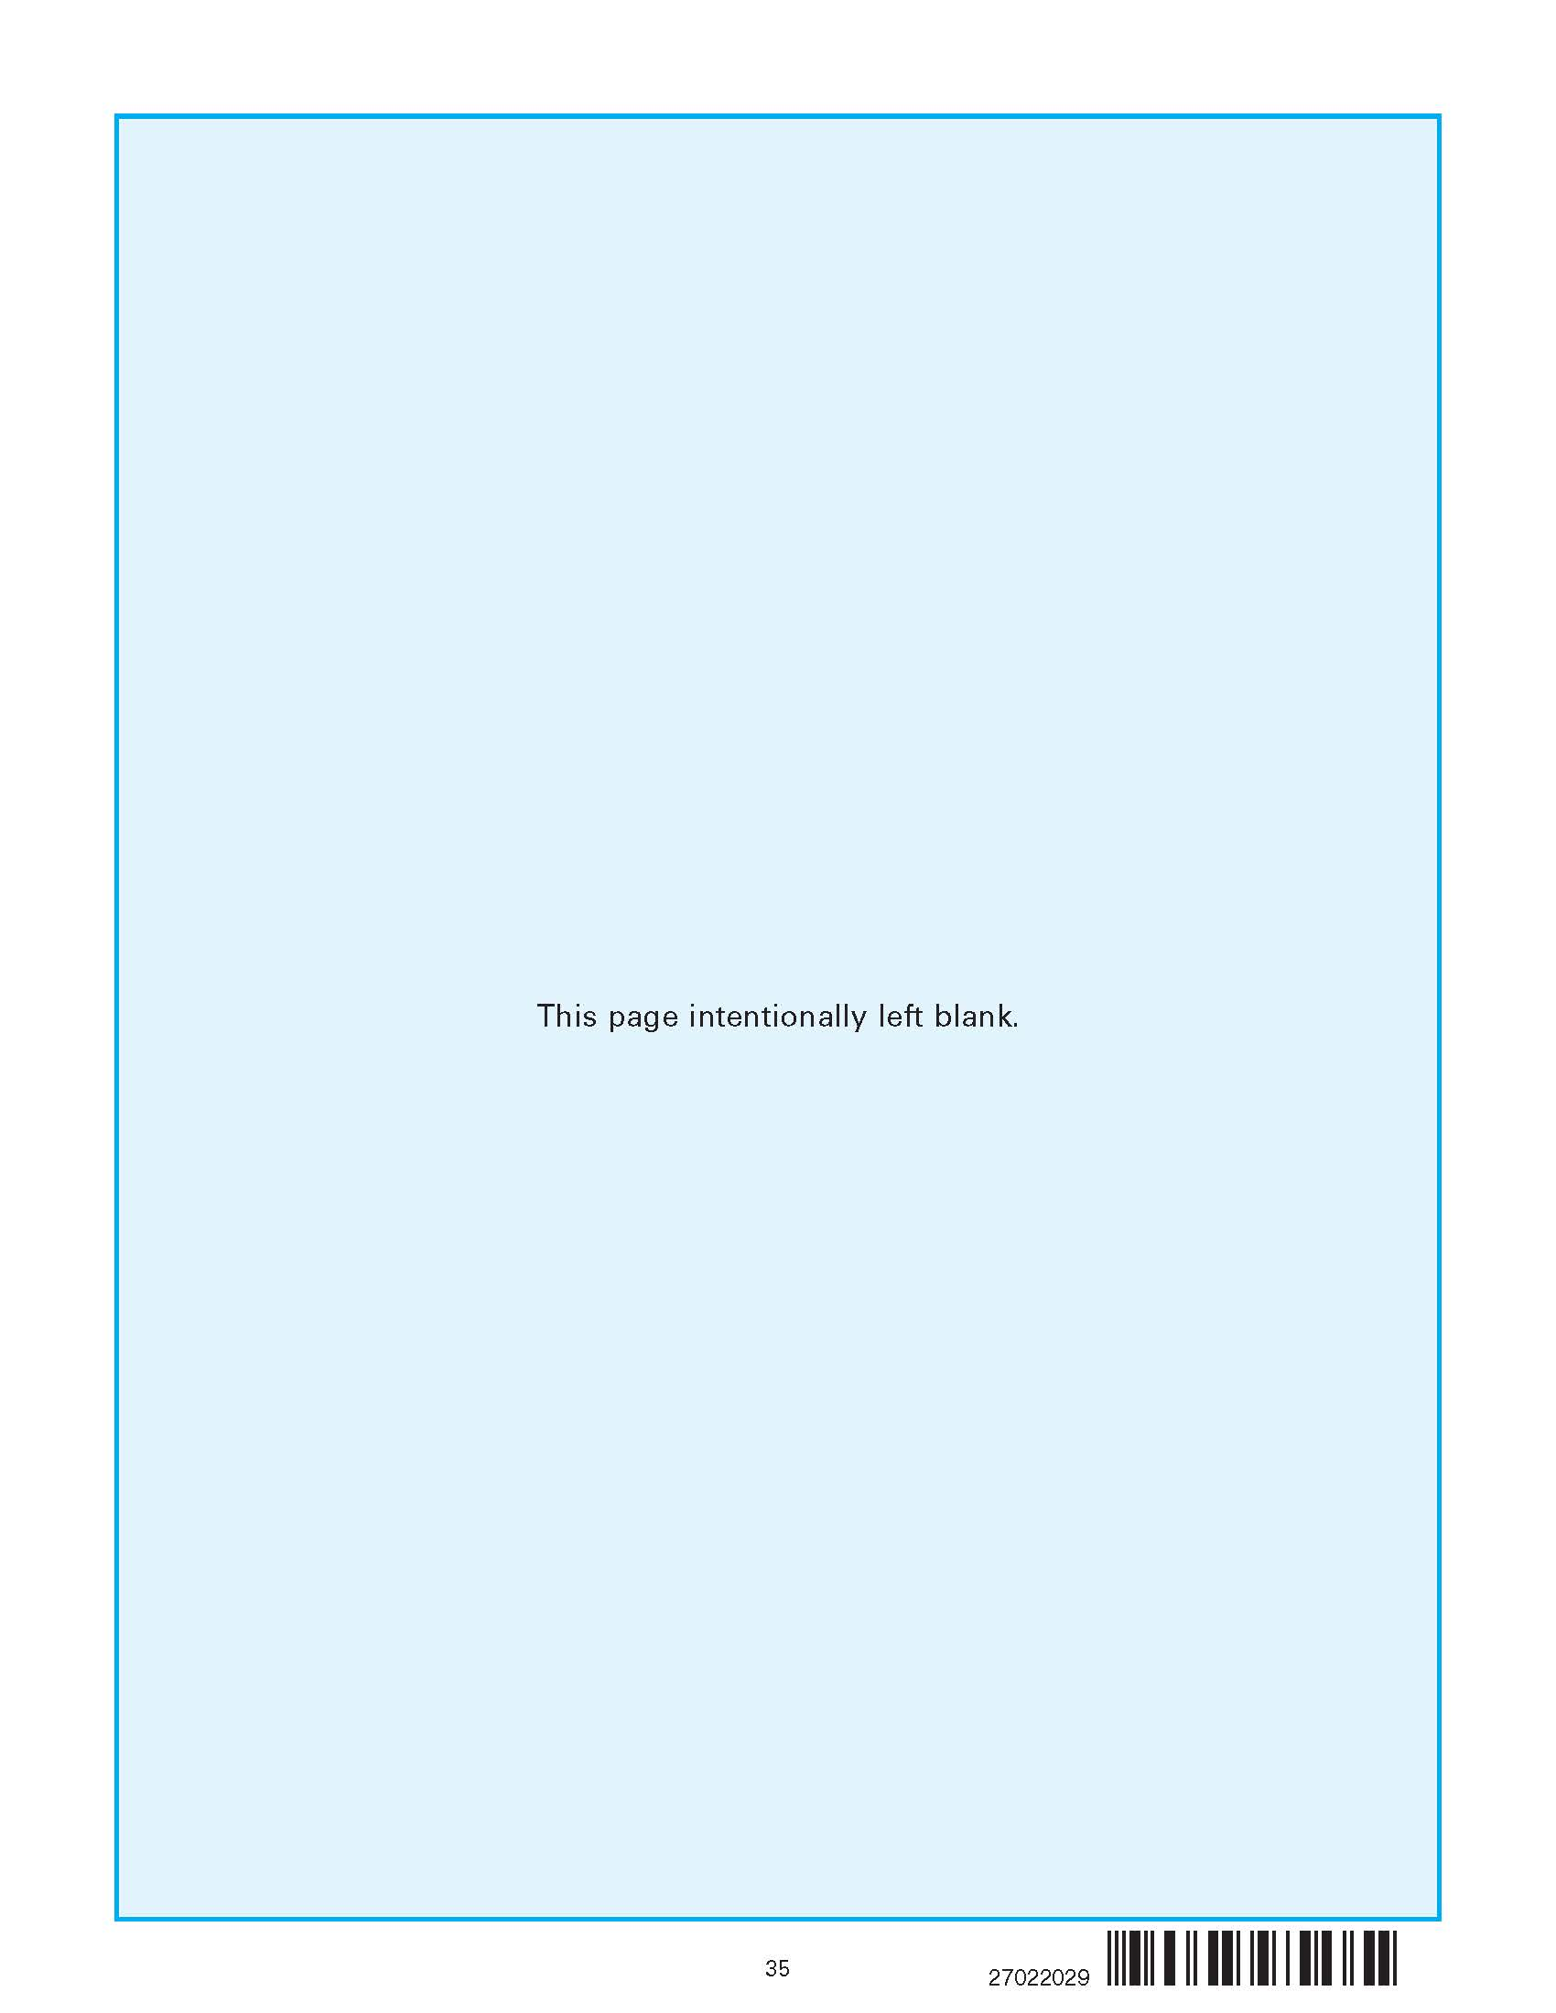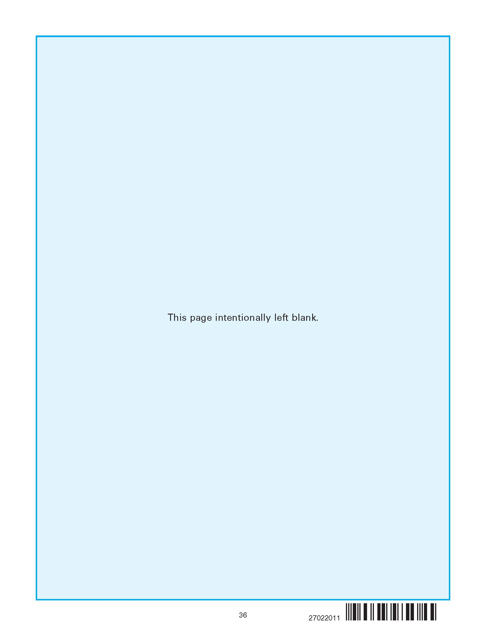

1. AAPOR Response Rate 3 was used to calculate the NSSRN Response Rate. For more details, please see the Response Rate Section of this report.
2. Numbers in this section and the tables within have been rounded according to Census Bureau Disclosure Review Board rules.
3. Given the sampling frame was created from files received from the nursing boards in early 2022, this sample may not be representative of nurses newly licensed in 2022 and 2023.
4. For additional details on the PVS process, please see Wagner and Layne (2014).
5. Half of the records with California as the licensing state were removed from the frame in order to unduplicate the samples for the 2022 NSSRN and the California Survey of Registered Nurses conducted by the California Board of Nursing (CBN). Records with even registered nurse license numbers were made ineligible for 2022 NSSRN sampling and removed from the frame while odd license numbers remained eligible.
6. This was determined to be a reasonable cutoff given the timing of acquiring the files from the Nursing Boards. Only licenses well over a year past their expiration data were deleted.
7. The calculation of the variance for the state estimates of RNs is ${\left(\frac{N_{1}}{N}\right)}^{2}{\frac{.5}{n_{1}}}^{2}\left(\frac{N_{1}-n_{1}}{N_{1}}\right)+ {\left(\frac{N_{2}}{N}\right)}^{2}{\frac{.5}{n_{2}}}^{2}\left(\frac{N_{2}-n_{2}}{N_{2}}\right)$ and the calculation of the variance for the state estimates of NPs is ${\frac{.5}{n_{2}}}^{2}\left(\frac{N_{2}-n_{2}}{N_{2}}\right)$. Where N, N1, N2 are the state total populations of RNs and NPs, RNs, NPs respectively, While n, n1, n2 are the state sample sizes of RNs and NPs, RNs, NPs respectively, A conservative estimate of 50 percent from the base of employed RNs and NPs is assumed. The state level variances include a finite population correction factor since the NP sample is a large portion of the NP population in many states.
8. Sampling rates for the NP stratum in AK, CT, NJ, and UT were inflated slightly. The APRN files we received for these states included other types of APRNs than just NPs without any designation for NPs. Therefore, all nurses holding an APRN license in these states were flagged as being an NP to ensure enough NPs were in the NP stratum and NP stratum sampling rates were inflated slightly to ensure an adequate state sample size of NPs.
9. The American Association for Public Opinion Research. 2016. *Standard Definitions: Final Dispositions of Case Codes and Outcome Rates for Surveys. 9th edition*. AAPOR.
10. It is acknowledged that this is a different treatment of ineligibles than in the calculation of the response rate. The motivation is to represent the 2021 nurse population as well as possible, since that is the information obtained from the nursing boards.
11. Because the population of NPs was small in most states and sample sizes were set to produce reliable state estimates, quite a few states had very large sampling fractions. In 29 states, the sample selected was 20 percent or greater of the NP population. In four of these states, the entire population was included in sample. Due to these high sampling rates, FPCs are needed in the replicate factors in order to adjust the variances accordingly.
12. Numbers in this table have been rounded according to Census Bureau Disclosure Review Board rules.
13. Imputation rates were computed as the ratio of the number of imputed cases of that variable to the total number of valid responses reported for that item.
14. Imputation rates were computed as the ratio of the number of imputed cases of that variable to the total number of valid responses reported for that item.